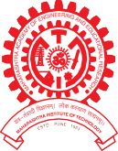MAEER PUNE’s

MAHARASHTRA INSTITUTE OF DENTAL SCIENCES & RESEARCH (DENTAL COLLEGE)
ESTD 2006

M I D S R

Address : Vishwanathpuram Ambajogai Road, Tel : (02382),227703, Email : principal@mitmidsr.edu.in Latur. 413531 (Maharashtra) 227424 midsr.latur@gmail.com
Fax : (02382) 228063 Website :www.mitmidsr.edu.in

Report of Department Day 13th Feb – 2022 Programme

Department of Oral & Maxillofacial Surgery
Department of Oral and Maxillofacial Surgery department conducted a Departmental Day Programme on 13th Feb 2022 due to celebration of 52 years of Inspiring Achievements in Oral & Maxillofacial Surgery.
Details of the Department Day Programme:
- Blood donation camp
- Oral Submucous fibrosis awareness camp
- Singing competition
- Poster ,tattoo rangoli Competition
- Treasure hunt
The programme was a huge success with many participants including head of department, staff, P.G. & Interns and U.G students of Department of Oral & Maxillofacial Surgery.
The programme was conducted in the Department of Oral & Maxillofacial Surgery, MIDSR Dental college, Latur. The program was started with ribbon cutting ceremony by our respected principal DR Suresh Kamble sir . HODs of different department also attended the program . The programme started with inauguration by lighting the lamp at the hands of Dr. Suresh Kamble (Principal MIDSR Dental College, Latur) Dr. Sheeraz Badal (Professor), Dr. Rahul Lature (Professor), Dr. Amol Doiphode (Professor) and Dr. Suresh Kangane was felicitated by Dr. Rahul Lature, Dr. Rahul Lature was felicitated by Dr. Sheeraz Badal, Dr. Amol Doiphode was felicitated by This was followed by the welcome address by Dr. Gopal Nagargoje. Welcome song was sung by interns . Presentation was made by DR Varsha for making everyone aware about specialty about oral and maxillofacial surgery . on the same day oral and Submucous fibrosis awareness camp and held to make people aware about the adverse effect of habits and also distributed medicine to them . we also organized blood donation camp and everyone enthusiastically participated in campaign program various competition were held like rangoli , singing ,poster , tattoo. UGs and PGs participated with zest. There were various group event . program was ended by cake cutting ceremony . winners of various competition were given certificate.. and thus we celebrated the day with dynamism
The inauguration was followed by start of blood donation camp.

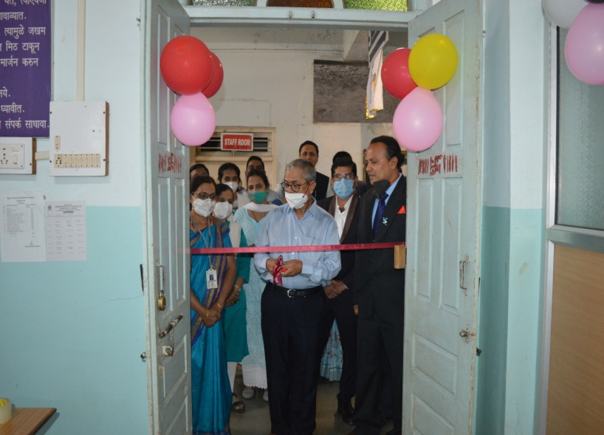

Ribbon cutting ceremony by Dr. Suresh Kamble

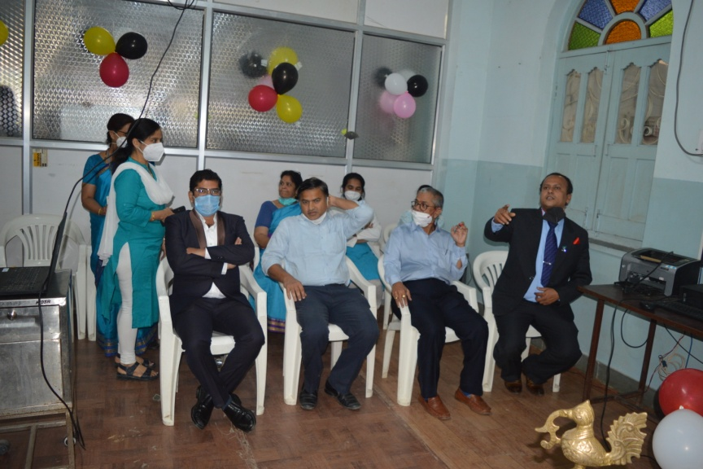

HOD from all department as Guests

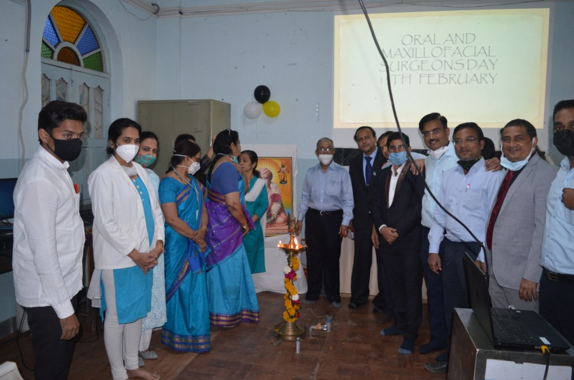

Lightening Lamp ceremony

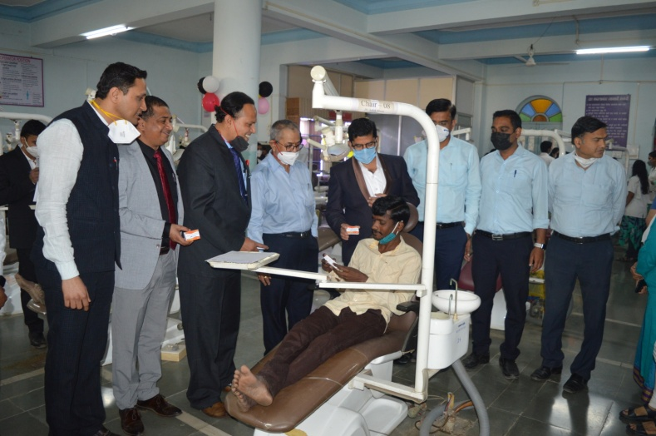

Oral Submucous fibrosis awareness camp

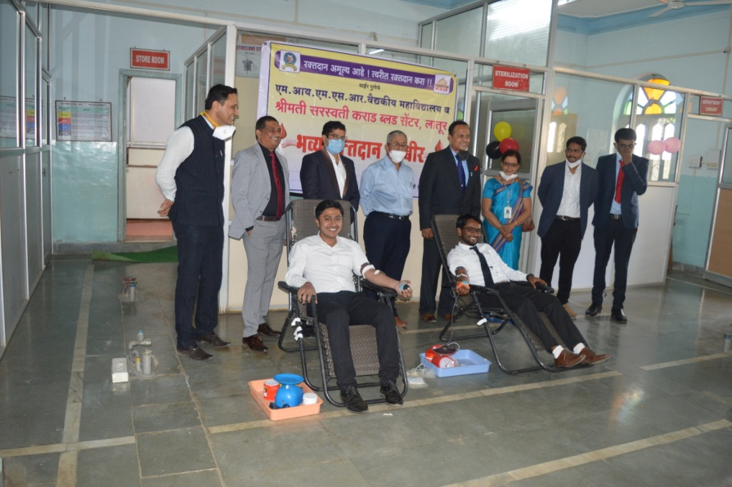

Blood donation Camp

