2ND ORTHODONTIC CDE
Organized by

DEPARTMENT OF ORTHODONTICS & DENTOFACIAL ORTHOPEDICS
MIDSR DENTAL COLLEGE & HOSPITAL, LATUR

ON 13/04/2020

title:
“A PICTURE WORTH THOUSAND WORDS”
WORKSHOP ON CLINICAL PHOTOGRAPHY.
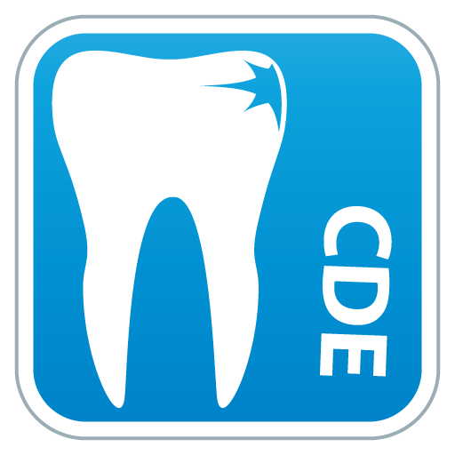

The CDE was graced by auspicious presence of Dr. Jayesh Rahalkar as chief guest & speaker. CDE program started with vishwashanti prayer, Dr Rahalkar inaugurated the program by lighting the traditional lamp with chairman of CDE and principal Dr. Syed Ahmed ,Organizing deputy chairman Dr. Suresh Kangane , organizing secretary Dr. Anand Ambekar and Administrative officer Mr. Sachin Munde. Following lamp lightning Principle, Dr Sayed Ahmed felicitated Dr Rahalkar
About Speaker –
Dr Jayesh Rahalkar MDS ,M Orth RCS(Edinburgh)(UK),DNB (Orthodontics), Diplomat &Director of Indian Board Of Orthodontics
(DIBO), currently working as Professor & P.G guide at Dept of Orthodontics, DR D.Y.Patil dental college & hospital ,Pimpri, Pune.
participants – 45 PG students from Parbhani,Solapur,Beed,Bagalkot,& MIDSR Latur participated and made the program successful.

SCHEDULE :
Date | 13-04-20
Sr. No. | Session | Time | Duration
1 | Registration & Breakfast | 9.00am-9.30am | 30min
2 | Inauguration | 09.30 am -10.00 am | 30 min
3 | Session I | 10.00 am -11.30 am | 90 Min
3 | Principles of photography (Basics)by Dr.Jayesh Rahalkar | 10.00 am -11.30 am | 90 Min
4 | Session II | 11.30 am-1.00 pm | 90 min
4 | Techniques: Intraoral, Extraoral Table-top, Procedure Image management in Photography by Dr.Jayesh Rahalkar | 11.30 am-1.00 pm | 90 min
5 | LunchBreak | 1.00 pm-2.00 pm | 60 min
6 | Session III | 2.00pm-3.30pm | 90 min
6 | Photography demonstration Understanding your camera system Practicing the technique. | 2.00pm-3.30pm | 90 min
7 | Session IV | 3.30pm-5.00pm | 90 min
7 | Critical evaluation of photographs Discussion Imagemanagement | 3.30pm-5.00pm | 90 min
8 | Validation | 5.00pm-5-30pm | 30 min

Morning lecture schedule started sharp at 10am with thoroughly informative lectures and impressive presentations by Dr. Rahalkar. After lunch the afternoon demonstrative session was scheduled in department of orthodontics where Dr. Rahalkar demonstrated using methods of different types of camera, their parts, and some advances in photography in an interactive session.
Participants received certificates with 5 CDE points at the end of session. The program was hugely appreciated by all the participants
