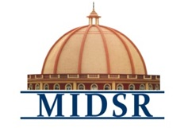

MAEER PUNE’S
MAHARASHTRA INSTITUTE OF DENTAL SCIENCES AND RESEARCH, LATUR
(DENTAL COLLEGE & HOSPITAL)

REPORT
- DEPARTMENT OF ORAL PATHOLOGY
* On occasion of Birth Anniversary of Dr. H.M. Dholkia’s, national Oral Pathologist Day was celebrated on 25Th Feb, 2021.

* Dr. Anuja Maniyar, Dr. Varsha Sangle, Dr. Smita Chaware Ma’am had conducted the program.

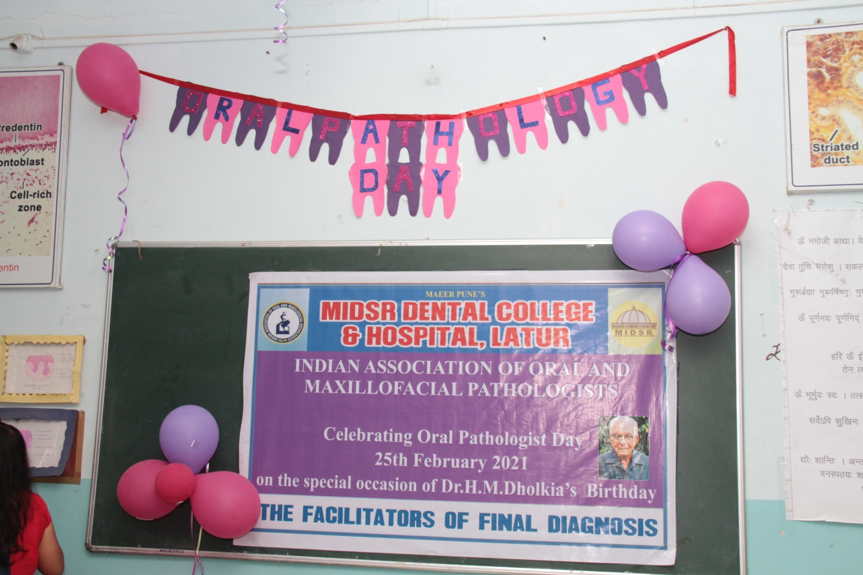

RANGOLI
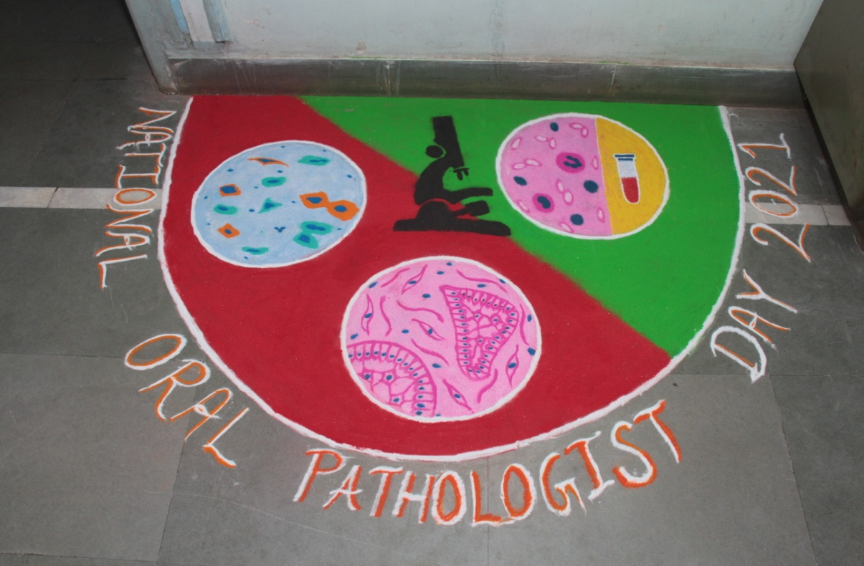
Rangoli at the entrance of department on OCCASION OF ORAL PATHOLOGIST DAY CELEBRATION

INAguration
* The program was inaugurated by Dr. Rutuja Ayachit Madam, the General Pathologist of MIMSR, Medical College and Dr. Suresh Kamble Sir, the Principal of MIDSR Dental College, Latur.

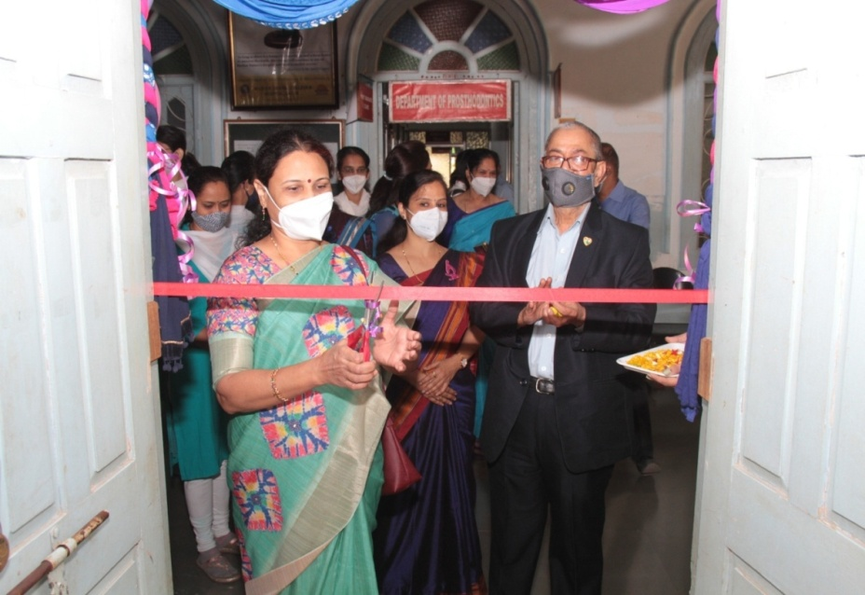
I
VISHWASHANTI PRAYER
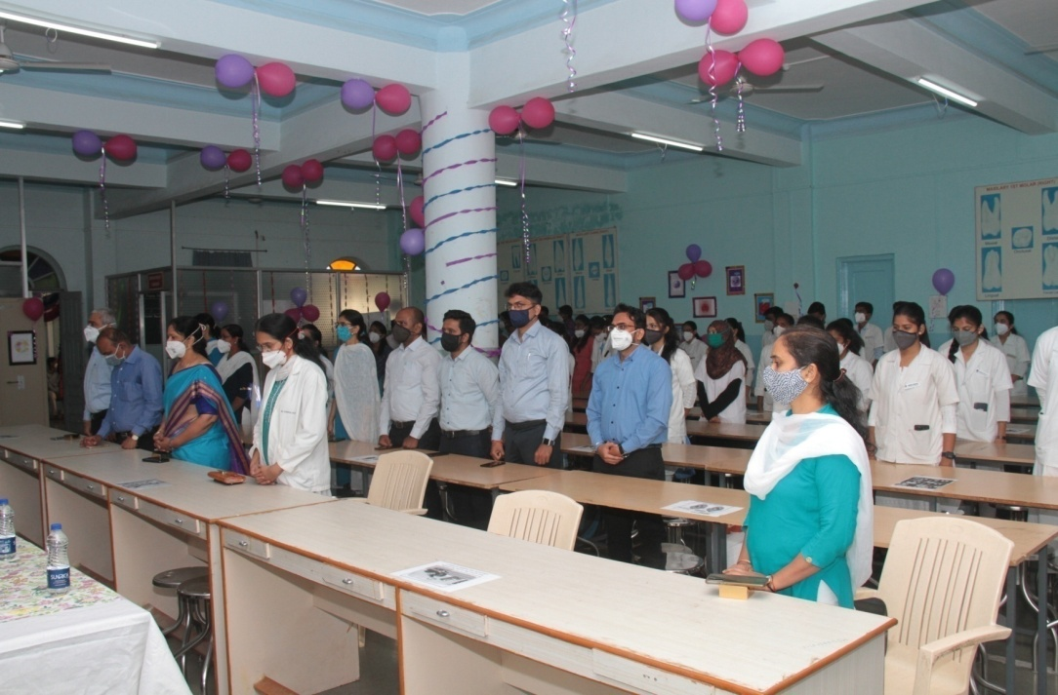
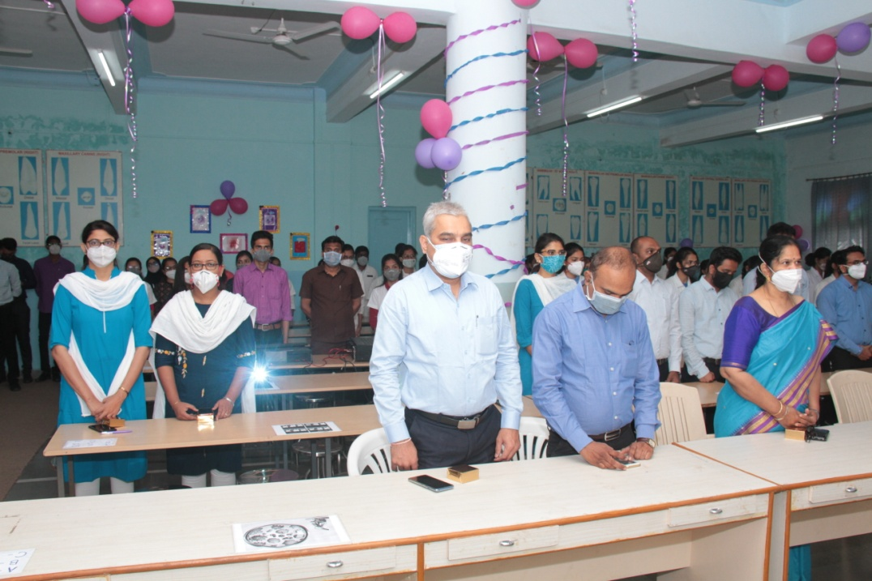
All the respected staff of MIDSR dental college....
LAMP LIGHTING
- The lamp lighting ceremony was started at 10:30 am.
- It was followed by saraswati vandana by Maithili Intern.

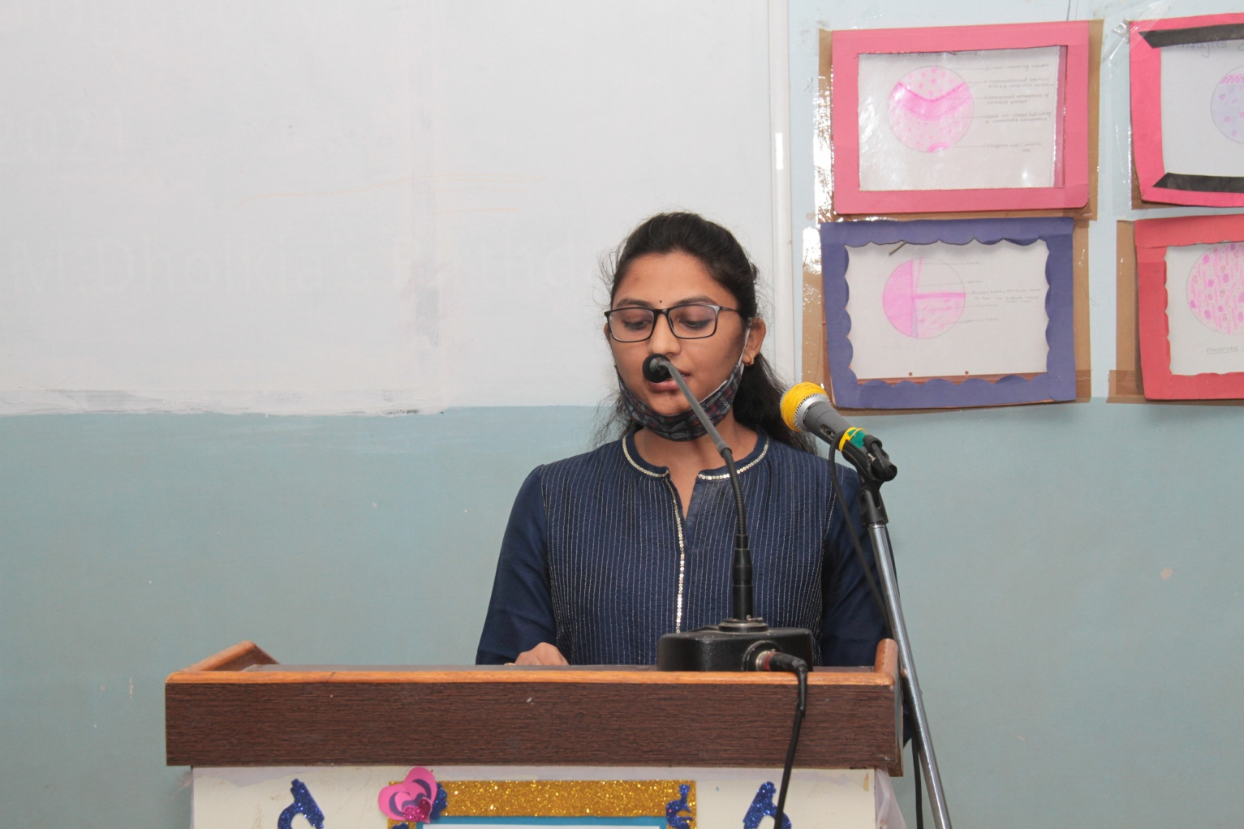
‘ya kundendu tusharahara dhavala……sarswati vandna’’

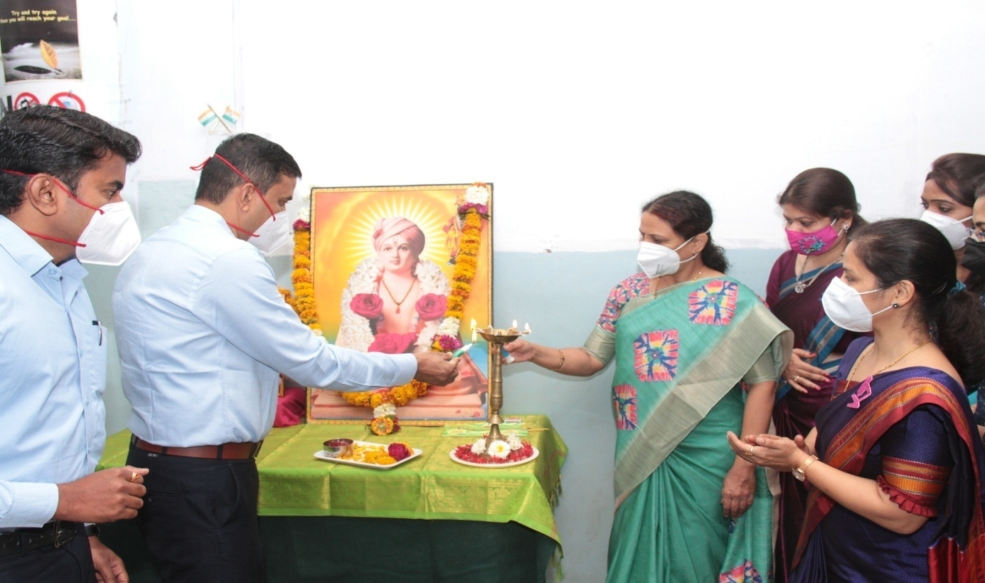

Lamp lighting Ceremony....
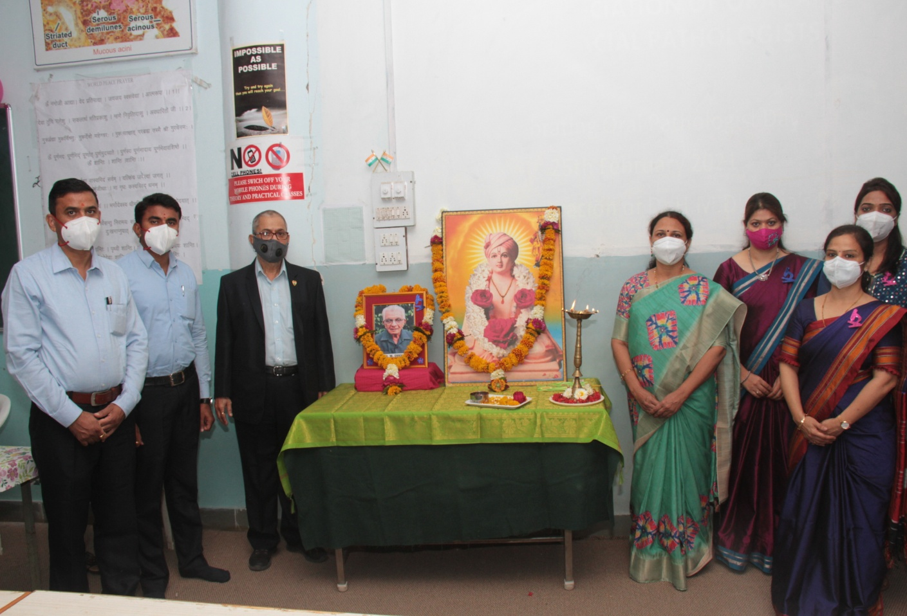

Felicitation
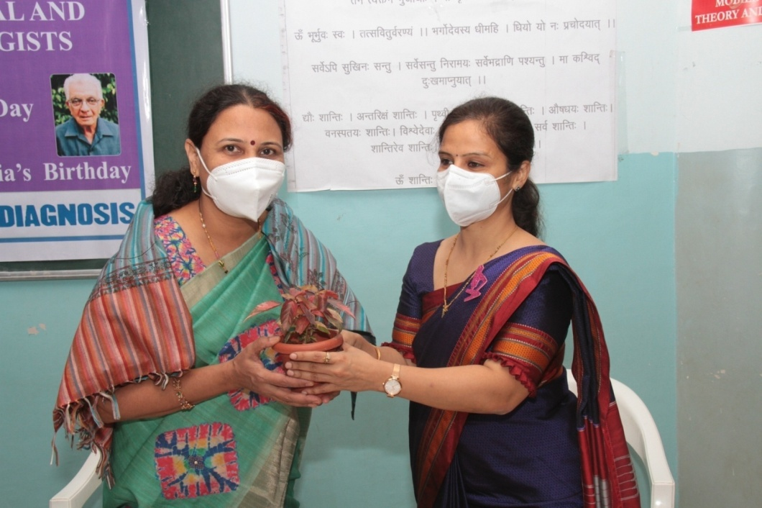
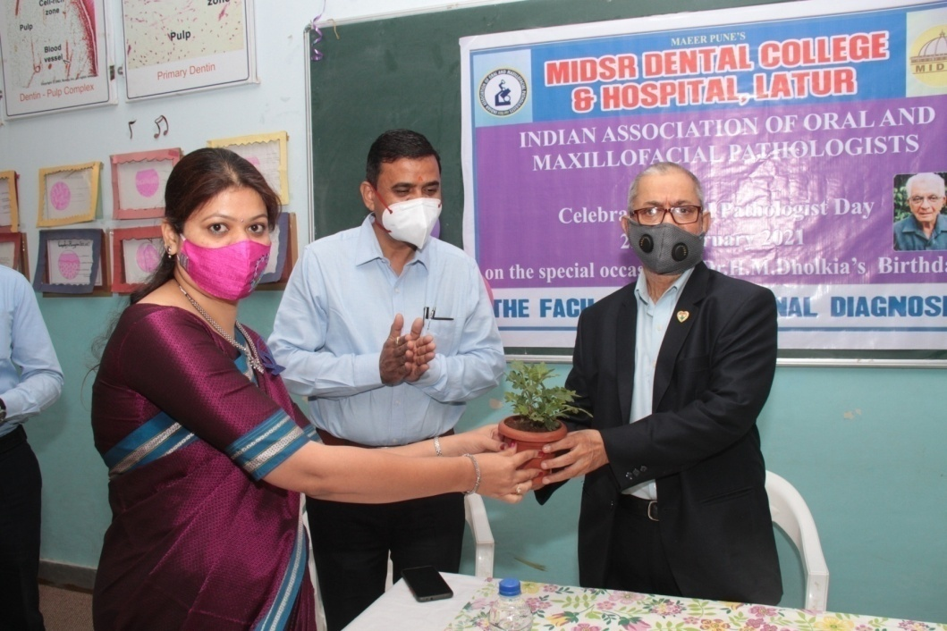
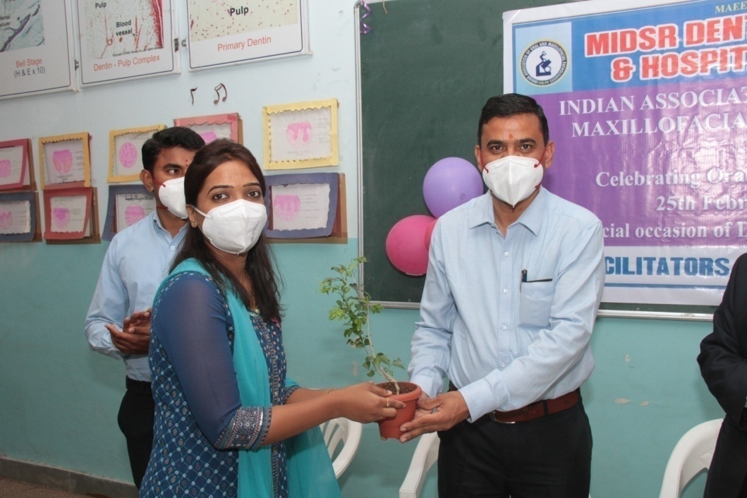

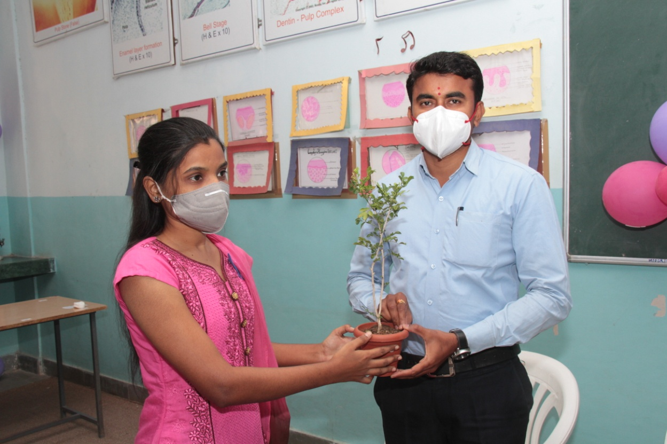

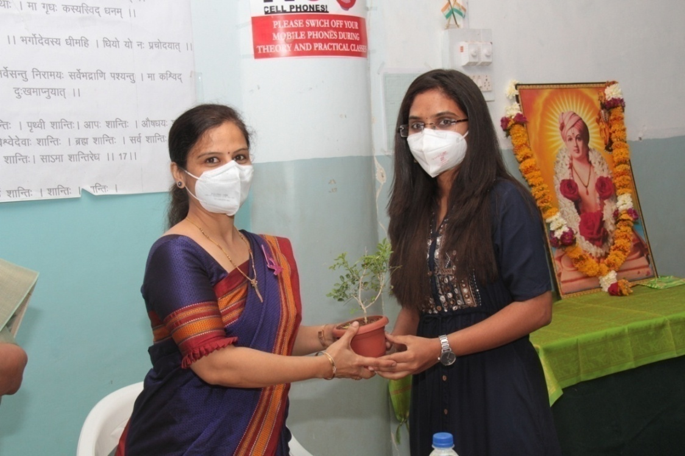

Cake cutting
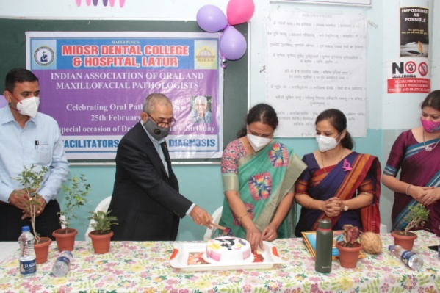
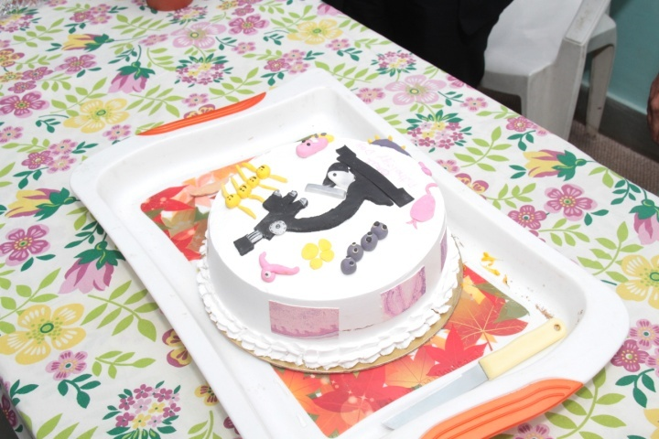

SPEECH
THAT WAS THE FABULOUS SPEECH , GIVEN BY Dr.Anuja Maniyar and our respected guest Dr. Rutuja Ayachit mam...
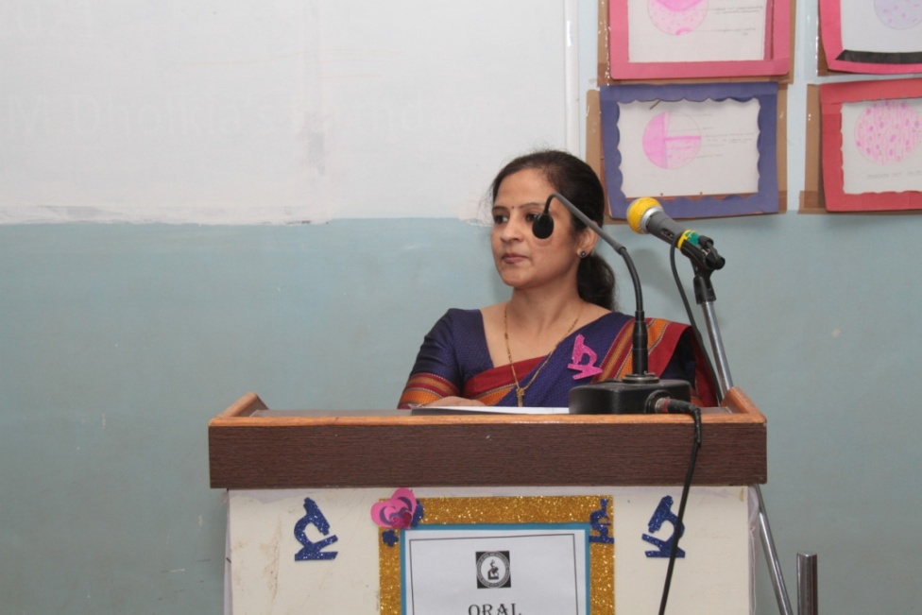

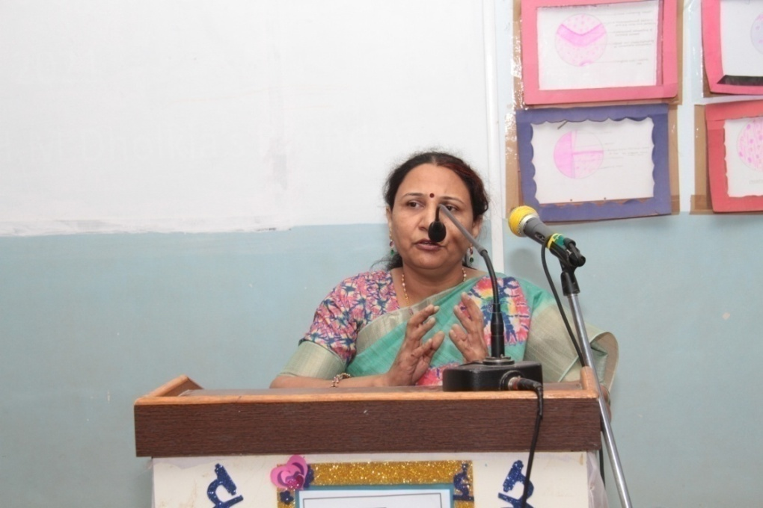

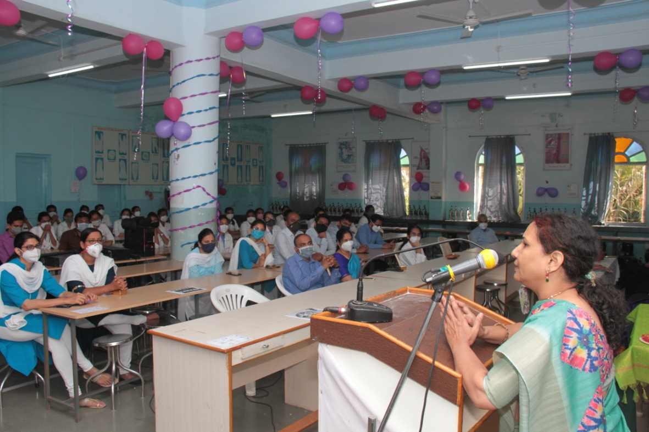

Vote Of Thanks
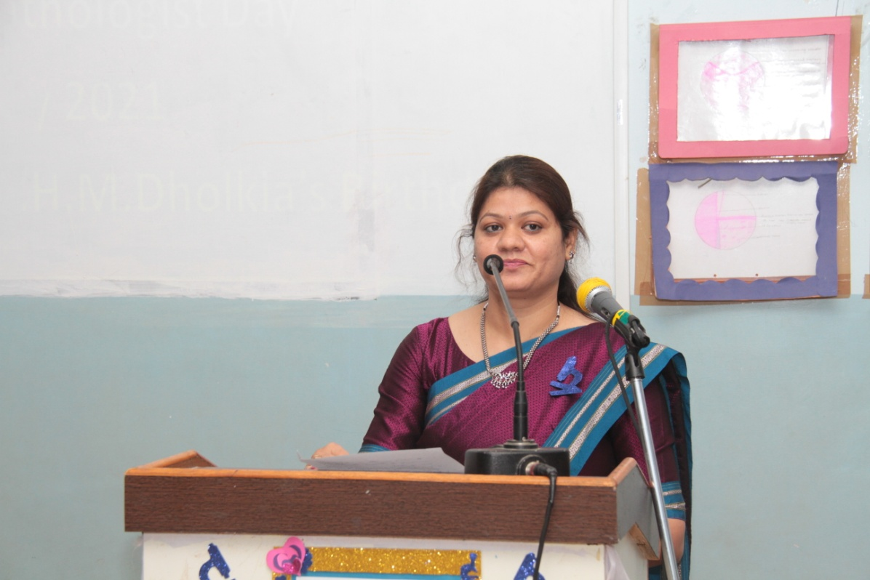

Dr. Varsha Sangle mam while giving vote of thanks speech....

Competition
Sculptomania
SOAP CARVING
The Soap Carving Competition was held and it was judged by Dr. Rutuja Ayachit mam and Dr.Om Baghele sir.
Price Distribution done on 25th Feb by Dr. Kangane sir.
WINNER:
1ST PRIZE: Apeksha Phapal, Ist Year student
2ND PRIZE: Siddhi Shete, Ist Year student
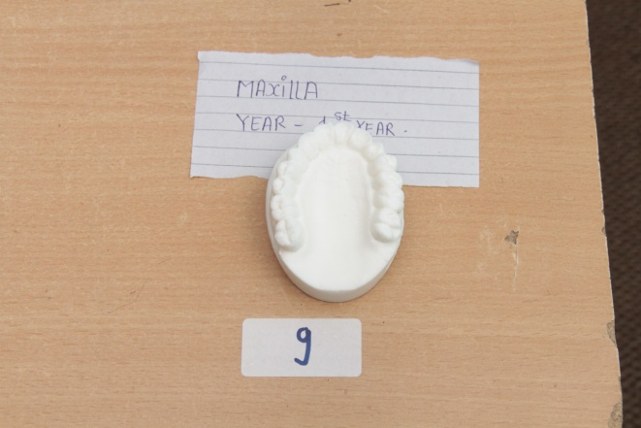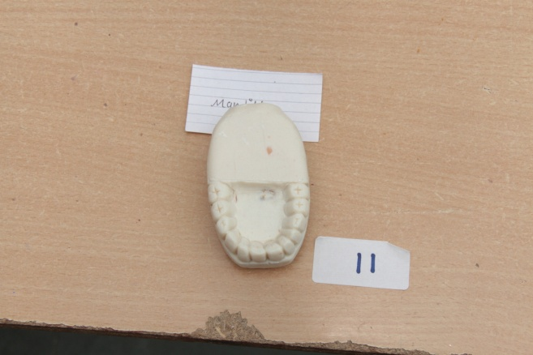
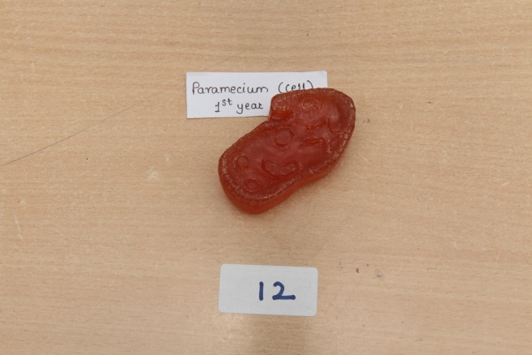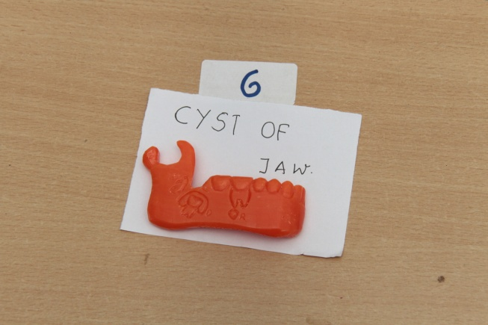
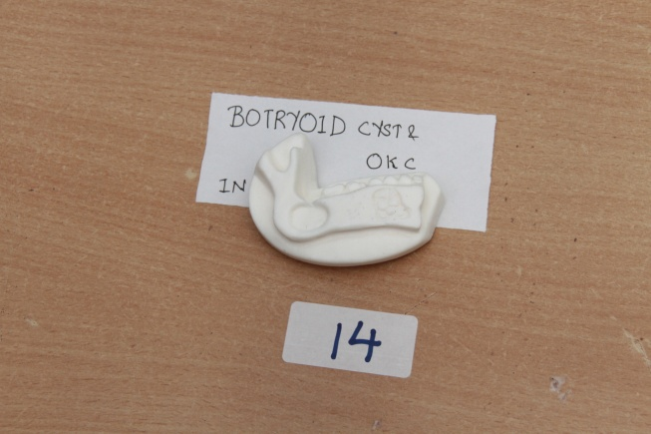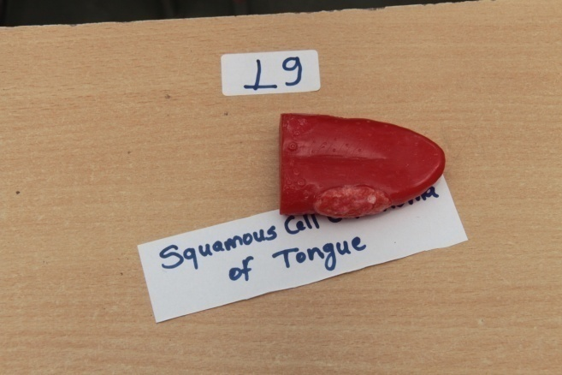
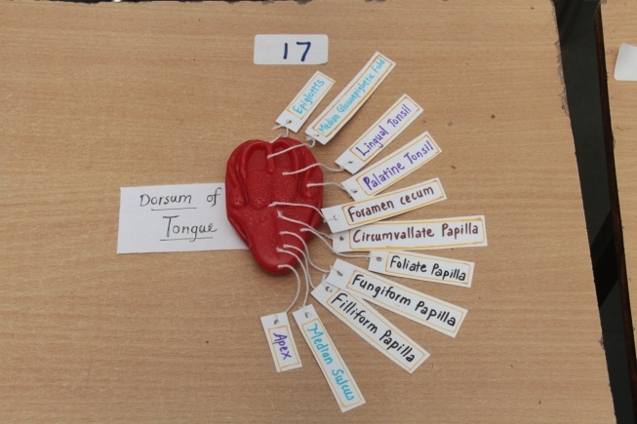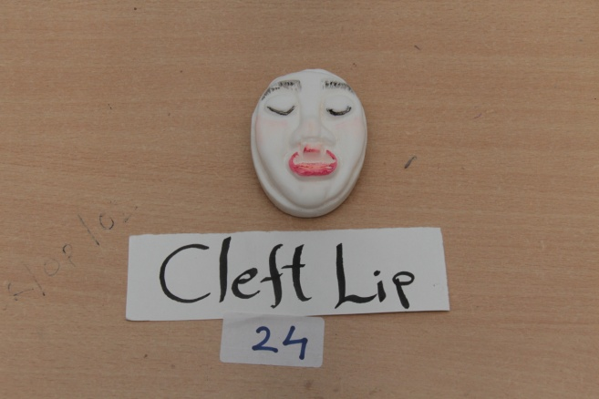

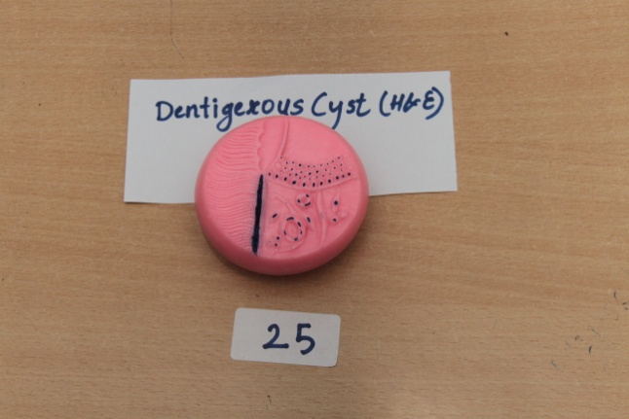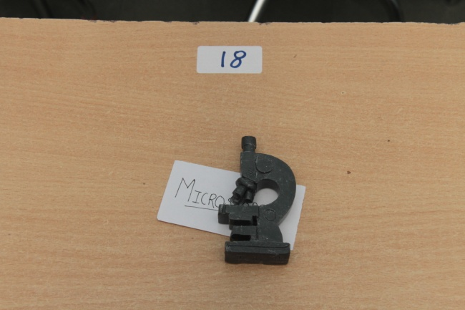

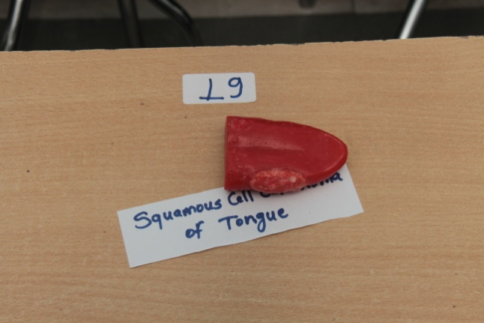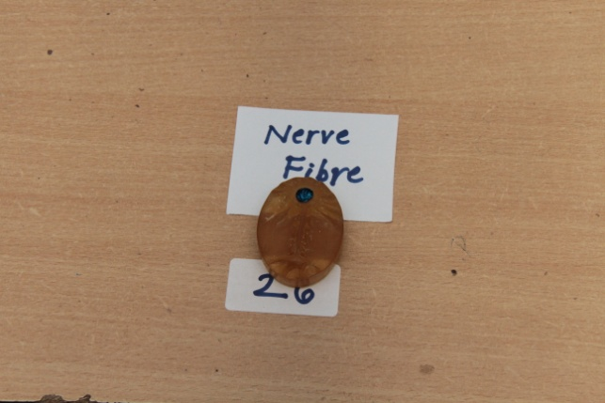

Judges while seeing soap carving.....

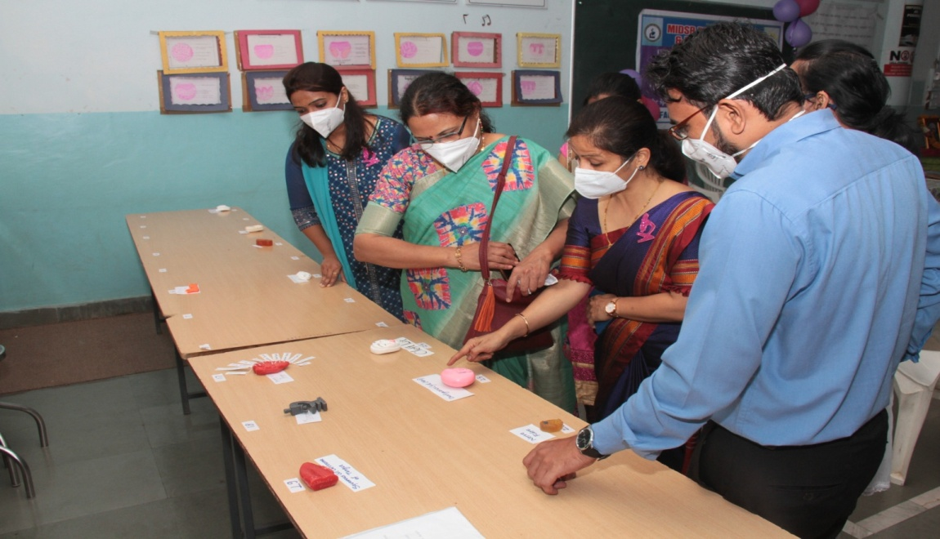

Pictoplasia
Poster competition
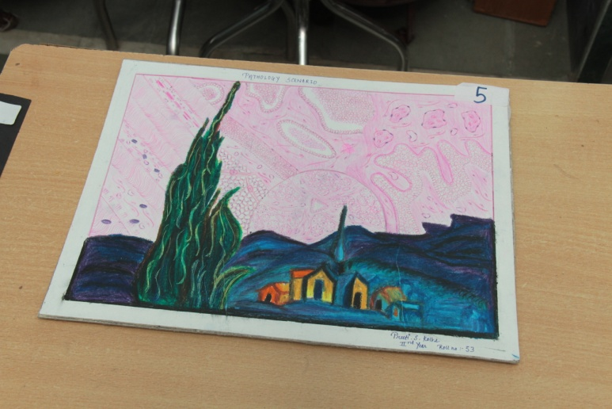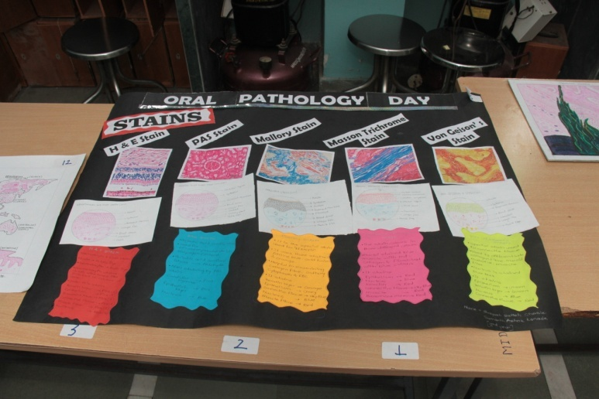

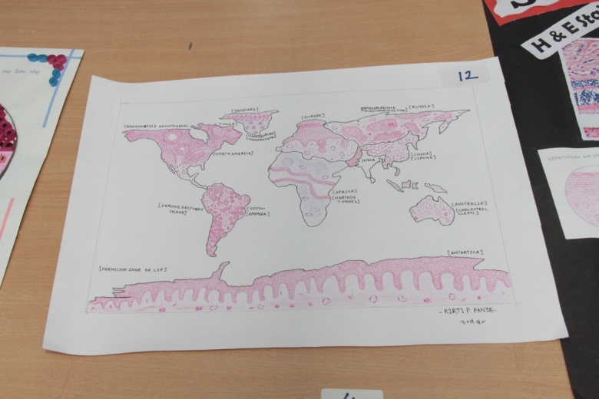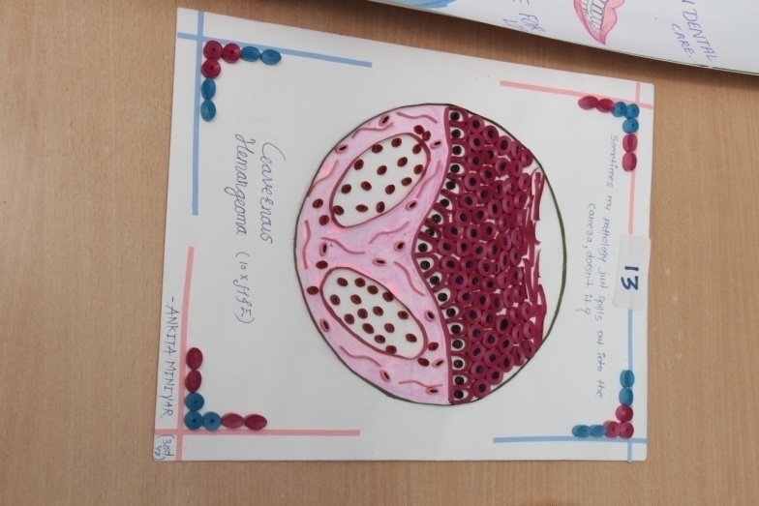
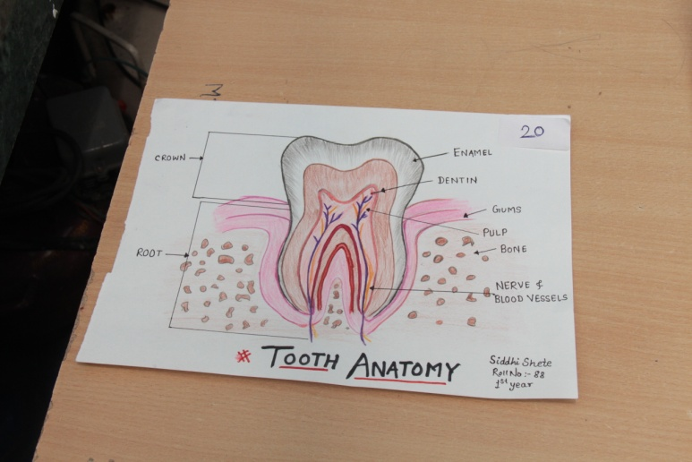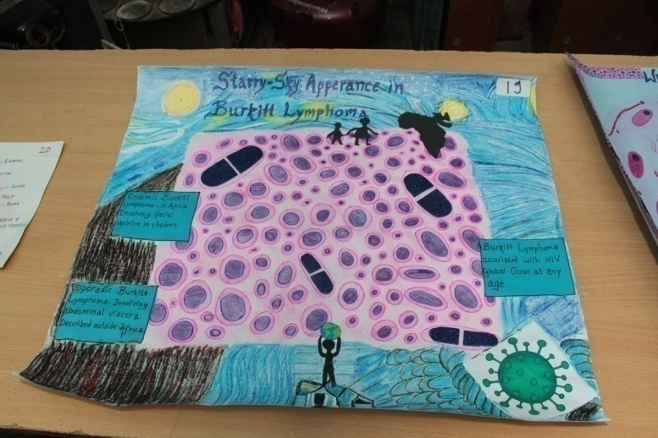

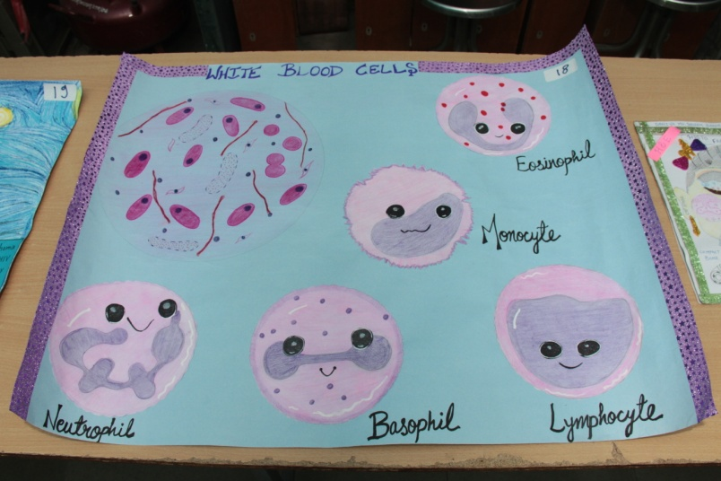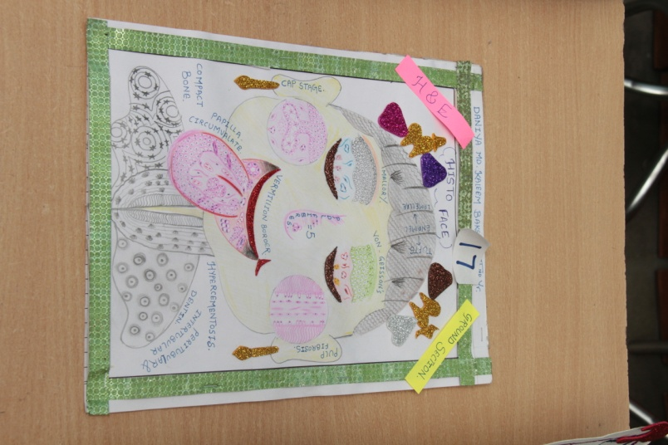
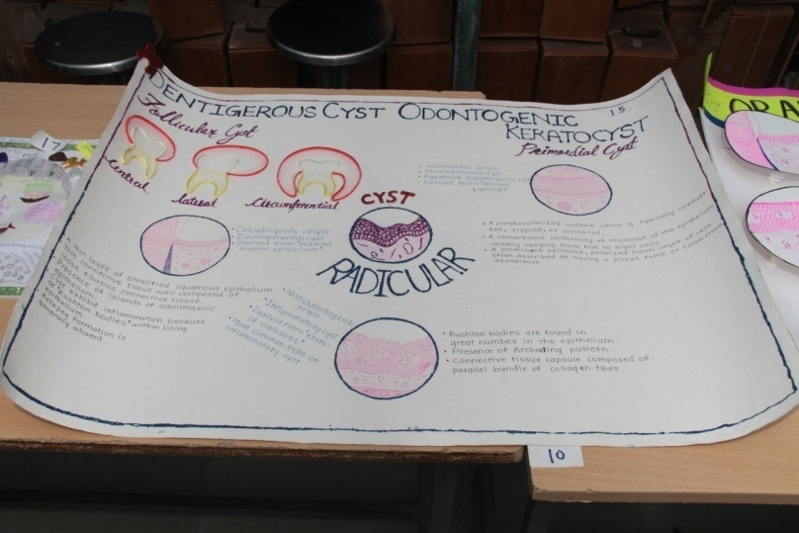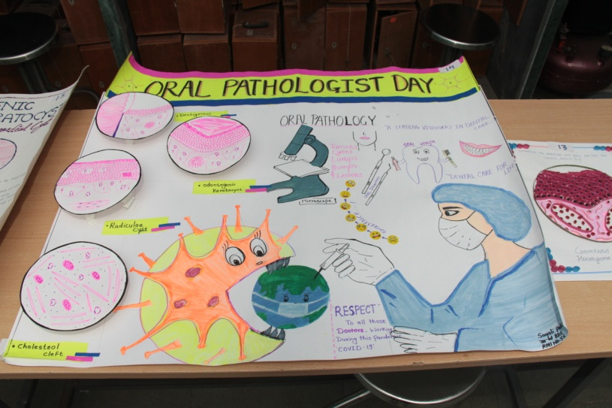

- There was an amazing posters for competition and it was judged by Dr. Shashi Patil, Dr. Ashwini Biradar and Dr.Ajit Shinde.
- Ankita Miniyar from 3rd year won the first prize in poster competition.
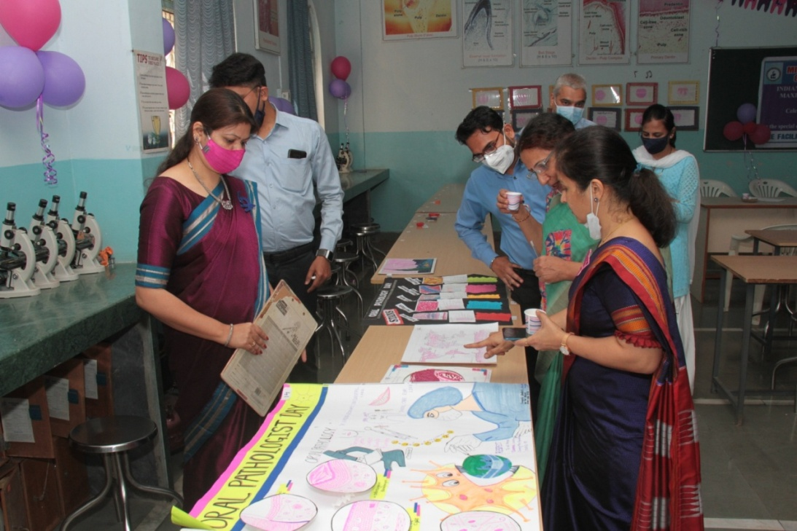
Judges ,while seeing posters......

Pleomorphic RANGOLI competition
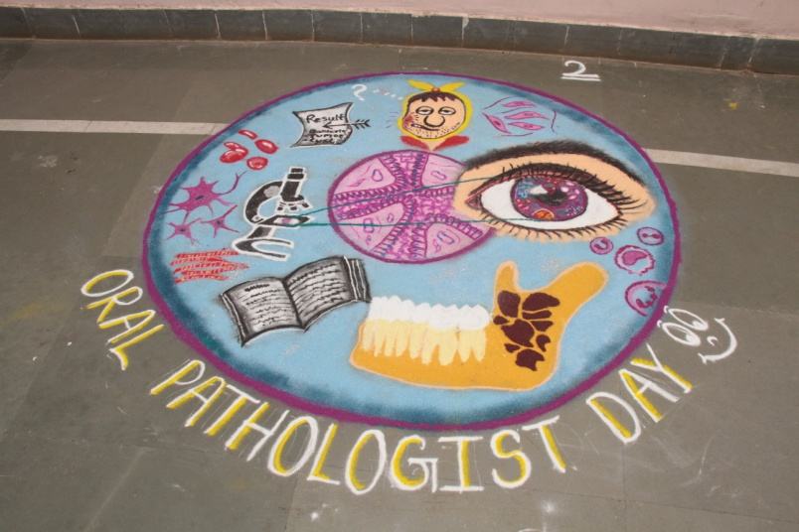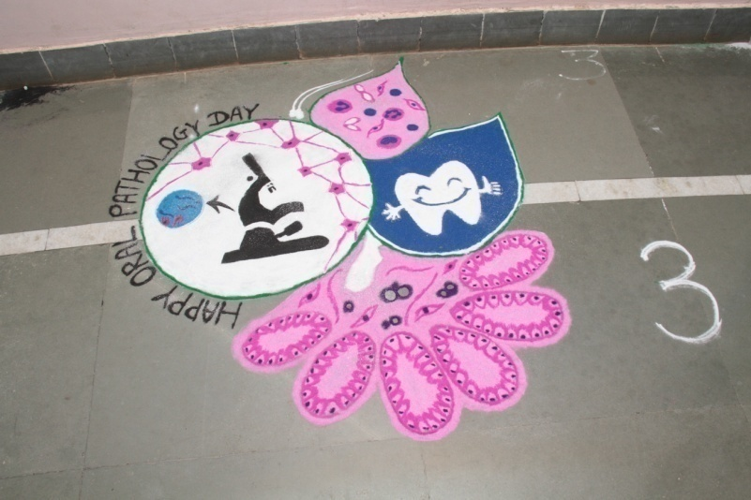
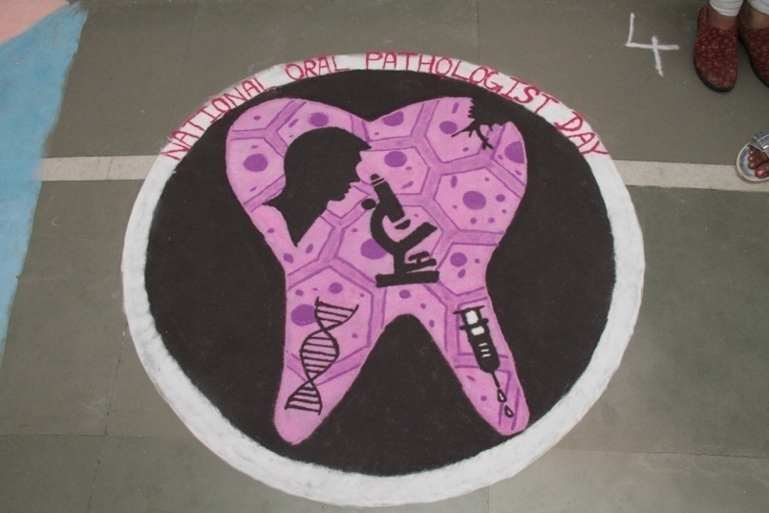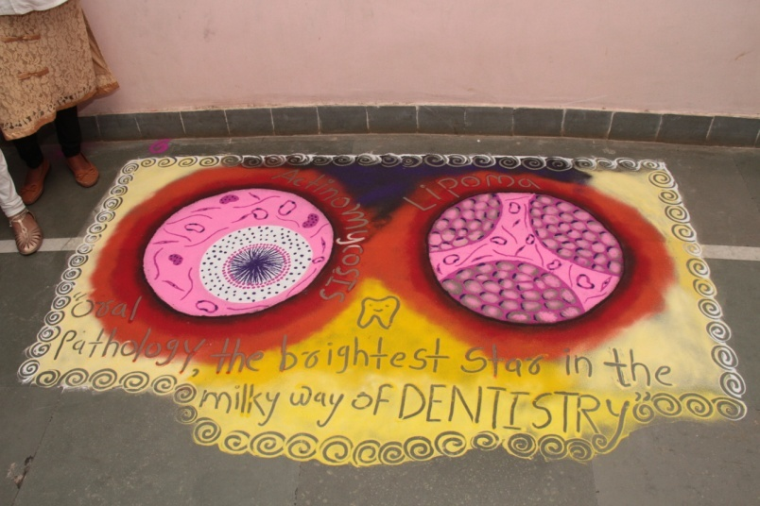
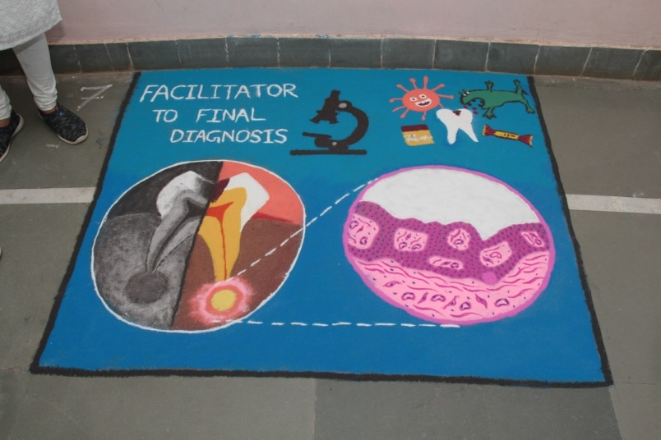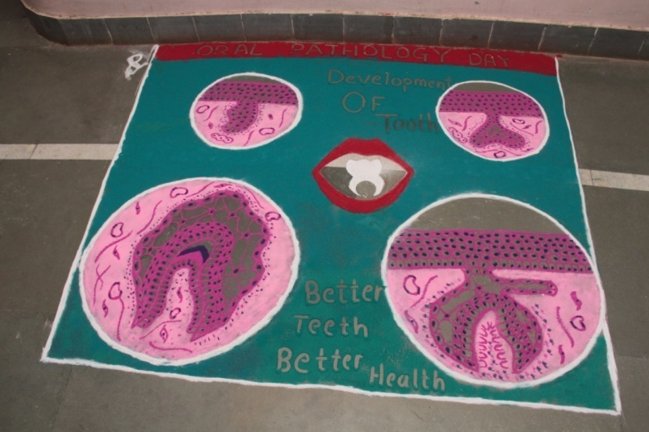

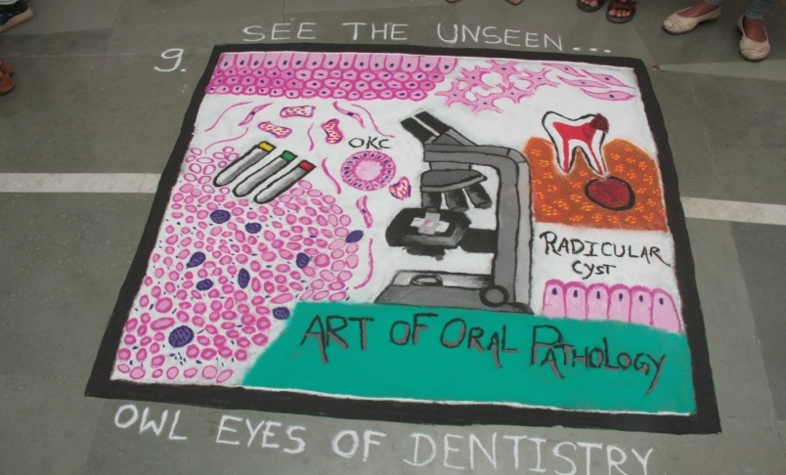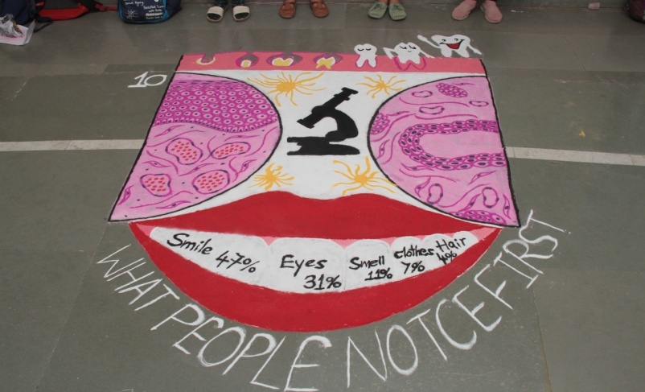
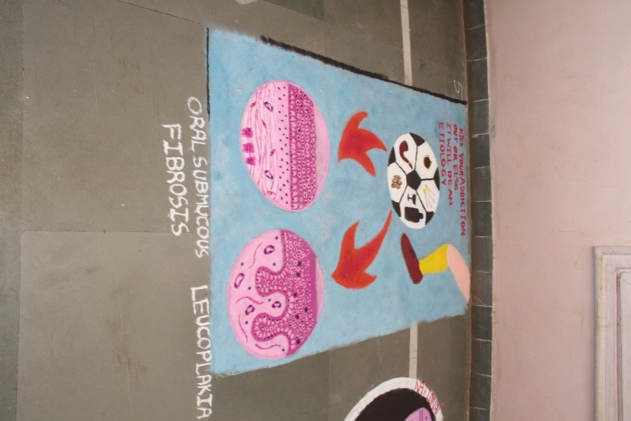

- There was rangoli competition held on that day .The judges for this competition were DR. Madhuri Agarwal and DR.Gauri Ugile
- First prize was given to Aishwrya Hude ,Sakshi Shegedar,Varsha Boyane group

crossword puzzle’ competition.

- The last and most different competition was held, was the ‘crossword puzzle’ competition.
- It was judged by Dr. Anuja Maniyar and Dr.Smita Chaware.
- The winner for this competition was Shreya Baher and Hajra sheikh.

PARTICIPANTS list
Rangoli
1.Snehal Biradar
Vaishnavi Biradar
Snehal Budde

2.Aishwarya Hude
Sakshi Shegedar
Varsha Boyane

3. Sakshi Aote
Sakshi Dhoot
Sneha Shranghare
Mayri Kharatmol

4.Shetal Mane
Anuja Aapet
Anuradha Birajdar
Snehal Mudpe

5.Dinal Malviya
Mansi Chate
Shraddha Adude
Arshiya Shaikh

6. Ankita Miniyar
Rohini Sawant
Diksha Sarpe
Nikita Satpute

7. Tejashree Mane
Nabha Manthale
Mohini Mhetre
Shreya Kayande

8.Sarita Batule
Savitra Bhatane
Samiksha Kasale
Pranita Gambire

9.Shivani Vibhute
Pushpa Yadav
Rutuja Narwade
Swapnaja Yadav

10. Shruti Mhetre
Sakshi Mamdge
Rachna Chavan
Siddhi Ladke

Crossword Puzzle
1. Shreya Baher
Hajra Shaikh
2. Navinkumar Shankurwar
Shirin Syed
3. Kirti Pande
Jasmin Faras
4. Ruta Gaikwad
Rachana Chavan
5. Shraddha Kombade
Tejaswini Ujankar
6. Aparna Malu
Tulsi Totla
7. Aditi Chandak
Pradnya Waghmare
8. Dinal Malviya
Ankita Miniyar
9. Diksha Sarpe
Nikita Wankhede

POSTERS
1. Sneha Bhavre
2. Ankita Bhingole
3. Tejaswini Vidhate
4. Amruta Kamble
5. Preeti Kolhe
6. Shreyash Chevle
7. Diksha Chavan
8. Aditi Darda
9. Samarth Kanade
10. Anuradha Birajdar
11. Asma Fatema
12. Kirti Pande
13. Ankita Miniyar
14. Sayali Patil
15. Mayuri Kothale
16. Shraddha Kombade
17. Daniya Baksh
18. Pradnya Waghmare
19. Neha Kalantri
SOAP CARVING
1. Mahewish Shaikh
2. Ankita Bhingole
3. Ritika Bharti
4. Shital Mane
5. Asma Fatema
6. Varsha Boyane
7. Snehal Biradar
8. Vishakha Panchakshari
9. Apeksha Phapal
10. Asmat Pathan
11. Shaikh Swaleha
12. Siddhi Shete
13. Vaishnavi Satwadhar
14. Jasmin Faras
15. Sayali Patil
16. Priyanka Bhosle
17. Mayuri Kothale
18. Tejaswini Ujankar
19. Shweta Kshirsagar
20. Ayush Puram
21. Nandini Trakantwar
22. Prayag Vaishnavi
23. Eshita Parab
24. Vaibhavi Choudhari
25. Muskan Kalal

