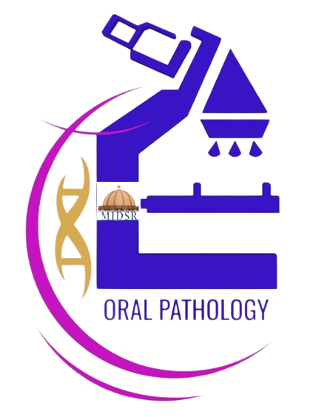

REPORT
Department of oral Pathology and Microbiology day celebration -2022
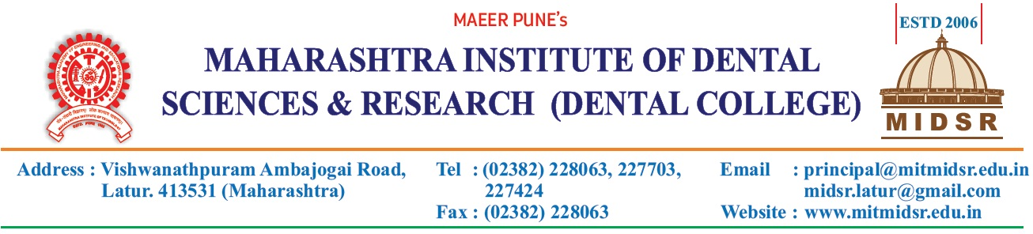
Report
DEPARTMENT OF ORAL PATHOLOGY
On occasion of Birth Anniversary of Dr. H.M. Dholkia’s, national Oral Pathologist Day was celebrated on 25th Feb, 2022.
Dr. Anuja Maniyar, Dr. Varsha Sangle, Dr. Smita Chaware and technician Samad Shaikh had conducted the program.
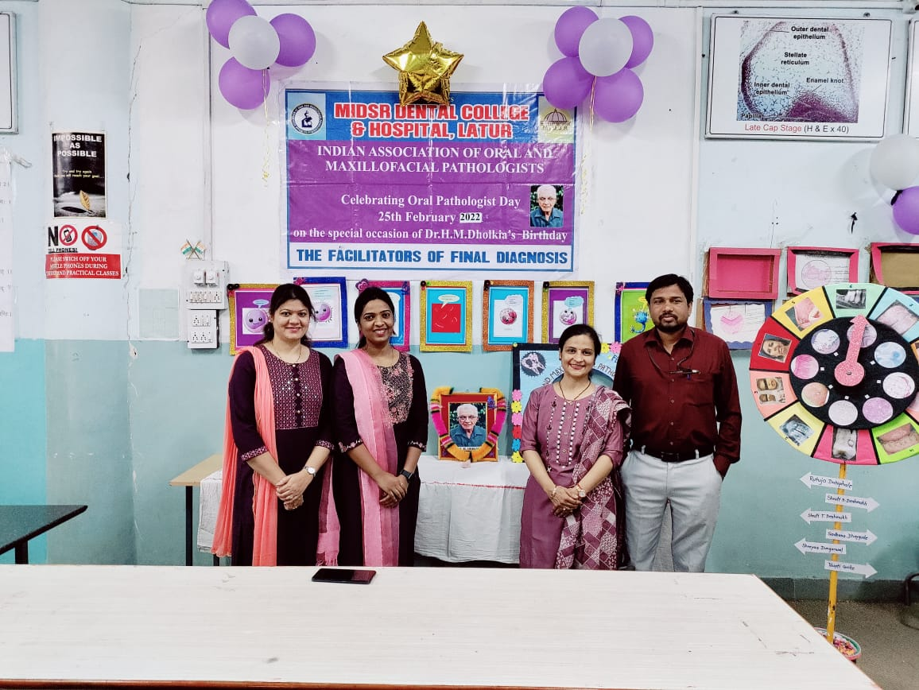

RANGOLI
Rangoli at the Entrance of Department on Occasion of Oral Pathologist Day Celebration
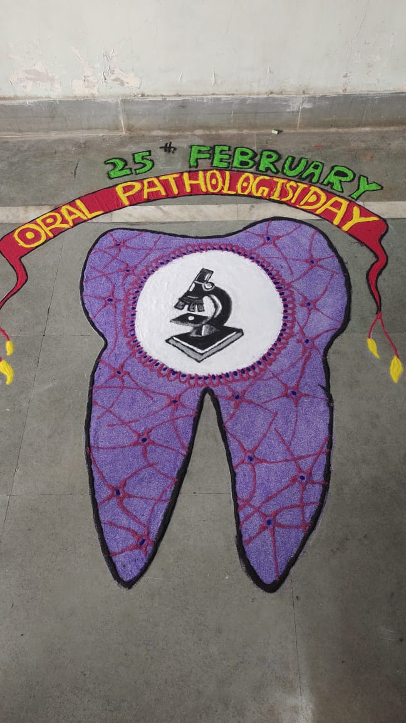

Competitions:
Sculptomania
SOAP CARVING
The Soap Carving Competition was held and it was judged by Dr. Vijayalaxmi mam and Dr. Amol Doiphode sir. Price Distribution done on 25th Feb by Dr. Vijayalakshmi mam and Dr. Amol Doiphode sir.
WINNER:
1st Prize: Amruta Taksale, 3rd BDS Student
2nd Prize: Amruta Kamble, 3rd BDS student

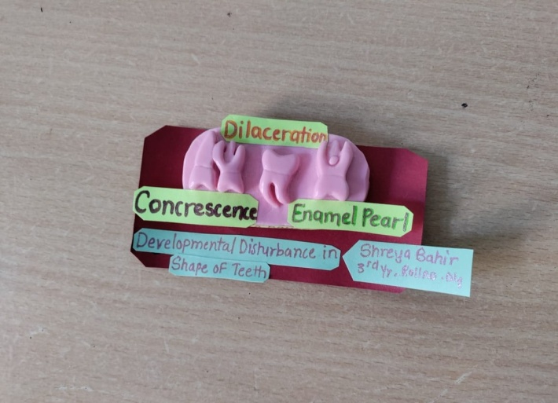

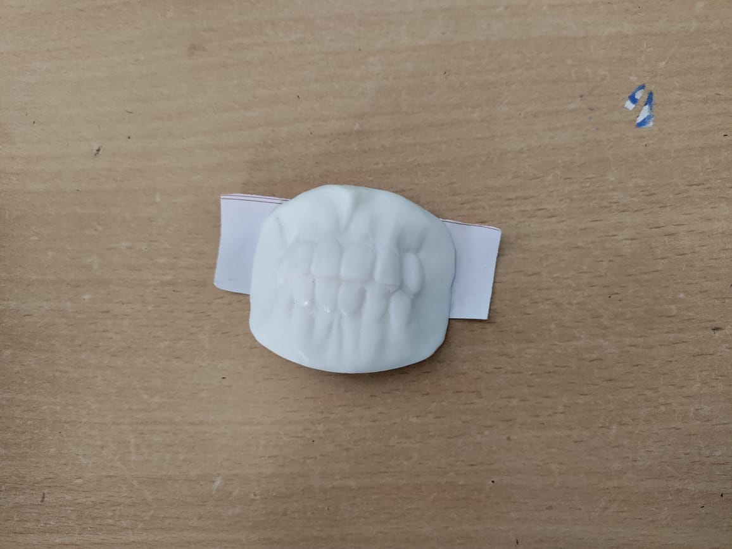

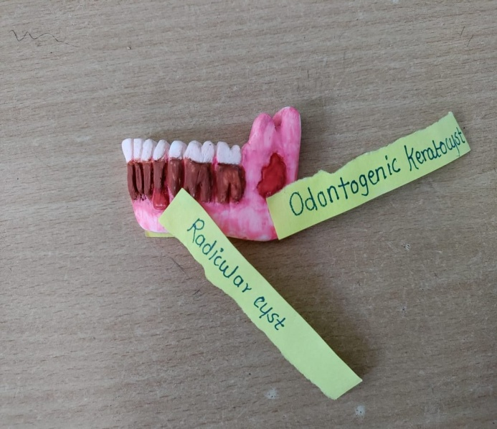

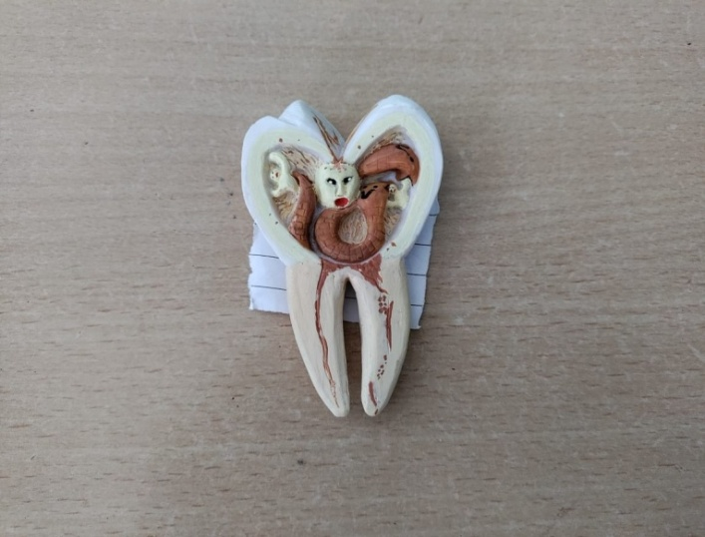

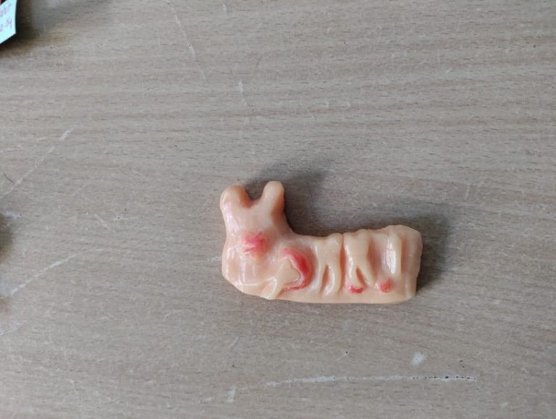

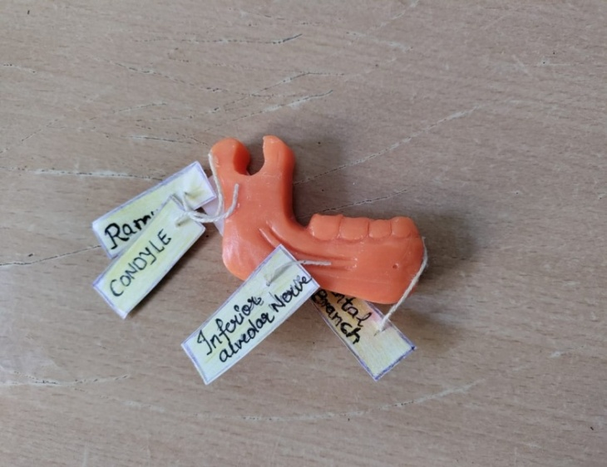

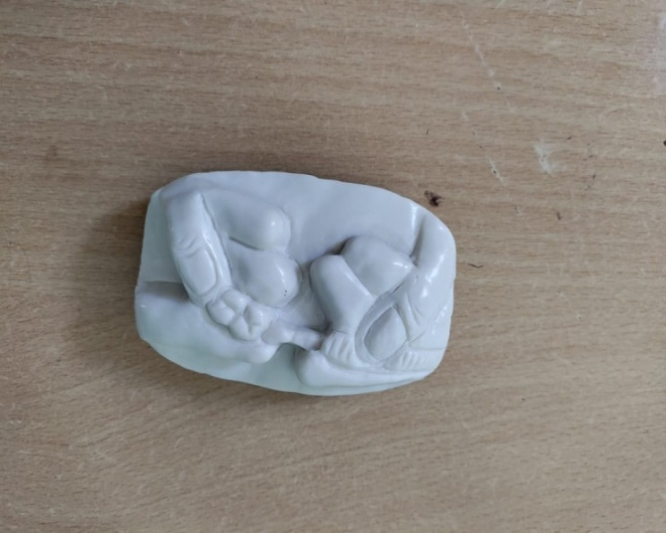

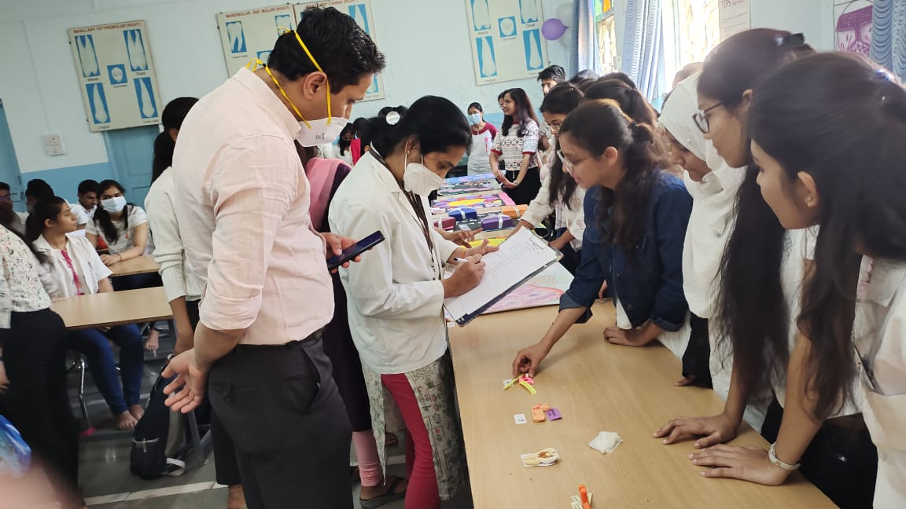
Judges while seeing soap carving.....

Prize Distribution......
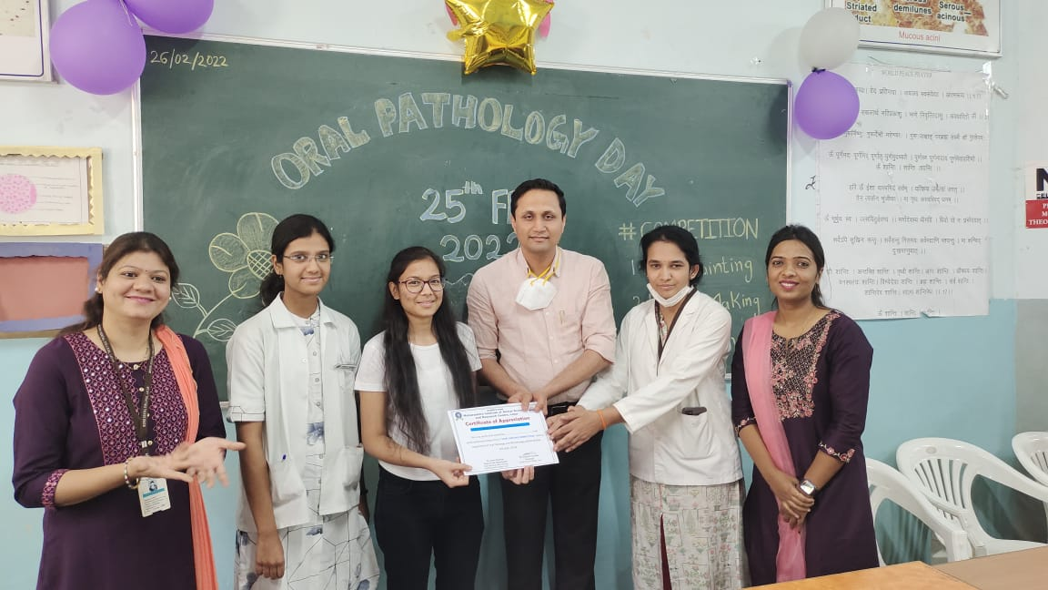
Poster competition
Pictoplasia
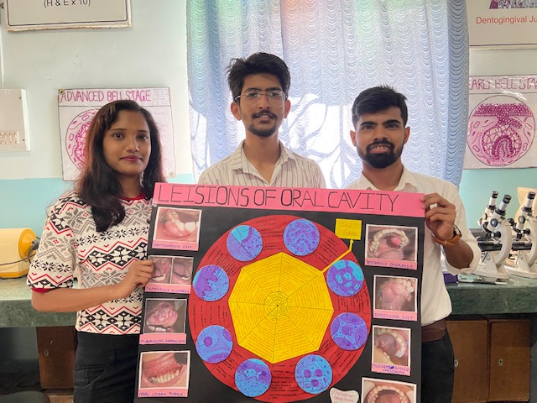
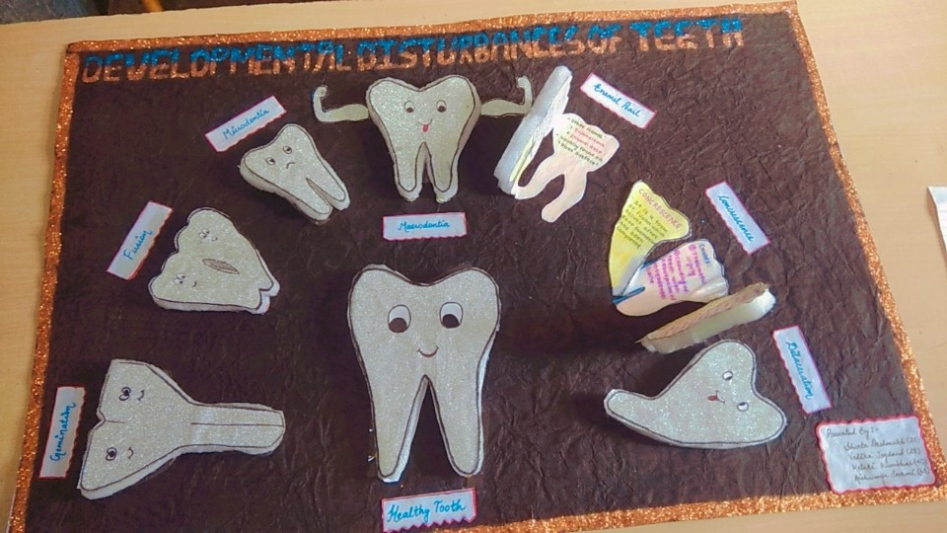
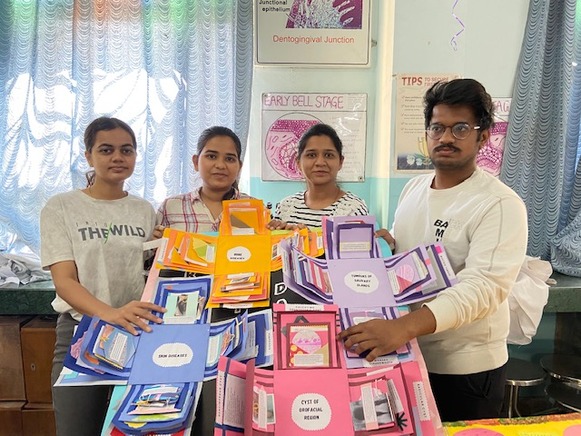

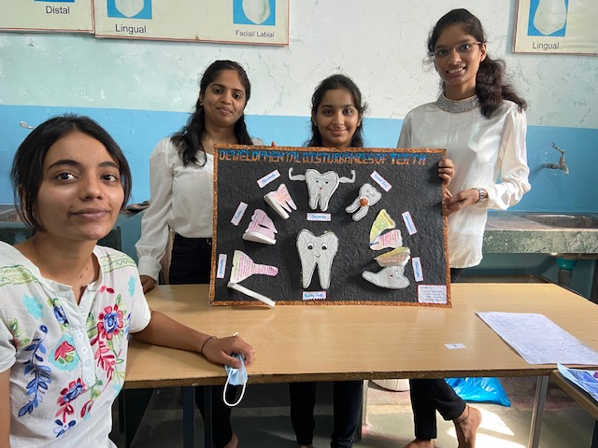
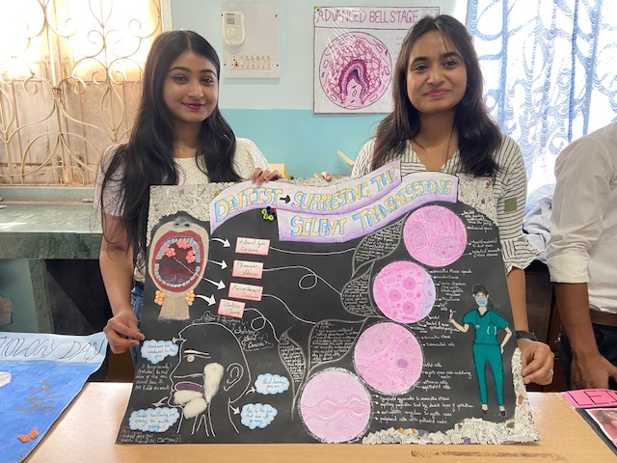
- There was an amazing poster competition and it was judged by Dr.Gauri Ugale, Dr.Priya Nagargoje and Dr.Shilpa Bikkad.
- Darda Aaditi, Ankita Bhingole,Dhas Akshada and Mahesh Kapare from 3rd year won the first prize in poster competition.

Judges, while seeing posters......
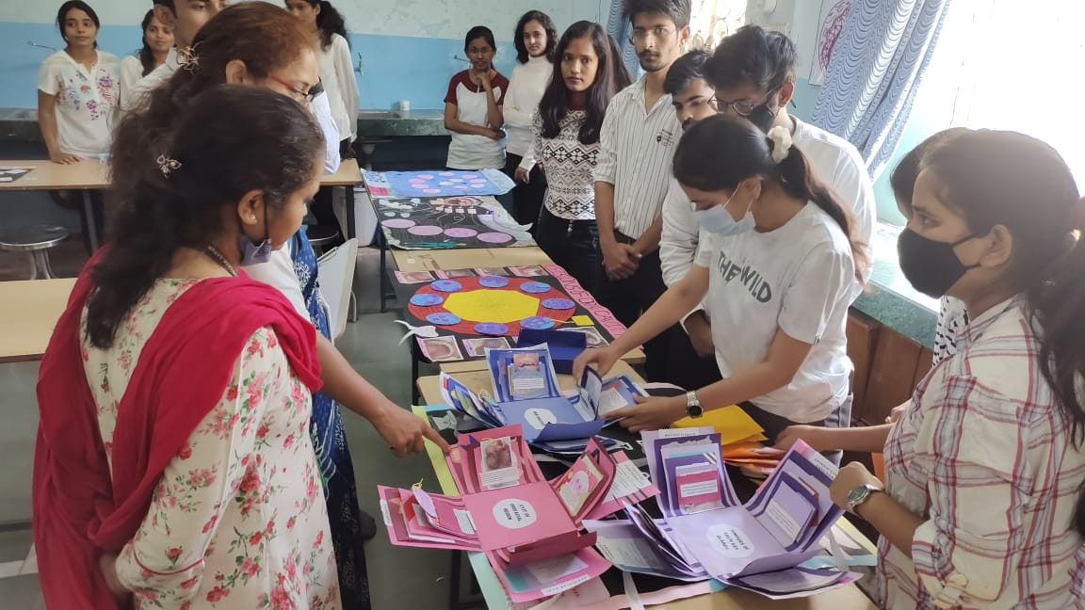
Prize Distribution –Posters
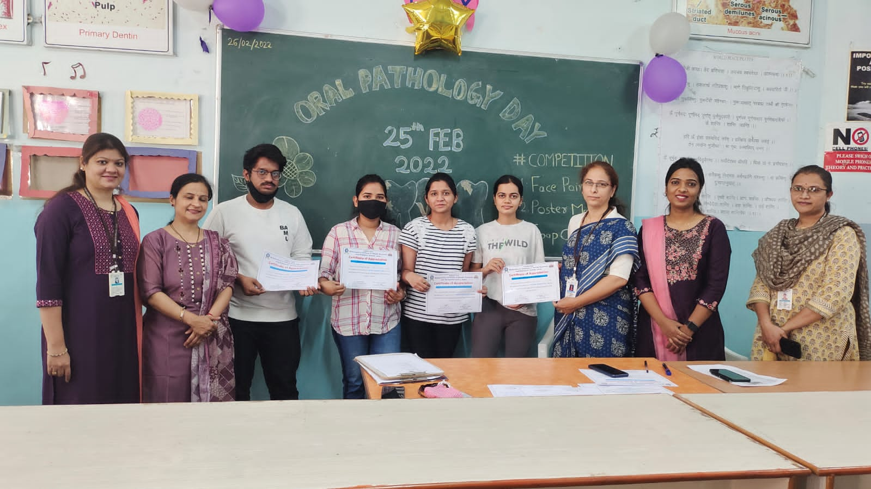

Face Painting Competition

The Face Painting Competition was held and it was judged by Dr. Ashwini Birajdar and Dr.Richa. Price Distribution done on 25th Feb.
WINNER
1ST PRIZE: Sneha Bhavare and Aparna patil , III rd Year student
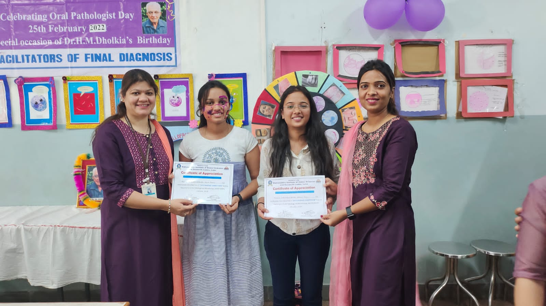
SPIN THE WHEEL competition
The last and most different competition was held, was the ‘SPIN THE WHEEL’ competition.
It was judged by Dr. Varsha Sangle and Dr.Smita Chaware.
The winner for this competition was
1st PRIZE: Daniya Baksh , Hajra Shaikh, III rd Year student
2nd PRIZE: Aparna Patil, Sneha Bhavre, III rd Year student
Vaishnavi Overikar, Jyoti Pande III rd Year student
