WORLD ORTHODONTIC HEALTH DAY CELEBRATION AT DEPARTMENT OF
ORTHODONTICS & DENTOFACIAL ORTHOPEDICS
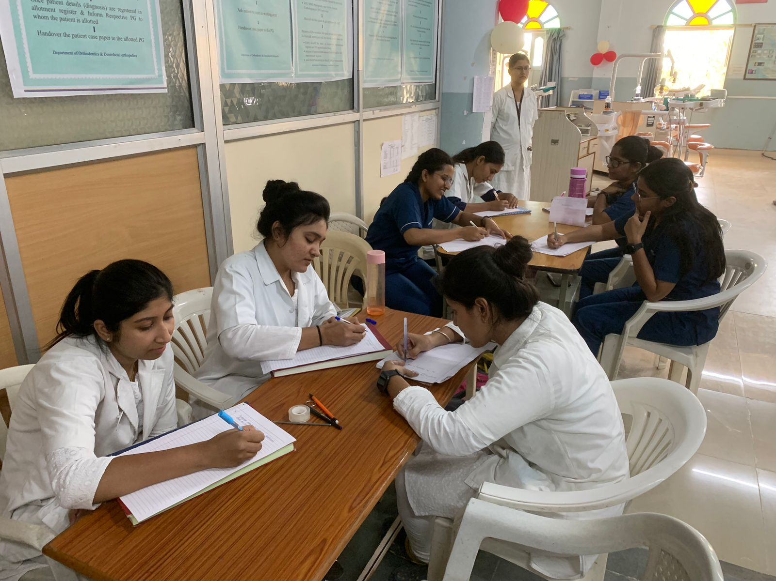
World Orthodontic Health Day was celebrated on 15th May 2023 in MIDSR Dental College, Department of Orthodontic and Dentofacial Orthopaedics. Under the guidance of Dr.Suresh Kangane Dr.Yatishkumar Joshi, Dr.Anand Ambekar, Dr. Pravinkumar Marure, Dr.Sujit Zhadake and Dr. Shilpa Kendre various activities were conducted in the department. Interns being the the participants an Essay writing competition and Innovative wire bending exercise were conducted .Essay writing competition was conducted with a time limit of 30 minutes with the topic “ Awarness about orthodontic treatment on oral health” followed by a 30 minutes innovative wire bending exercise, participants were allowed to select wire bending design of their own will. After completion of both the exercises all the results were examined and the winners of the competition were announced by Dr. Pravinkumar Marure and Dr. Sujit Zhadake, Winner of essay writing competition was “Intern Shweta Johri” and winner of innovative wire bending exercise was “Intern Diksha Thorat”. All the winners were awarded with Certificates followed by cake cutting to mark the end of celebration of “world Orthodontic Health Day”

Commencement of Essay writing competition
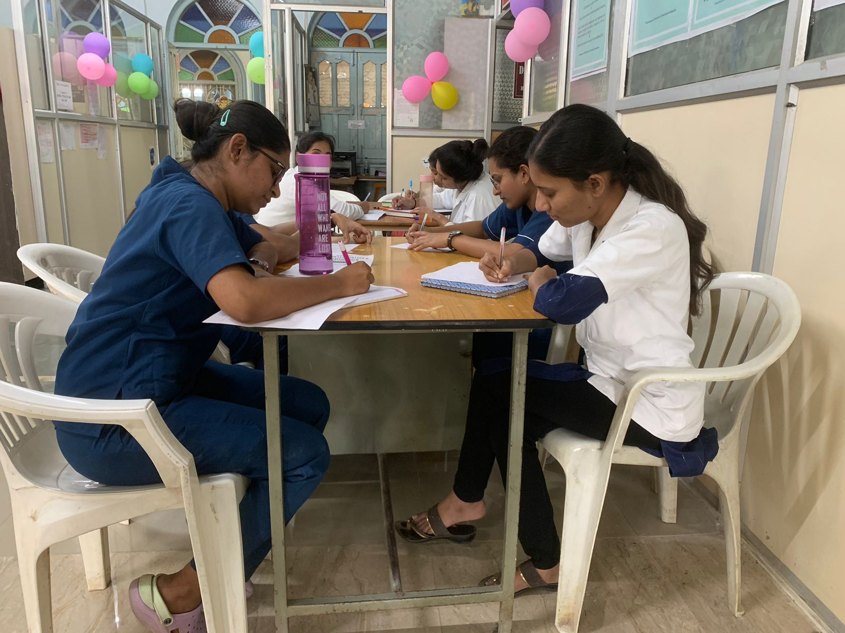

Enthusiastic participation was seen in the competition

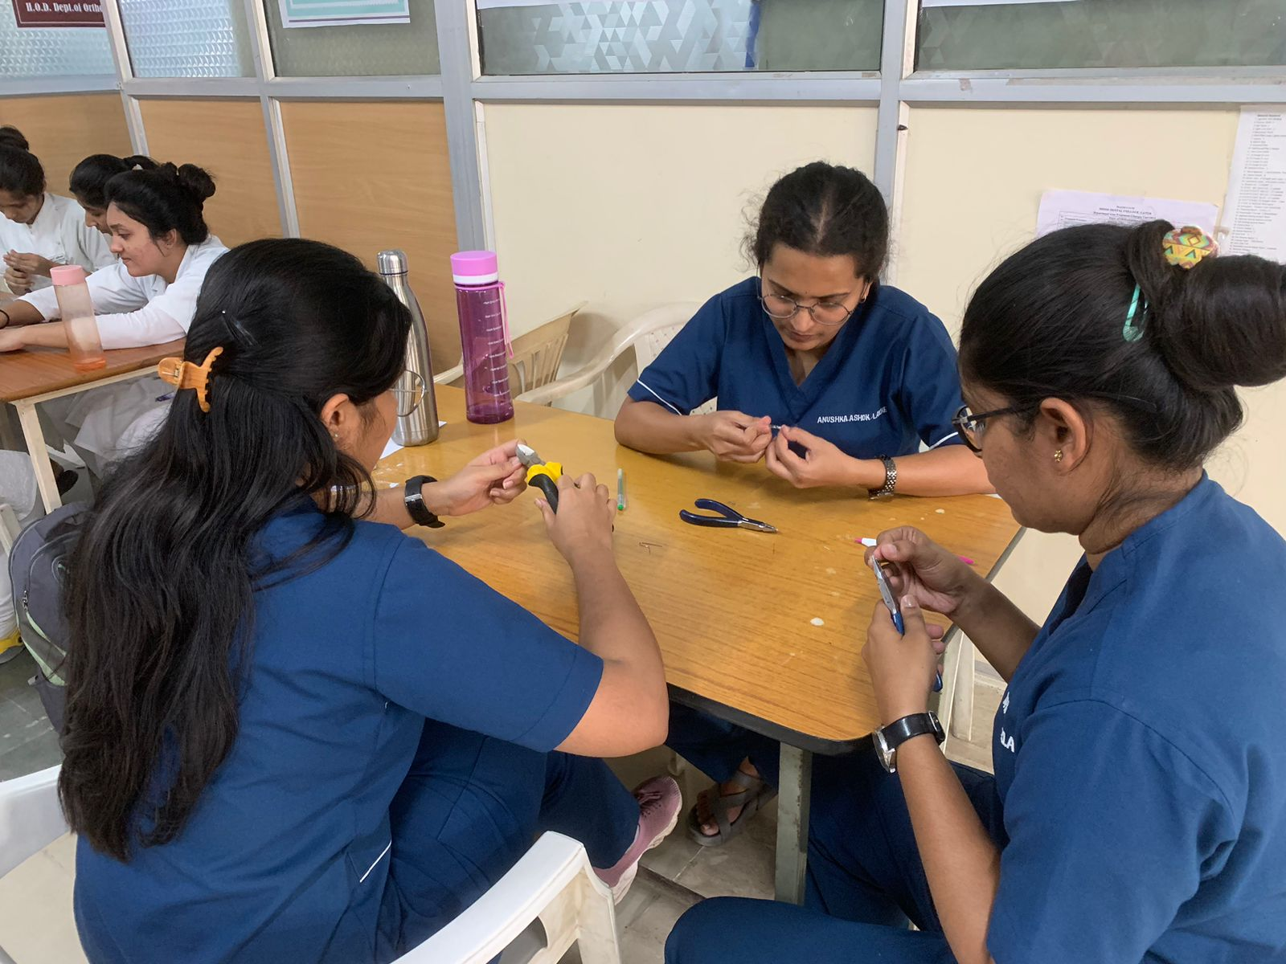

This was followed by innovative wire bending exercise

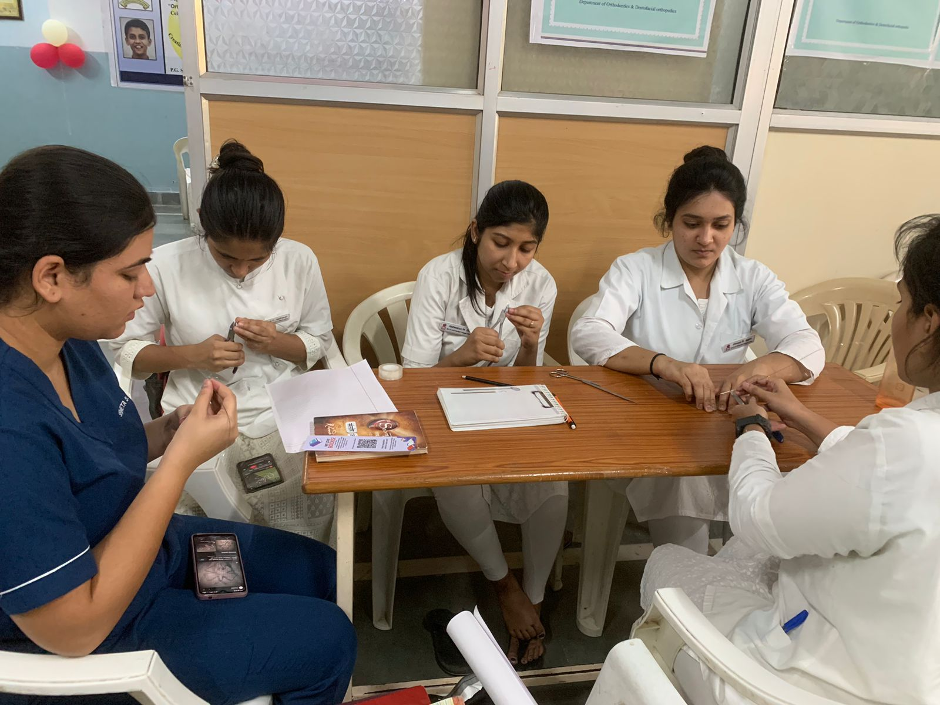

Participants were free to choose the design for the wire bendings

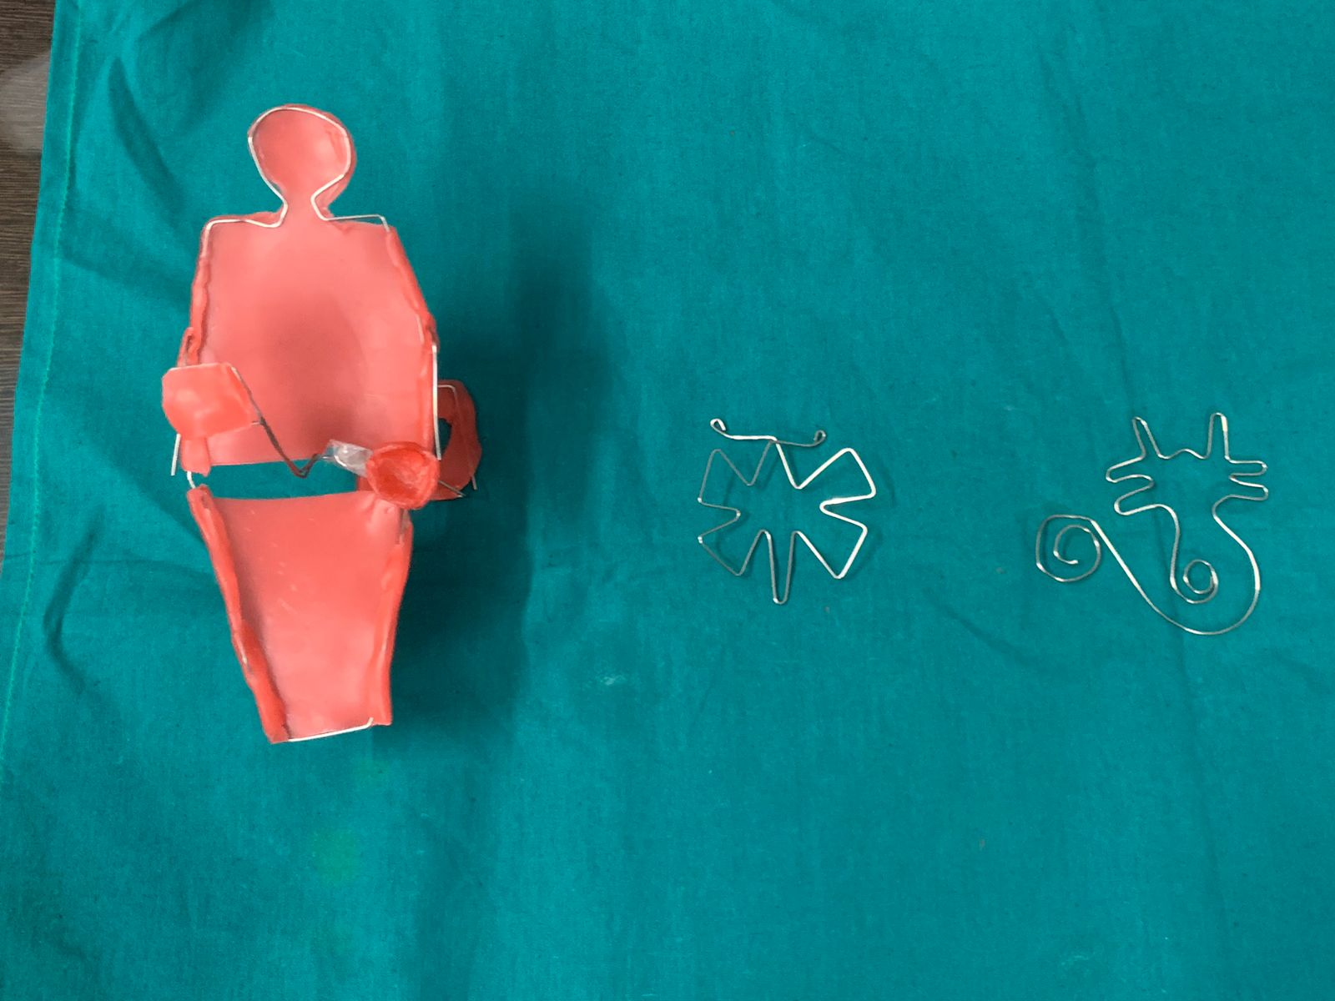

Some of the innovative wire bendings that were submitted

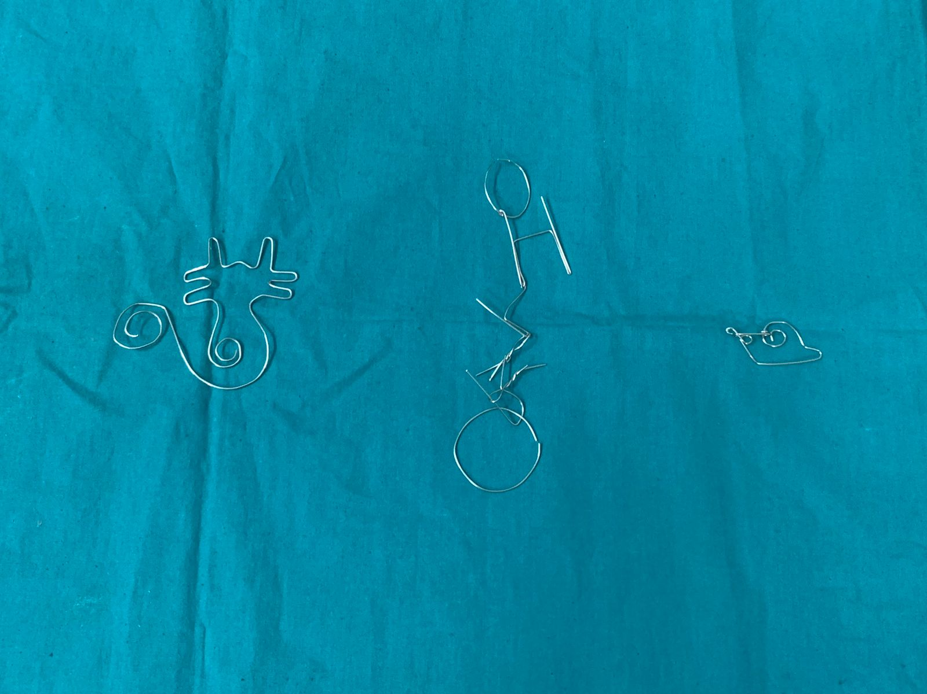

Participants were quick with the given 30 minutes for the wire bendings

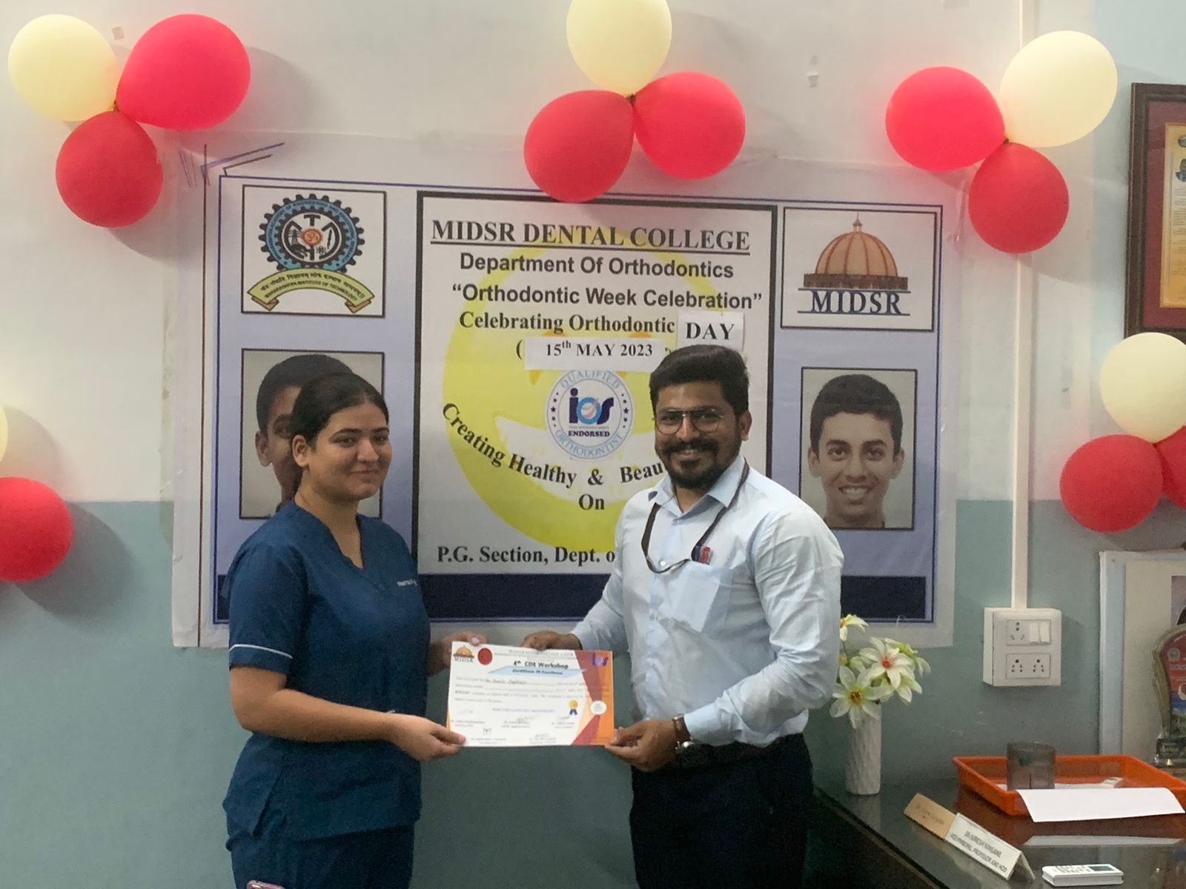

Intern Shweta Johri stood first in essay writing competition

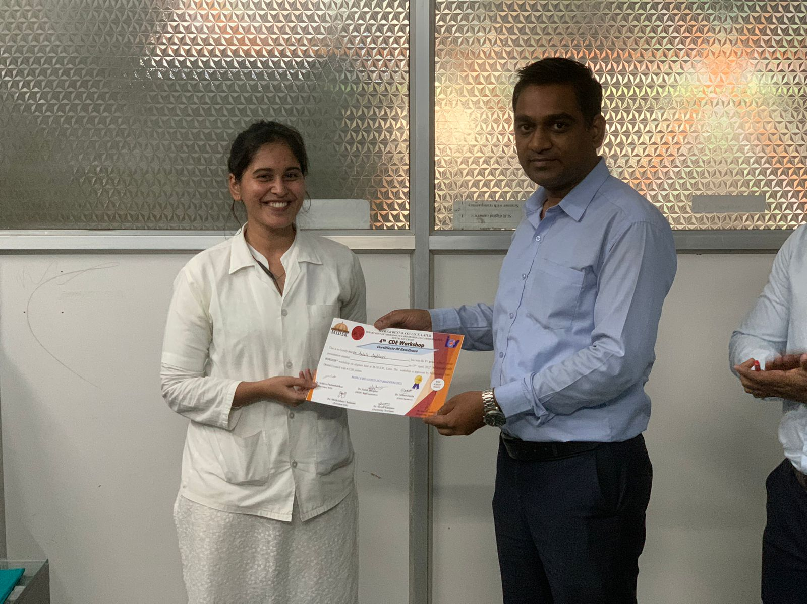

Intern Diksha Thorat stood first in Innovative wire bending exercise
(The Model of a dental chair)
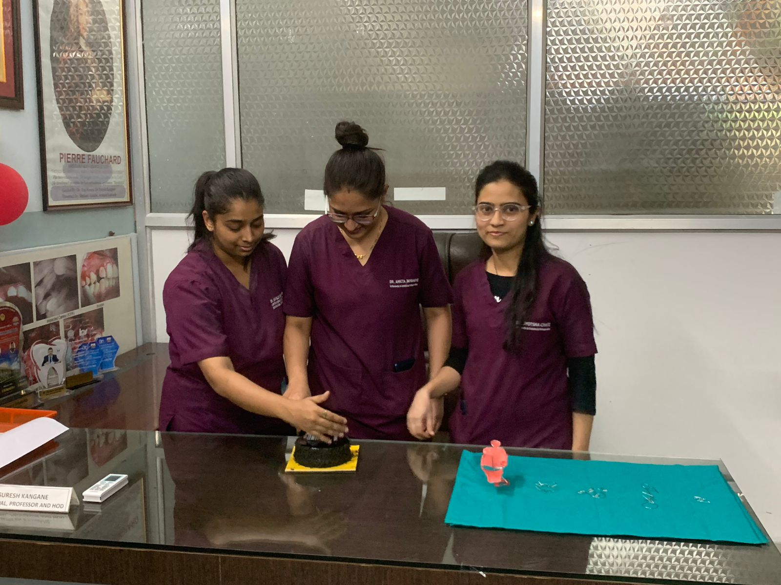

Cake cutting ceremony by the Post graduate students

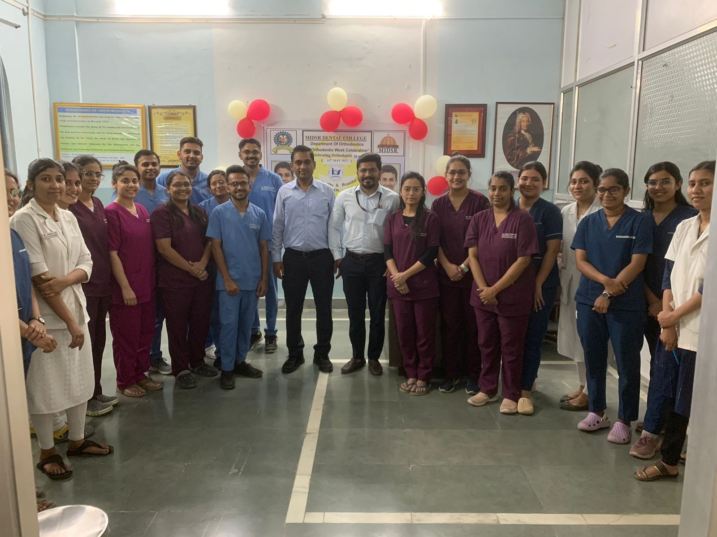

Department faculty,PG students and Interns

