4th ORTHODONTIC CDE
Organized by

DEPARTMENT OF ORTHODONTICS & DENTOFACIAL ORTHOPEDICS
MIDSR DENTAL COLLEGE & HOSPITAL, LATUR

ON 11/04/2022

title:
“Align beyond horizon”
WORKSHOP ON aligners.
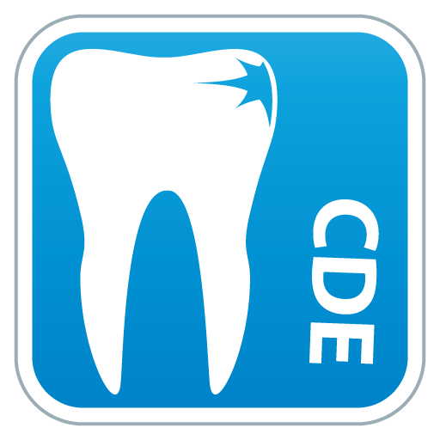

The CDE was graced by auspicious presence of Dr. Milind Darda as chief guest & speaker. The other guest where Dr. Sagar mapare, Dr. Chandrashekhar patil & Dr. Mayur Bidarkar. CDE program started with vishwashanti prayer, Dr. Milind Darda inaugurated the program by lighting the traditional lamp with principle Dr. Suresh Kamble, chairman of CDE Dr. Suresh Kangane, Organizing Secretary Dr. Anand Ambekar.
About Speaker –
Dr. Milind Darda MDS
Consulting Orthodontist, Pune.
Participants – 31 PG students & staff from Parbhani, Solapur, Beed, Bidar & MIDSR Latur participated and made the program successful.

SCHEDULE :
4th CDE On “ALIGN BEYOND HORIZON”
Workshop On Aligners & Intraoral 3D Scanner Schedule
TIME | TOPIC
09:00 am To 09:30 am | Breakfast
09:30 am To 10:00 am | Inaugural function
10:00 am To 11:00 am | Getting started with aligners
11:00 am To 12:00 pm | Biomechanics of aligners
12:00 pm To 12:30 pm | Question answer session
12:30 pm To 01:30 pm | Lunchbreak
01:30 pm To 02:30 pm | Clinical cases–Simple to complex with invisalign
02:30 pm To 03:15 pm | Intraoral3DScanner –Is it worth to be part of practice
03:15 pm To 03:30 pm | High Tea
03:30 pm To 05:30 pm | Handson
05:30 pm To 06:00 pm | Validatoryfunction and Certificate distribution

Morning lecture schedule started sharp at 10 am with thoroughly informative lectures and impressive presentations by Dr. Milind Darda. After lunch the afternoon demonstrative session was scheduled in department of orthodontics where Dr. Milind Darda demonstrated different types of 3D scanners for aligners, their parts, and some advances in aligners in an interactive session. Poster presentation competition was held at the department participants and winners received certificates and trophy with MSDC 6 CDE points at the end of session.
UG students of the college who got distinction in summer 2021 in the subject orthodontics and Dentofacial Orthopedics were felicitated with certificate and trophy.
The program was hugely appreciated by all the participants. Program was ended by Pasaydan Prayer.
Online feedback were collected from the respective participants. The article regarding 4th Orthodontic CDE Programme was published in many newspapers and also mentioned in IOS times May 2022

GLIMPSE OF 4TH ORTHODONTIC CDE PROGRAMME 2022

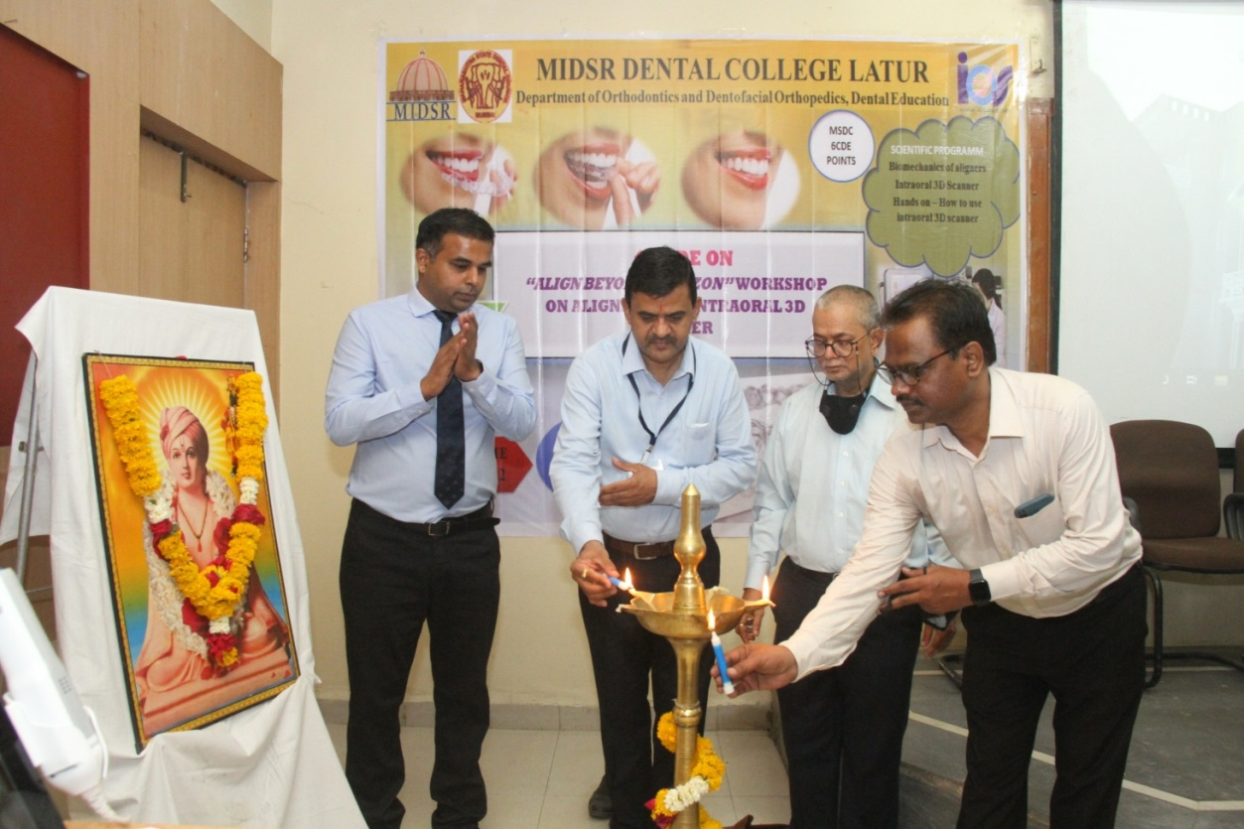

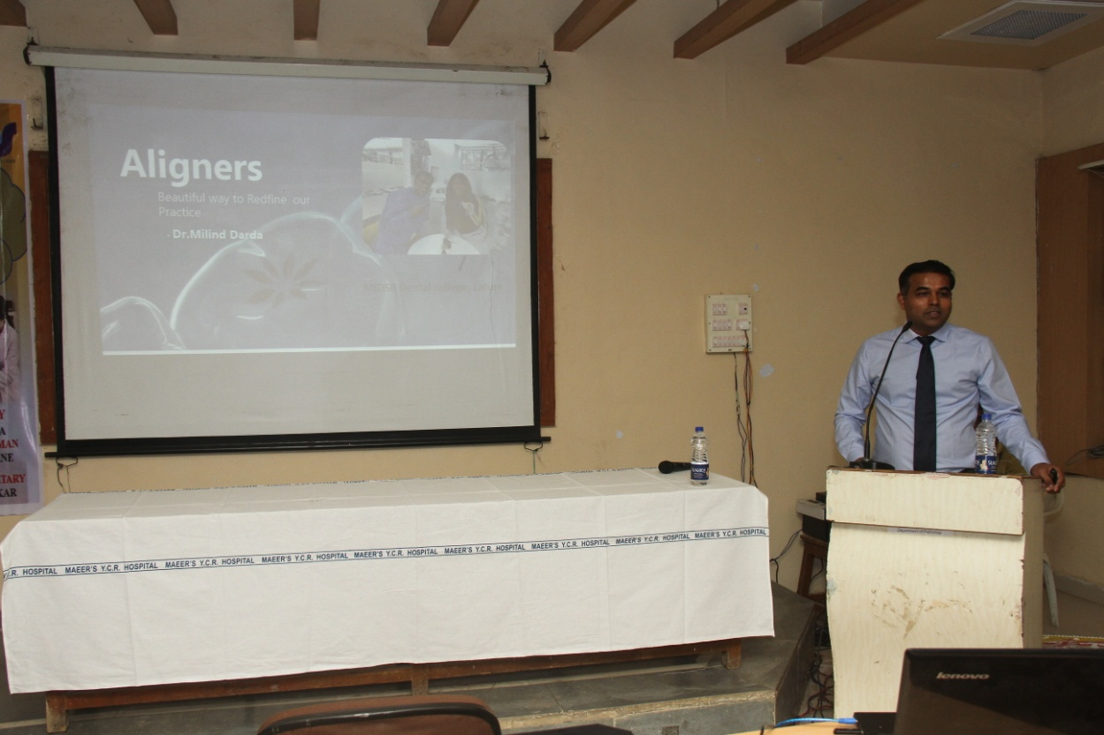
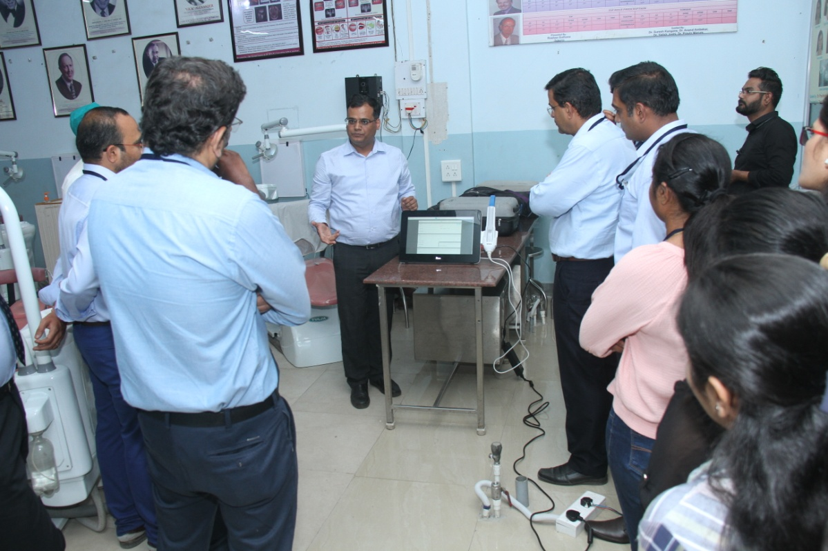

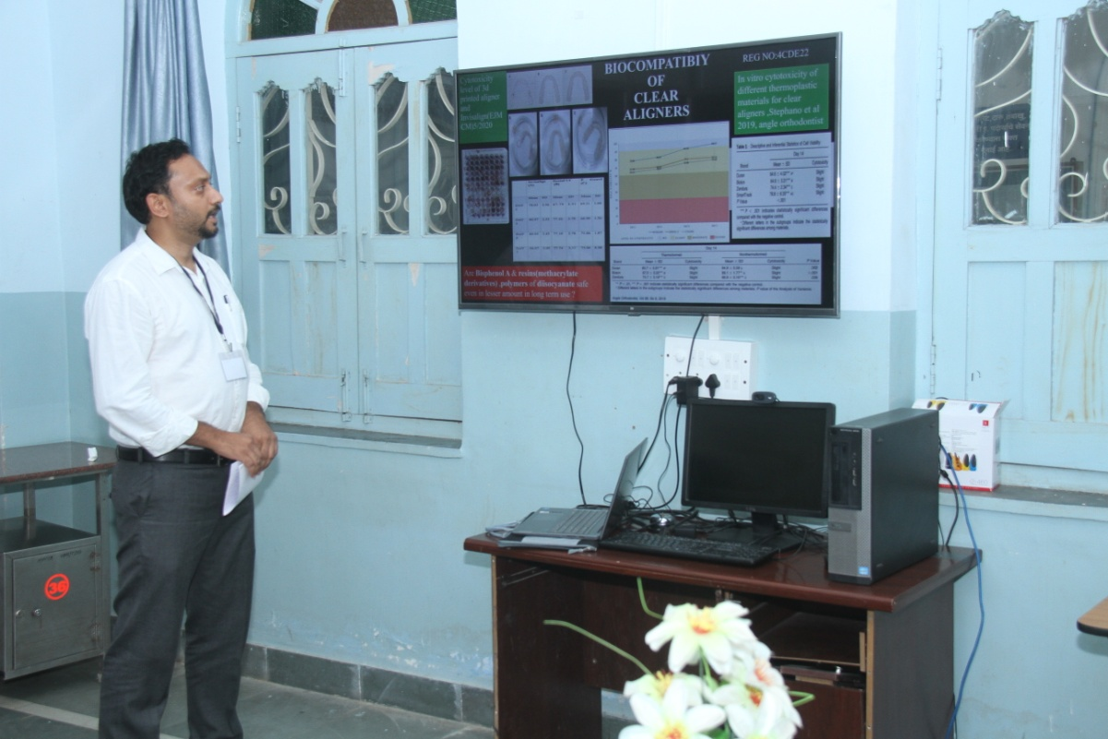
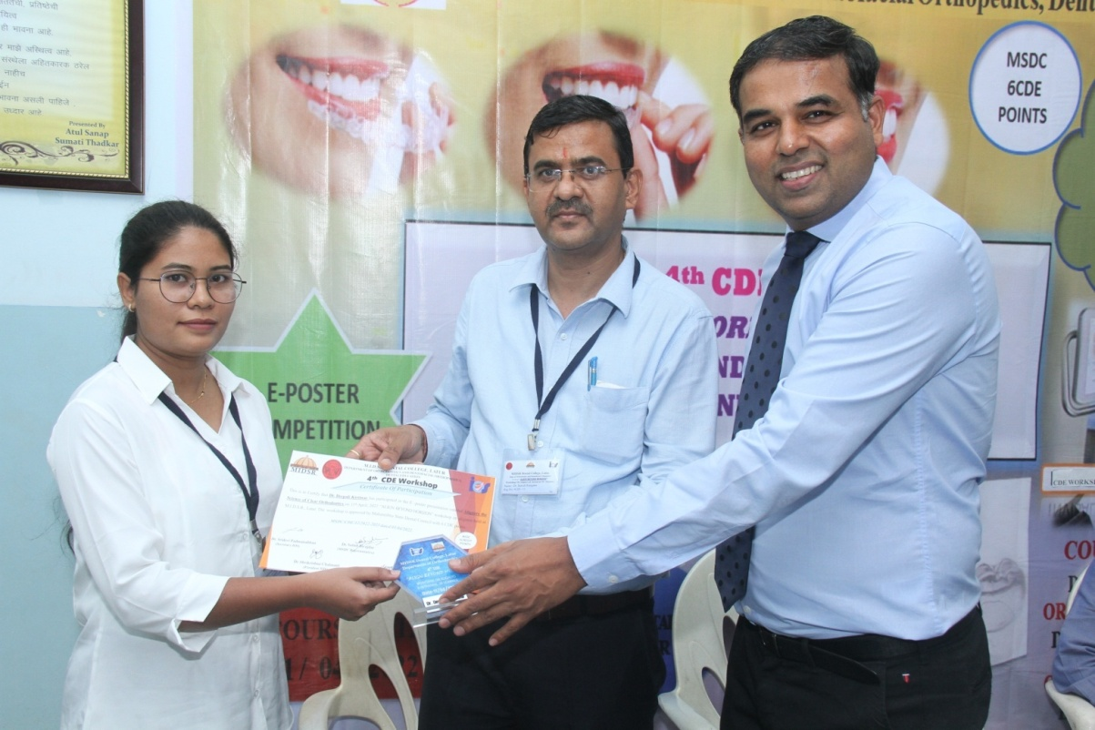
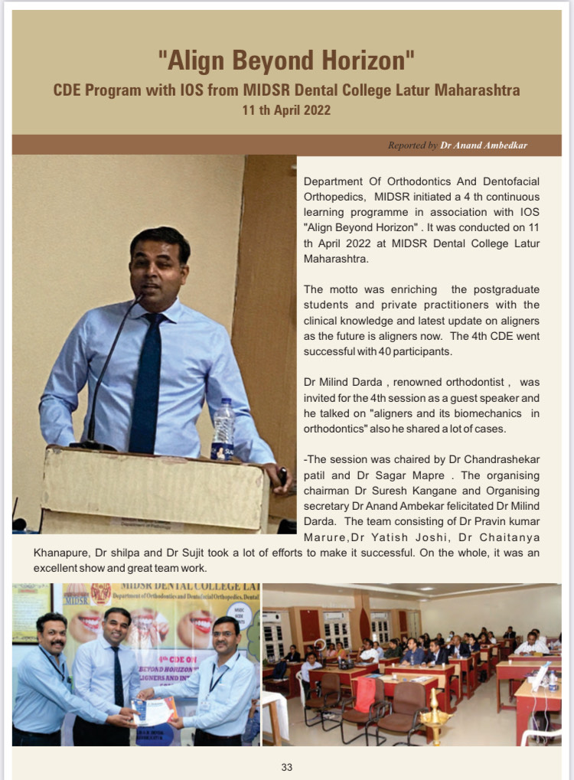
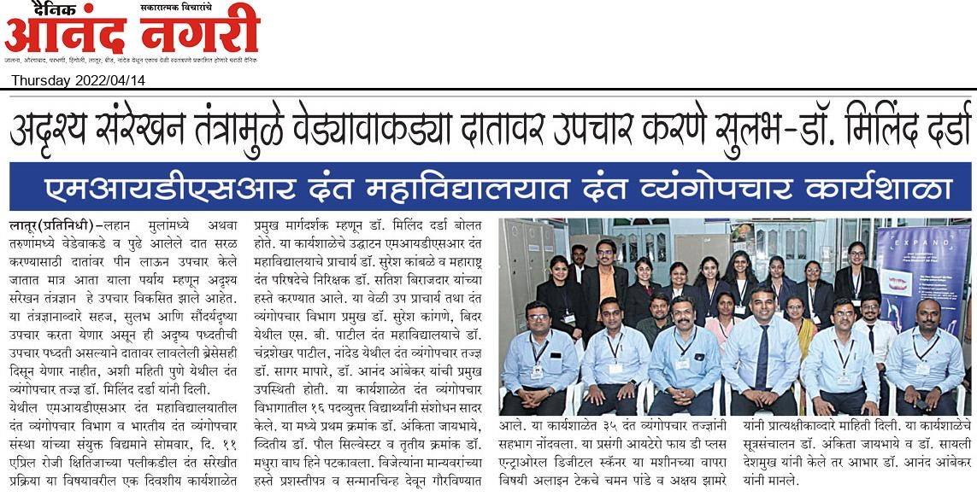

The article regarding 4th Orthodontic CDE Programme was published in newspaper and also mentioned in IOS times May 2022

