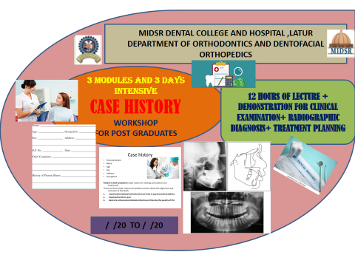
21.12.2020 TO 23.12.2020

21.12.2020 to 23.12.2020

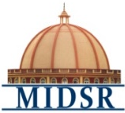
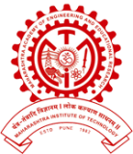

MAHARASHTRA INSTITUTE OF DENTAL SCIENCES AND RESEARCH, DENTAL COLLEGE, LATUR (MAHARASHTRA)
Workshop On “CASE HISTROY ’’
Organized By – Department of Orthodontics and Dentofacial Orthopedics
Maharashtra Institute of Dental Sciences and Research, Latur

CONTENT:
The study of the following–
- A brief history
- Diagnosis and treatment planning
- Cephalometric analysis evaluation
- Study model analysis
- To set the goals for treatment
- To set the Aims and Objectives of each case
- Finishing the case.
- Appliance removal and retention protocol
- LEARNING OBJECTIVES:
- To establish a positive professional relationship
- To provide the clinician with information concerning the patients past dental, medical and personal history
- To provide clinician with the information that may be necessary for making a diagnosis
- To provide information that aids the clinician in making decisions concerning the treatment of the patient
- To develop high standards of practice.
- To overcome the challenges experienced during the clinical application of orthodontic mechanics, bracket positioning and treatment plan.
- To have more focus on significance of finishing the case after the completion of treatment.

- THE PROGRAM CURRICULUM AND SCHEDULE INCLUDES:
- Theoretical lectures
- Clinical Diagnosis Demonstartion

- WORKSHOP DESCRIPTION
CASE HISTORY Workshop is a planned, well organized departmental event that provides an introduction to systemized orthodontic treatment planning to post graduates. From this knowledge-based workshop, post graduates will learn to understand the philosophy of diagnosis and treatment planning in orthodontics and its clinical application, to avoid forthcoming errors in clinical practice while treating patients.

- TOPICS INCLUDE:
Module I :
- A brief history of patient
- Examination of patient
- Problem list of patient regarding dental, skeletal an soft tissue
- Diagnosis and treatment planning

Module II :

- Hard tissue cephalometrics
- Soft tissue cephalometrics
- Tracings on different radiographs
- Study model analysis

Module III :

- Diagnosis and treatment planning
- Treatment mechanics

- WORKSHOP OUTCOME
After completion of CASE HOSTORY Workshop, post graduate students will be equipped with basic understanding of the following:
- Provide post graduates with the orthodontic diagnosis and treatment planning in daily clinical practice, so they can understand the rationale for clinical use.
- Identify characteristics and phases of treatment to endure efficient treatment outcome.
- To have more focus on finishing and retention protocol.

- WORKSHOP SUMMARY

MODULES | III MODULES / 3 DAYS
Duration : | 12 HOURS COURSE
Start Date : | 21/12/2020
End Date : | 23/12/2020
Category : | Post graduate Student Education
WORKSHOP Level : | Add on course

CASE HISTORY
Module I | Focus on brief history , Diagnosis and treatment planning and treatment mechanics.
Module II | Focus on Cephalometric and study model analysis for treatment planning
Module III | Focus on Diagnosis and Treatment planning

- ELIGIBILITY OF CANDIDATES : Orthodontic Post Graduate students
- EXPECTED COURSE OUTCOME:
All the Orthodontic post graduate students will be getting benefit by gathering basic knowledge about CASE HISTORY and demonstration of Case history taking and clinical examination will help to understand its clinical implementation in orthodontics.
- ASSESSMENT METHODOLOGY:
All orthodontic post graduate will be informed through circular regarding curriculum and schedule of the course. All the participants are suppose to gather in the lecture hall 10 minutes prior to start of the workshop and this workshop is compulsory for all the orthodontic post graduates and attendance is compulsory for all 3 modules.
- REGISTRATION FEES: Free for all students
- FACILITIES:
Participation and lecture presentation certificate will be given after completion of workshop.

Workshop “ On CASE HISTORY”
Organized By – Department of Orthodontics and Dentofacial Orthopedics
Maharashtra Institute of Dental Sciences and Research, Latur

Sr. No. | Date | Timing & duration | Topic name | Speaker | Signature
 | Day 1  (21 /12/2020) | 9 am -10 am  (1 hour) | A brief Case history history(Introduction)– LECTURE | Dr. Suresh Kangane
 |  | 10am -11am  (1 hour) | Clinical examination- LECTURE | Dr. Anand Ambekar
 |  | 11 am -12pm (1 hour) | Clinical examination- DEMONSTRATION | Dr. Anand Ambekar
 |  | 12 Pm -1 pm (1 hour) | Functional examination- LECTURE | Dr. Pravin Marure
 |  | 2 pm -3 pm (1 hour) | Functional examination- DEMO | Dr. Pravin Marure

Workshop “ On CASE HISTORY ”
Organized By – Department of Orthodontics and Dentofacial Orthopedics
Maharashtra Institute of Dental Sciences and Research, Latur

Sr. No. | Date | Timing & duration | Topic name | Speaker | Signature
 | Day 2  (22 /12 /2020) | 9 am -10 am (1 hours) | Soft tissue examination- LECTURE | Dr. Yatish Joshi
 |  | 10 am -11pm  (1 hour) | Soft tissue examination- DEMONSTRATION | Dr. Yatish Joshi
 |  | 11pm – 12pm  (1 hour) | Model analysis- LECTURE | Dr. Chaitanya Khanapure
 |  | 12pm – 1 pm  (1 hour) | Space problem-LECTURE | Dr. Shilpa Kendre
 |  | 3pm – 5pm  (2 hour) | Cephalometric analysis- LECTURE | Dr. Suresh Kangane

Workshop “ On CASE HISTORY”
Organized By – Department of Orthodontics and Dentofacial Orthopedics
Maharashtra Institute of Dental Sciences and Research, Latur

Sr. No. | Date | Timing & duration | Topic name | Speaker | Signature
 | Day 3  ( 23/12 /2020) | 9 am -11 am (2 hour) | Diagnois in Orthoontics- LECTURE | Dr. Anand Ambekar
 |  | 11 am -12am (1 hour) | Aims and Objectives of orthodontic treatment - LECTURE | Dr. Pravin Marure
 |  | 12 am -1pm (1 hour) | Treatment Planning-  LECTURE | Dr. Pravin Marure
 |  | 2 pm -3 pm (1 hour) | Finishing the case- LECTURE | Dr. Yatish Joshi
 |  | 3pm – 4pm  (1hours) | Appliance removal and retention protocols- LECTURE | Dr. Chaitanya Khanapure

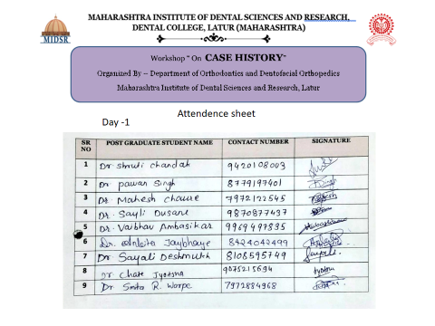
Above students attended workshop successfully.
21.12.2020

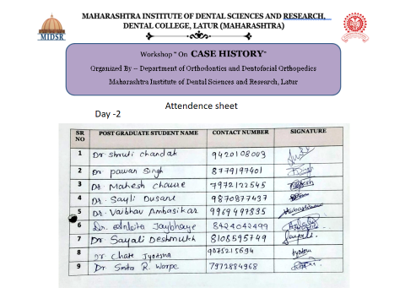
Above students attended workshop successfully.
22.12.2020

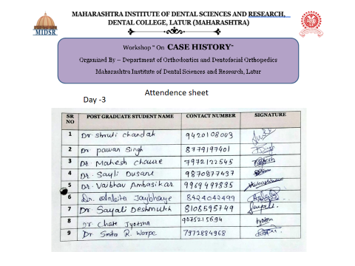
Above students attended workshop successfully.
23.12.2020

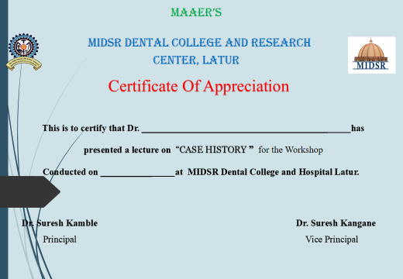

DEMONSTRATION AND DISCUSSION OF CASE HISTORY

HOD
Department of Orthodontics
MIDSR Dental College, Latur

