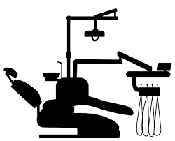
D
W

Reader Room

Lecture Room

PG Student Room

PG Sterilization Room

Dark Room

Esthetic Clinic

RVG Room

Endo Micro Surgical Room
Door
W
W
W
W
W
W
W
W
W
W
W
W
D
Door
D
D
D

D
D

D
PG Clinical Area

D

Museum
W
W
W
W
W
W
W
W
D
D
D
D

Record Room
Wash Basin

Wash Basin

Duct

HOD Room

Sterilization Room

Autoclave Room

Toilet

Toilet
Toilet
D
Door
Door
UG Clinical Area
Door
Door

