Brochure of course

HIDDEN EYES IN PATHOLOGY
ADD-ON COURSE REPORT 2020-2021

Department of Oral Pathology, MIDSR Dental College Latur organized an ADD-ON course “Hidden eyes IN PATHOLOGY”, 12-08-21 to 09-09-21
A. Introduction:

This course was offered by Department of Oral Pathology, MIDSR College Latur. This Microscopy course was an understanding of the theoretical background as well as practical skills of various types of microscopes. Lectures were followed by practical demonstrations. This course provided an introduction to microscopy and operation of a various types of microscope.
Course learning outcome:
After this course, students were able to identify and understand the basic principal components of simple and compound microscope, working principals and advances of specialized microscope, its set-up and uses.
Objectives of the Training:
- To identify and understand the working principal of simple and light microscope
- To identify and understand the working principal of specialized microscope
- To understand the microscopic advantages.
Learning Resources:
A variety of learning resources were utilized in terms of lectures with power point presentation, & videos
Course Assessment
Assessment of student was done on the basis of exercises (slide tests and interactive sessions) allotted to them along with viva question.
Course certification: The course was conducted by Department of Oral Pathology and Microbiology, MIDSR College Latur. At the end of 4th module participants were presented with the certificate; provided that he/she should have completed the course.

Modules were conducted by:
Dr. Anuja Maniyar (Prof and HOD, Department of Oral Pathology and Microbiology)
Dr. Varsha Sangle (Reader, Department of Oral Pathology and Microbiology)
Dr. Smita Chaware (Sr. Lecturer, Department of Oral Pathology and Microbiology)
Eligibility-All FIRST BDS students could join the course.
Course schedule – It comprised of four modules of 16 hours within stipulated time period of a month. Course starts by August-September of every year.

Sr. No. | Name of topic | Theory/ practical | Hours | Type of module | Description | Staff name
1 | Introduction and registration |  | 1 hr. | Module-1 | Introduction to microscope | Dr. Varsha Sangle and Dr. Smita Chaware
2 | Basic Principal of Simple Microscope | Theory | 1 hr. | Module-1 | Working principals of simple microscope  And its advances | Dr. Anuja  Maniyar
3. | Compound microscope Part-I | Theory | 1 hr. | Module-1 | Working principals of compound microscope And its advances | Dr. Varsha Sangle
4. | Compound microscope Part-II | Theory | 1 hr. | Module-1 | Components Of Compound Microscope | Dr. Varsha Sangle
5. | Specialized microscope: Part-1  Dark-field and phase contrast | Theory | 1 hr. | Module-2 | Working principals of of Dark-field and phase contrast microscope And its advances | Dr. Smita Chaware
6. | Specialized microscope: Part-2 Polarized microscope | Theory | 1 hr. | Module-2 | Working principals of Polarized microscope And its advances | Dr. Anuja Maniyar
7. | Specialized microscope: Part-3: Fluorescent microscope | Theory | 1 hr. | Module-2 | Working principals of Fluorescent microscope And its advances | Dr. Varsha  Sangle
8. | Interference, Confocal and Stereo microscope | Theory | 1 hr. | Module-2 | Working principals of Stereo microscope And its advances | Dr. Anuja Maniyar
9. | Electron microscope | Theory | 1 hr. | Module-3 | Working principals of Electron microscope And its advances | Dr. Smita Chaware
10. | Tissue Processing | Theory | 1 hr. | Module-3 |  | Dr. Anuja Maniyar
11. | Decalcification And Ground Section | Theory | 1 hr. | Module-3 |  | Dr. Anuja Maniyar
12. | Specialized Staining | Theory | 1 hr. | Module-3 |  | Dr. Anuja Maniyar
13. | Slide Show of Webinar | Practical | 1 hr. | Module-4 |  | Dr. Varsha Sangle
14. | Demonstration videos of the webinar Part-I | Practical | 1 hr. | Module-4 | Demonstration and working principals of specialized microscope | Dr. Varsha Sangle
15. | MCQ’s Questionnaire | Practical | 1 hr. | Module-4 | MCQ’s test | Dr. Smita Chaware
16. | Demonstration videos of the webinar Part-II | Practical | 1 hr. | Module-4 | Demonstration and working principals of specialized microscope | Dr. Smita Chaware

B. Communication Letters of the programme:- (ANNEXURE I)
Permission letter from Principal, Academic Committee, Circular

C. Report:
ADD-ON course was conducted in Department of Oral Pathology, MIDSR Dental College Latur. First BDS students of MIDSR College attended the course.
Sr. no. | Title | No. of Participants
1 | Hidden eyes IN PATHOLOGY | 100

Dr. Anuja Maniyar (HOD &Prof), Dr. Varsha Sangle (Reader), Dr. Smita Chaware (Lecturer), and Samad Shaikh (Technician) had conducted the program. Orientation lecture conducted by Dr. Varsha Sangle and Dr. Smita Chaware, Module discussion by Dr. Anuja Maniyar, Dr. Varsha Sangle and Dr. Smita Chaware and Validectory function conducted by all staff.

D. Course Schedule:

Date | Time | TOPIC | SPEAKER
12-08-2021 | 9:00am-10:00am  1hrs | Introduction and Registration | Dr. Varsha Sangle and  Dr. Smita Chaware
12-08-2021 | 10:00am-11:00am  1hrs | Basic Principal of Simple Microscope | Dr. Anuja Maniyar
13-08-2021 | 9:00am-11:00am  2hrs | Compound microscope | Dr. Varsha Sangle
16-08-2021 | 9:00am-11:00am  2hrs | Specialized microscope: Part-1  Polarized microscope | Dr. Anuja Maniyar
30-08-2021 | 9:00am-11:00am  2hrs | Specialized microscope: Part-2  Dark-field and phase contrast | Dr. Smita Chaware
02-09-2021 | 9:00am-11:00am  2hrs | Specialized microscope: Part-3  Fluorescent Microscope | Dr. Varsha Sangle
03-9-2021 | 9:00am-11:00am  2hrs | Electron microscope | Dr. Smita Chaware
06-9-2021 | 9:00am-11:00am  2hrs | Tissue Processing  Decalcification And Ground Section  Specialized Staining | Dr. Anuja
09-9-2021 | 9:00am-11:00am  2hrs | Valedictory Function | ALL STAFF

E. LIST OF PARTICIPANTS (ANNEXURE II)
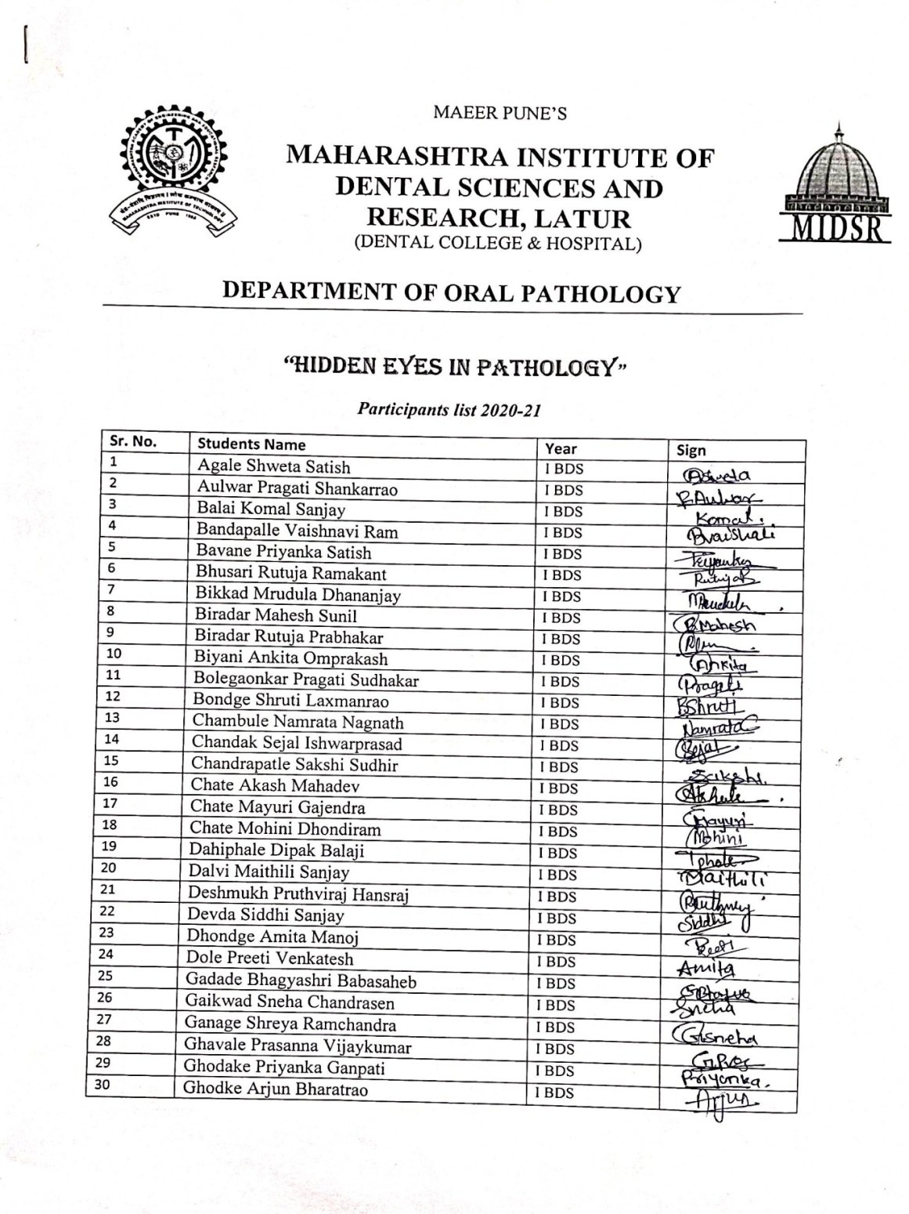
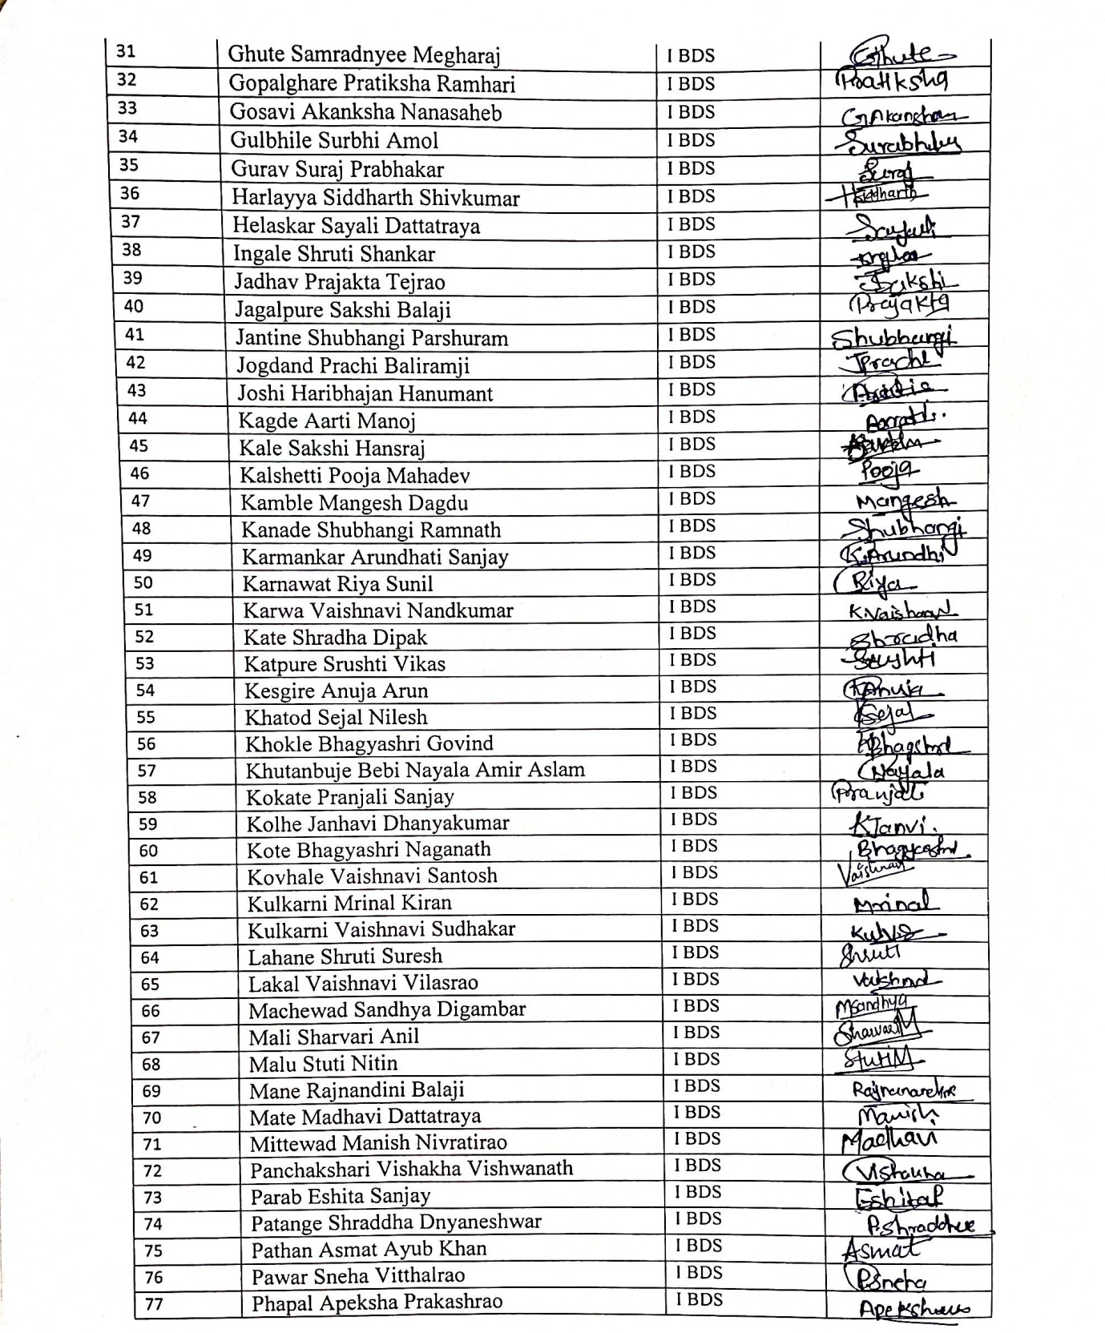
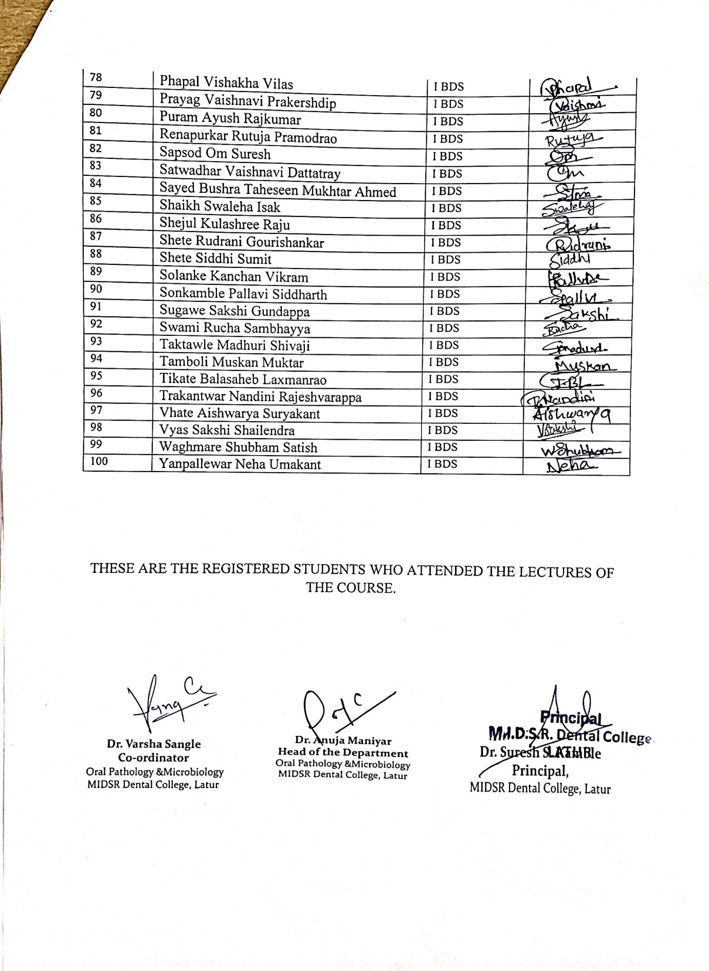

F. Certificate:
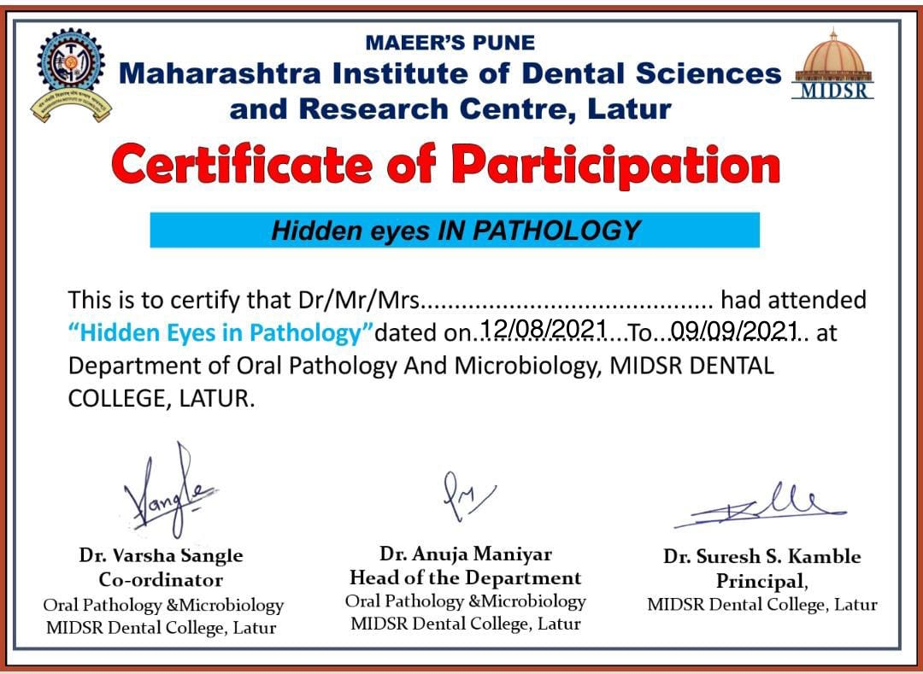
G. Photos of the Event:
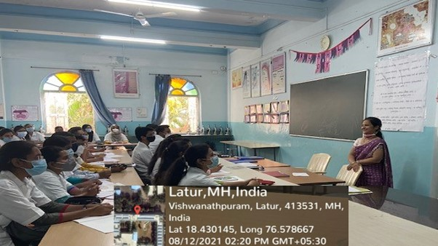
Dr. Anuja Maniyar taking session

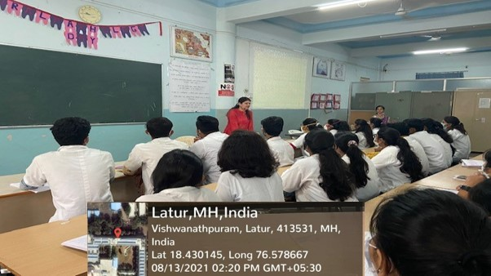
Dr. Varsha Sangle- taking session session
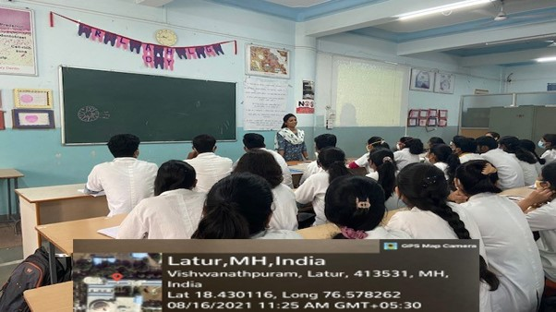
Dr. Smita Chaware taking session

H. Overview of the Programme:
The programme was successful. Students got knowledge and cleared their queries regarding Microscope and Lab-techniques. It improved interactions and sharing of valuable knowledge.

