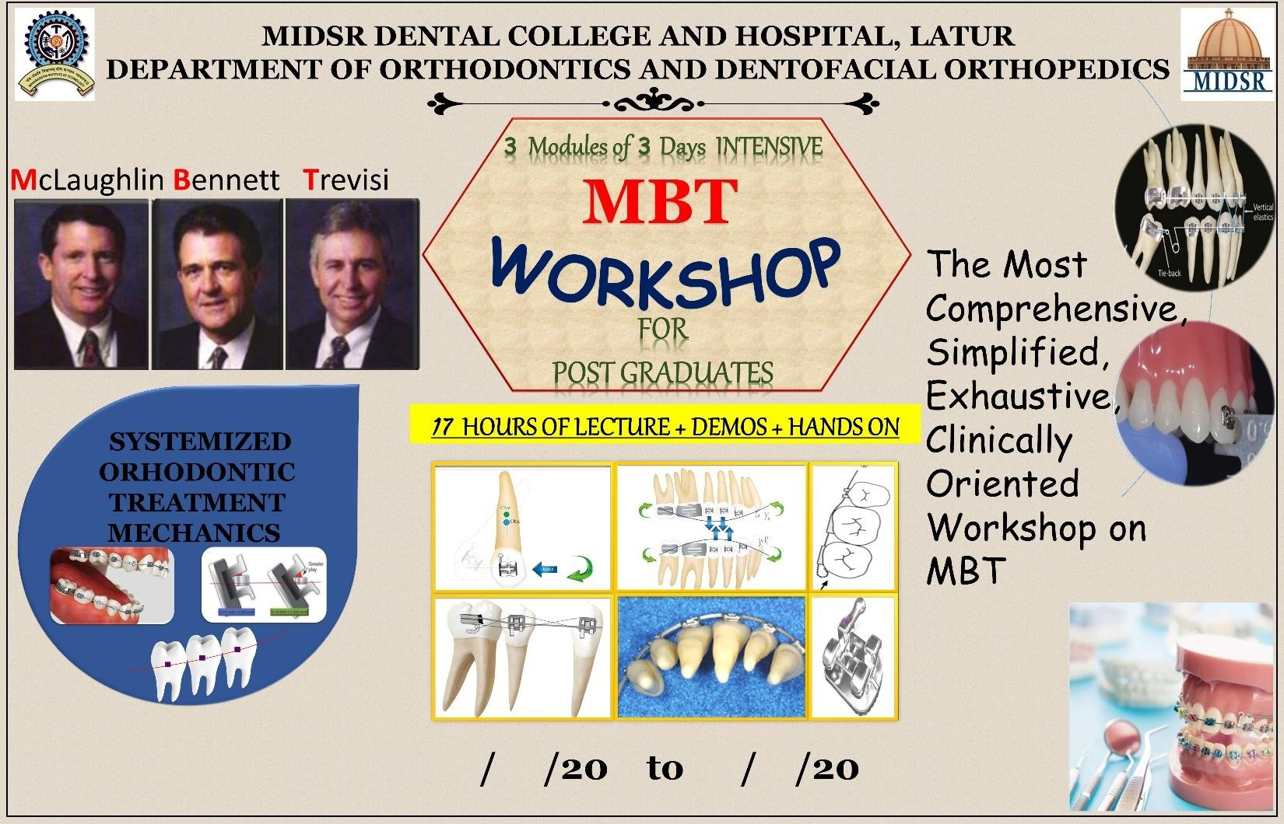
21/12/2020 to 23/12/2020
VALUE ADDED COURSE




MAHARASHTRA INSTITUTE OF DENTAL SCIENCES AND RESEARCH, DENTAL COLLEGE, LATUR (MAHARASHTRA)
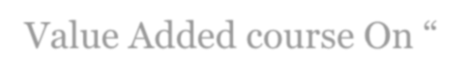
Value Added course On “ McLaughlin Bennett Trevisi (MBT) Technique ’’
Organized By – Department of Orthodontics and Dentofacial Orthopedics Maharashtra Institute of Dental Sciences and Research, Latur

I CONTENT:
The study of the following –
- A brief history and overview of treatment mechanics
- Appliance specifications - variations and versatility
- Bracket positioning and case set-up
- Arch form
- Anchorage control during tooth leveling and aligning
- Arch leveling and overbite control
- An overview of Class II treatment
- An overview of Class III treatment
- Space closure and sliding mechanics
- Finishing the case.
- Appliance removal and retention protocols

LEARNING OBJECTIVES:

  - To discuss the evolution of orthodontic mechanics from Andrews, Roth and MBT eg. Tip, Torque
  - To apply theoretical knowledge of orthodontic treatment mechanics into more practical way.
  - To develop high standards of practice.
  - To overcome the challenges experienced during the clinical application of orthodontic mechanics, bracket positioning and treatment plan.
  - To have more focus on significance of finishing the case after the completion of treatment.

THE PROGRAM CURRICULUM AND SCHEDULE INCLUDES:
  - Theoretical lectures
  - Demonstration on typhodont
  - Hands on- on typhodont

VALUE ADDED COURSE DESCRIPTION
McLaughlin Bennett Trevisi (MBT) Technique Workshop is a planned, well organized departmental event that provides an introduction to systemized orthodontic treatment mechanics to post graduates. From this knowledge-based workshop, post graduates will learn to understand the philosophy of MBT in orthodontics and its clinical application, to avoid forthcoming errors in clinical practice while treating patients.

TOPICS INCLUDE:

Module I :
  - A brief history and overview of treatment mechanics
  - Appliance specifications - variations and versatility
  - Bracket positioning and case set-up

Module II :

- Arch form
- Anchorage control during tooth leveling and aligning
- Arch leveling and overbite control
- An overview of Class II treatment

Module III :

- An overview of Class III treatment
- Space closure and sliding mechanics
- Finishing the case
- Appliance removal and retention protocols

VALUE ADDED COURSE OUTCOME
After completion of McLaughlin Bennett Trevisi (MBT) Technique Workshop, post graduate students will be equipped with basic understanding of the following:
Provide post graduates with the principles of MBT and guideline of orthodontic treatment in daily clinical practice, so they can understand the rationale for clinical use.
Identify characteristics and phases of treatment to endure efficient treatment outcome.
To have more focus on finishing and retention protocol.

VALUE ADDED COURSE SUMMARY

MODULES | III MODULES / 3 DAYS
Duration : | 17 HOURS COURSE
Start Date : | 21 / 12 / 2020
End Date : | 23 / 12 / 2020
Category : | Post graduate Student Education
WORKSHOP  Level : | Continuing Education

Mclaughlin Bennet Trevisi (MBT) Technique
Module I | Focus on brief history of treatment mechanics, Appliance specifications and Bracket positioning.
Module II | Focus on Arch form, Anchorage control, Arch leveling and overbite control and An overview of Class II treatment.
Module III | Focus on An overview of Class III treatment, Space closure and sliding mechanics, Finishing the case, Appliance removal and retention protocols.

- ELIGIBILITY OF CANDIDATES: Orthodontic Post Graduate students

EXPECTED COURSE OUTCOME:

All the Orthodontic post graduate students will be getting benefit by gathering basic knowledge about McLaughlin Bennett Trevisi (MBT) Technique and demonstration of systemized orthodontic treatment mechanics will help to understand its clinical implementation in orthodontics.

ASSESSMENT METHODOLOGY:

All orthodontic post graduate will be informed through circular regarding curriculum and schedule of the course. All the participants are suppose to gather in the lecture hall 10 minutes prior to start of the workshop and this workshop is compulsory for all the orthodontic post graduates and attendance is compulsory for all 3 modules.
- REGISTRATION FEES: Free for all students

FACILITIES:

Participation and lecture presentation certificate will be given after completion of add on course.


VALUE ADDED COURSE “ On McLaughlin Bennett Trevisi Technique ”
Organized By – Department of Orthodontics and Dentofacial Orthopedics Maharashtra Institute of Dental Sciences and Research, Latur

Sr.  No. | Date | Timing & duration | Topic name | Speaker | Signature
1. | Day 1  (21 /12/2020) | 9 am -10 am  (1 hour) | A brief history and overview of treatment mechanics – LECTURE | Dr. Suresh Kangane
2. |  | 10am - 11am  (1 hour) | Appliance specifications - variations and versatility -  LECTURE | Dr. Anand Ambekar
3. |  | 11 am -  12pm (1 hour) | Appliance specifications -  variations and versatility - DEMONSTRATION | Dr. Anand Ambekar
4. |  | 12 Pm -1  pm (1 hour) | Bracket positioning and case set-up  - LECTURE | Dr. Pravin Marure
5. |  | 2 pm -3 pm  (1 hour) | Bracket positioning and case set-up  - DEMO and HANDS ON | Dr. Pravin Marure

VALUE ADDED COURSE “ On McLaughlin Bennett Trevisi Technique ”
Organized By – Department of Orthodontics and Dentofacial Orthopedics Maharashtra Institute of Dental Sciences and Research, Latur

Sr.  No. | Date | Timing & duration | Topic name | Speaker | Signature
6. | Day 2  (22 /12 /2020) | 9 am -10 am (1 hours) | Arch form - LECTURE | Dr. Yatish Joshi
7. |  | 10 am -11pm  (1 hour) | Arch form -  DEMONSTRATION | Dr. Yatish Joshi
8. |  | 11pm – 12pm  (1 hour) | Anchorage control during tooth leveling and aligning-  LECTURE | Dr. Chaitanya Khanapure
9. |  | 12pm – 1 pm  (1 hour) | Arch leveling and overbite  control -LECTURE | Dr. Shilpa Kendre
10. |  | 3pm – 5pm  (2 hour) | An overview of Class II  treatment- LECTURE | Dr. Suresh Kangane

VALUE ADDED COURSE “ On McLaughlin Bennett Trevisi Technique ”
Organized By – Department of Orthodontics and Dentofacial Orthopedics Maharashtra Institute of Dental Sciences and Research, Latur

Sr.  No. | Date | Timing & duration | Topic name | Speaker | Signature
11. | Day 3  ( 23/12 /2020) | 9 am -11 am  (2 hour) | An overview of class III  treatment- LECTURE | Dr. Anand Ambekar
12. |  | 11 am -12am  (1 hour) | Space closure and sliding  mechanics- LECTURE | Dr. Pravin Marure
13. |  | 12 am -1pm (1 hour) | Space closure and sliding mechanics – DEMONSTRATION  and HANDS ON | Dr. Pravin Marure
14. |  | 2 pm -3 pm  (1 hour) | Finishing the case- LECTURE | Dr. Yatish Joshi
15. |  | 3pm – 4pm  (1hours) | Appliance removal and retention  protocols- LECTURE | Dr. Chaitanya  Khanapure

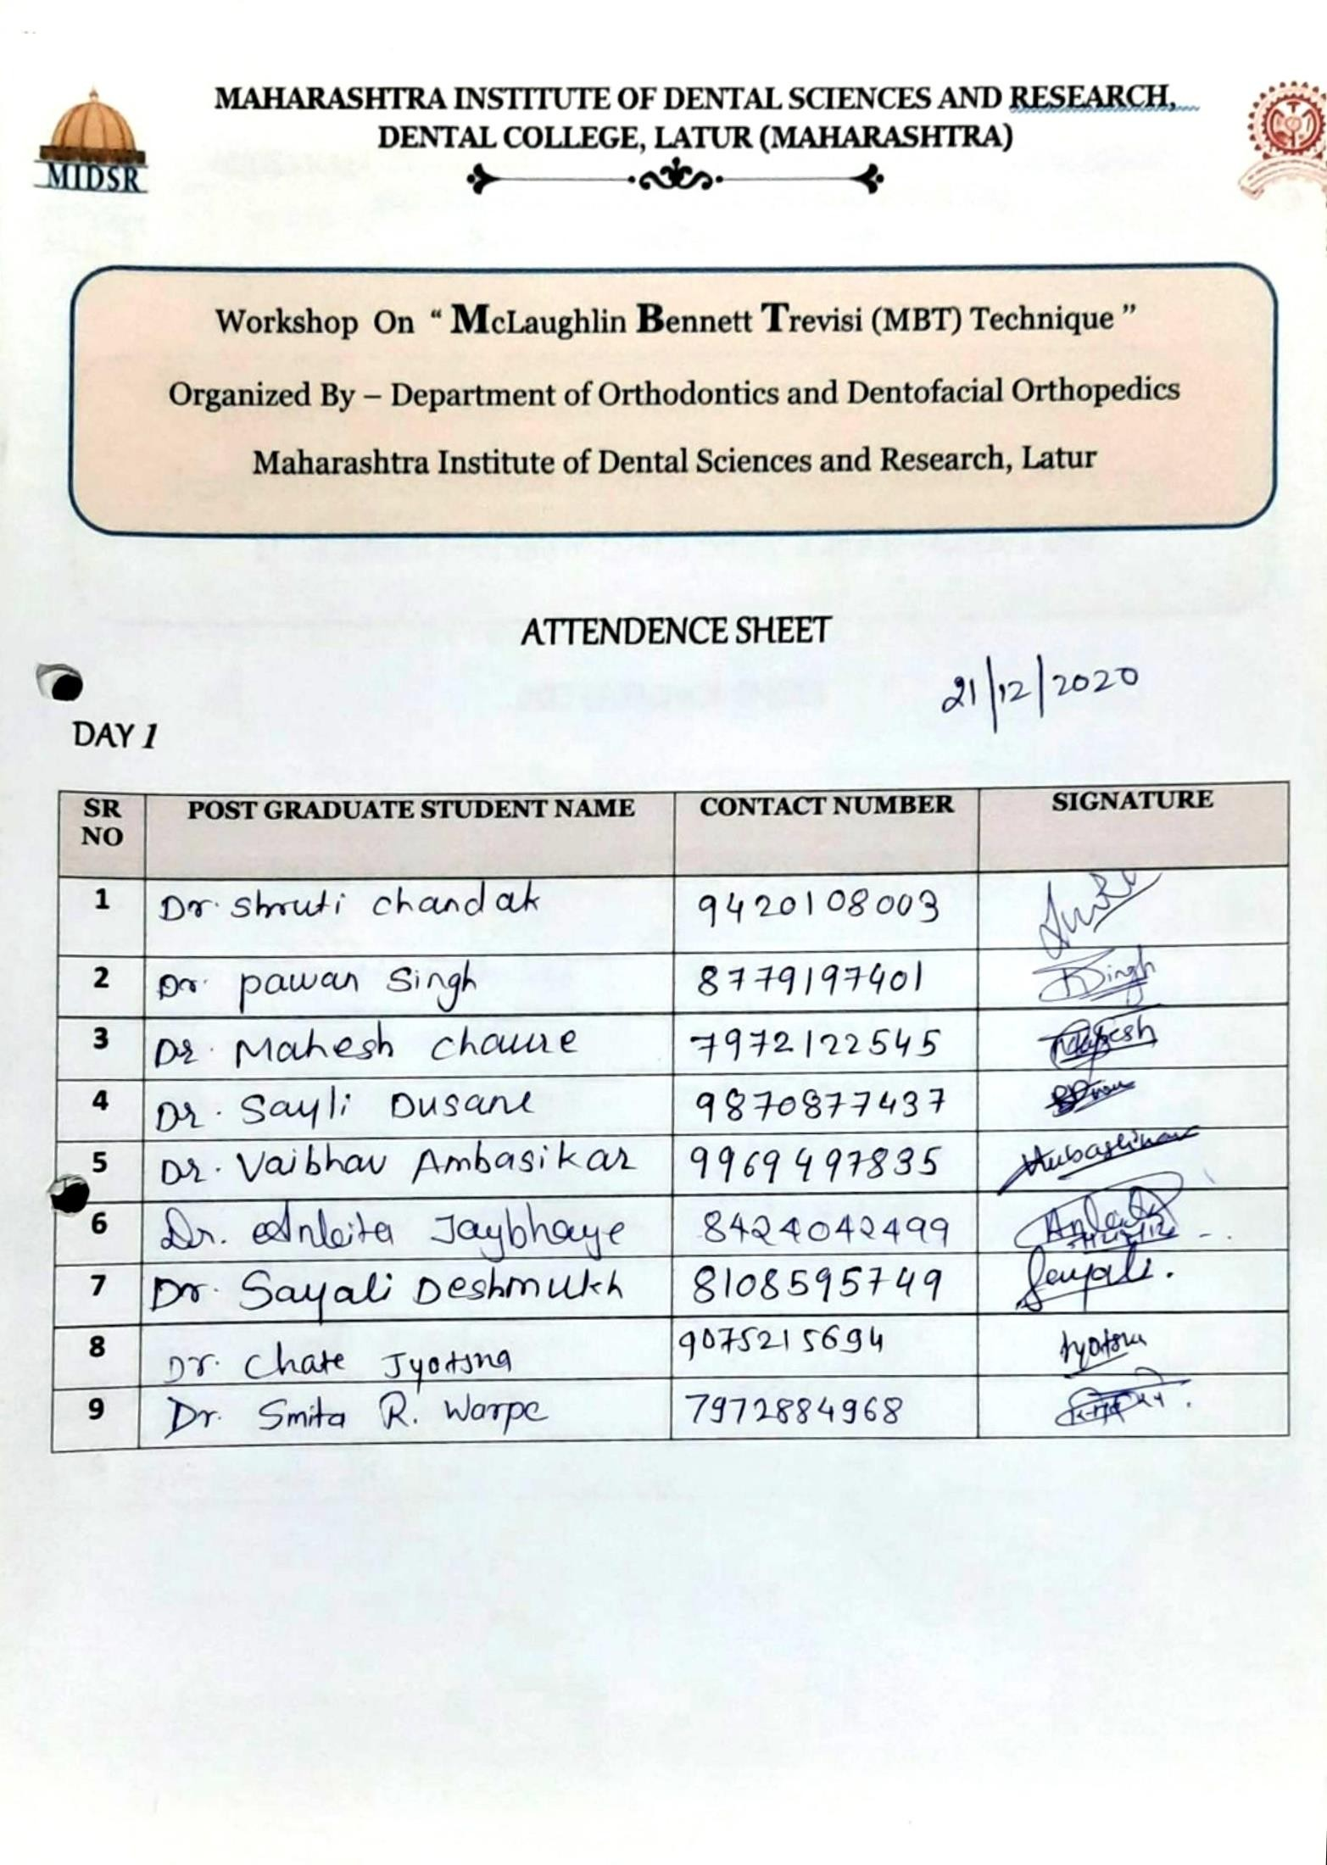

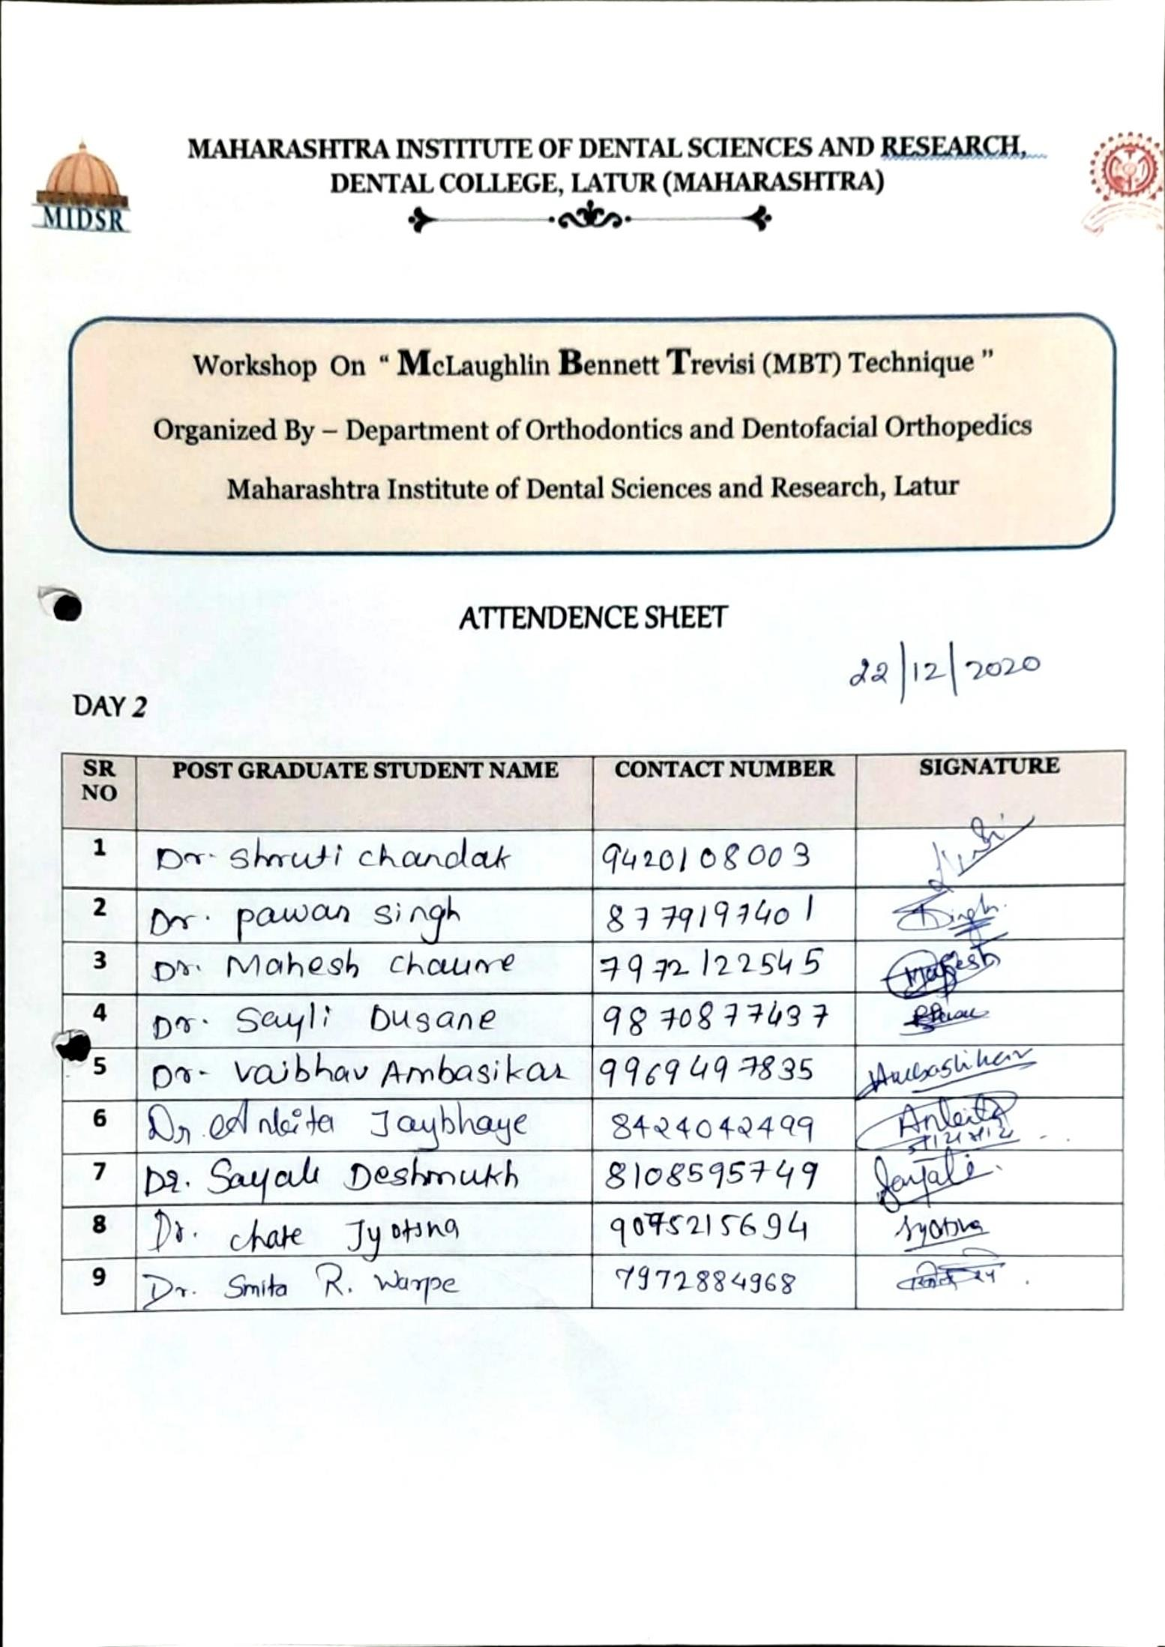

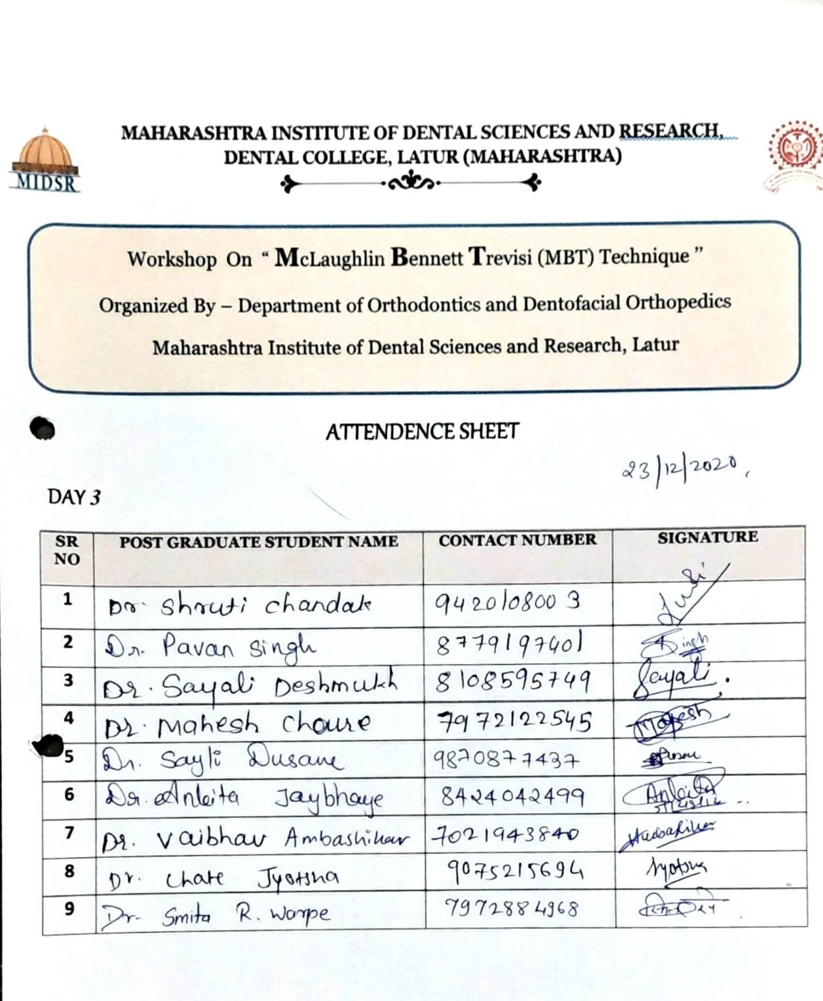

These participants have successfully completed the course.
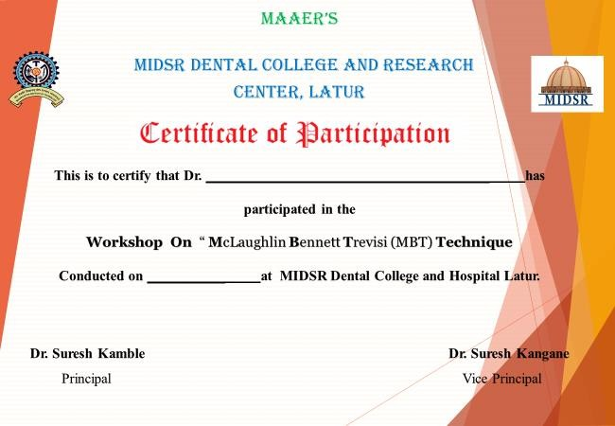
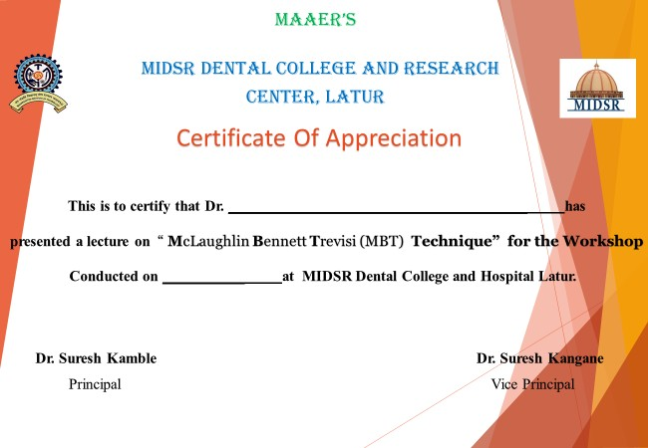
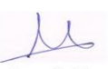


Lecture taken MBT Technique
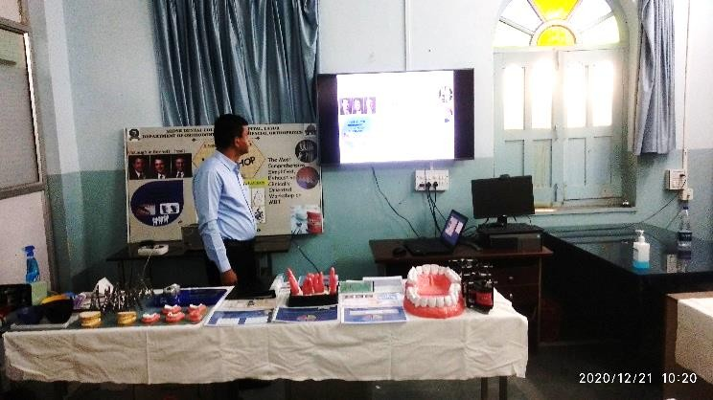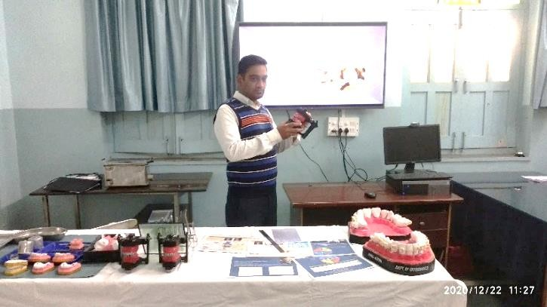

All the speaker were presented with appreciation certificates

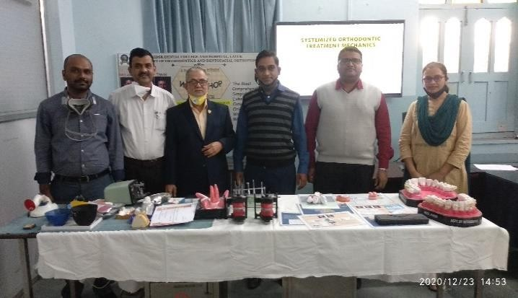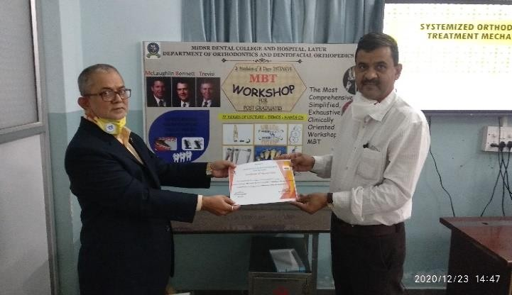

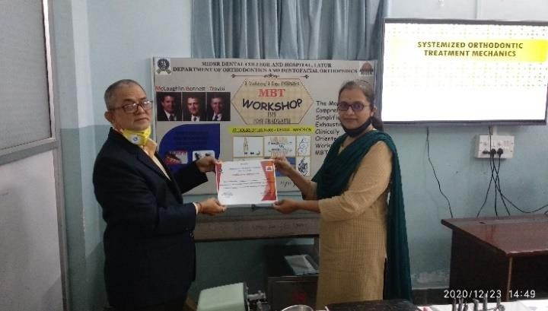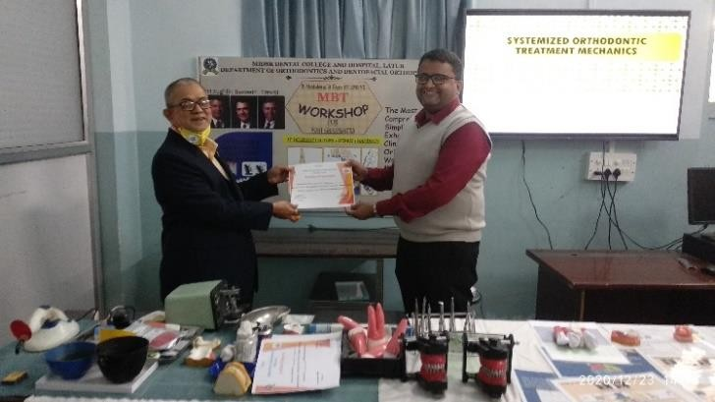

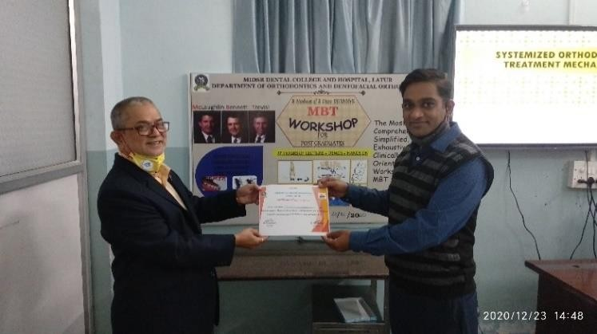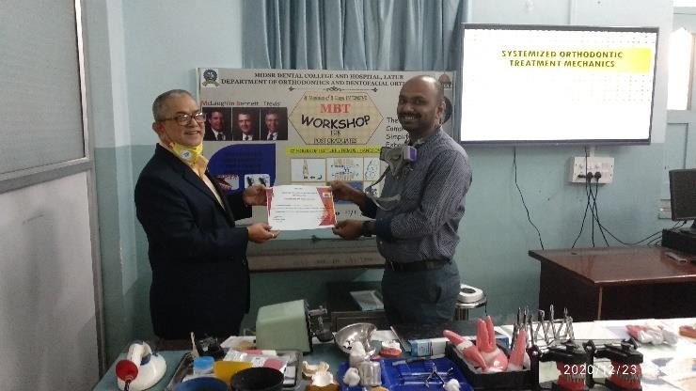

Students were presented with attendance certificate

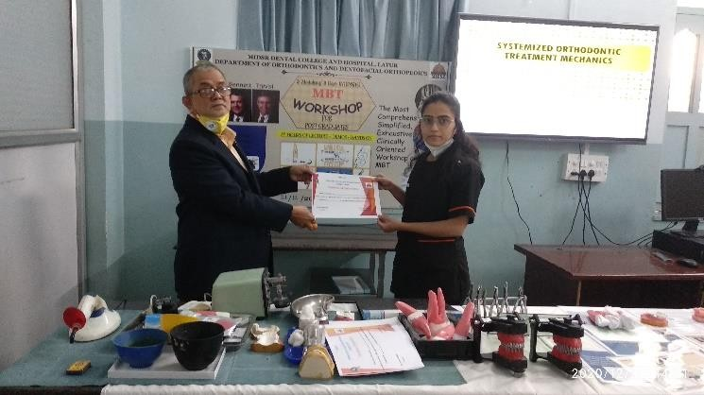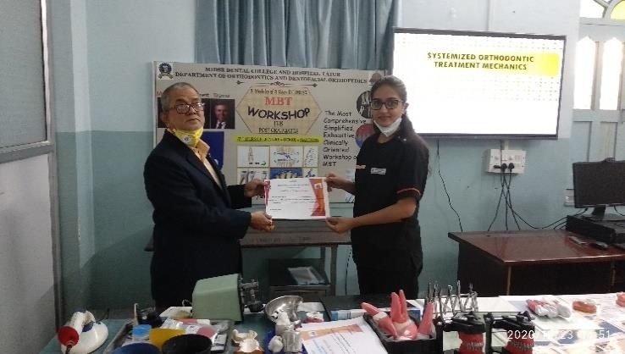

Demonstration

