MIDSR DENTAL COLLEGE AND HOSPITAL
5/08/2019
LATUR
DEPARTMENT OF PERIODONTICS

ORAL HYGIENE DAY CELEBRATION REPORT
August 01, 2020

Oral hygiene day is celebrated all across India on August 1st to commemorate the ‘Birth Anniversary of Dr. G. B. Shankwalkar’ the doyen of Indian Periodontics. As part of the oral hygiene day celebration, DEPARTMENT OF PERIODONTICS took the opportunity to spread awareness and importance of oral health in the community. This year due to COVID 19 pandemic as per the government guidelines and regulations for COVID 19 we celebrated oral hygiene day maintaining social distancing and we have presented a video convaying “Similar to hand hygiene, oral hygiene is essential in reducing infection from the oral cavity.” In this video Dr. Bhandari (HOD of Periodontics department) along with all the staff of periodontics department Dr. Omkumar Baghele, Dr. Gauri Ugale, Dr. Raghvendra Metri, Dr. Mukesh Aradle, Dr.Sukanya Vyavhare, Dr. Poonam Kedar have spoken about importance of oral hygiene in this COVID 19 pandemic and post graduate students Dr. Fatima Pathan, Dr. Smita Malbhage, Dr. Saleem Khan, Dr Kanishka Magdum, Dr. Madhura Vairagi , Dr. Shrirang Sangle, Dr. Khushbu Bezalwar, Dr. Priyanka Jadhav, Dr. Rohini Male have demonstrated brushing techniques and also the importance of tongue cleaning, significance of using toothbrush. When to change toothbrush and how to keep it clean and isolated. We have shared link of this video on Youtube, Facebook and whatsapp groups.
Link of the video : https://youtu.be/l0y5Ru8HN34

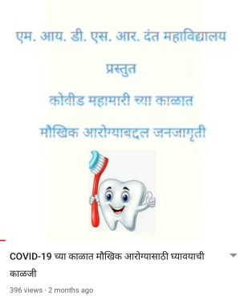 | 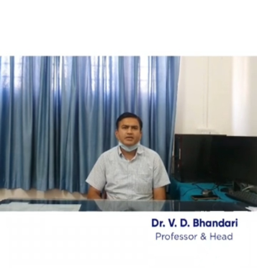 | 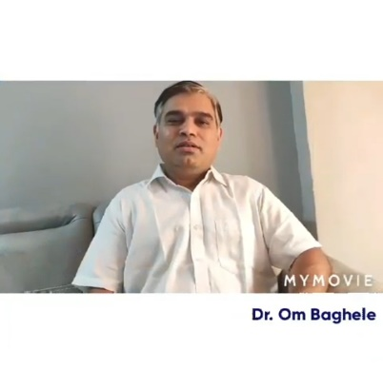 | 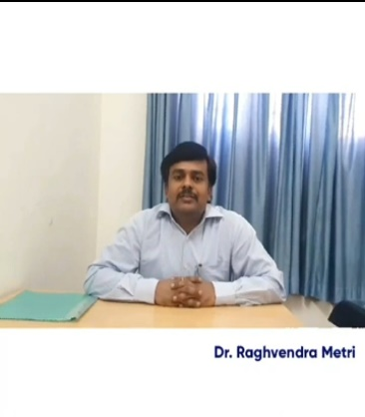
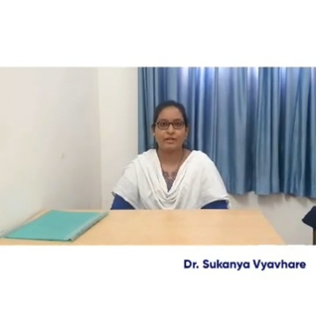 | 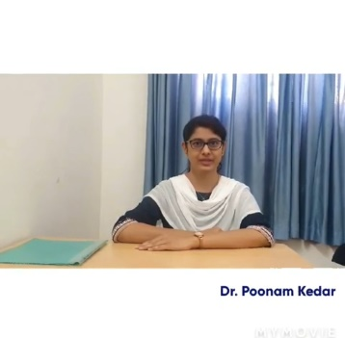 | 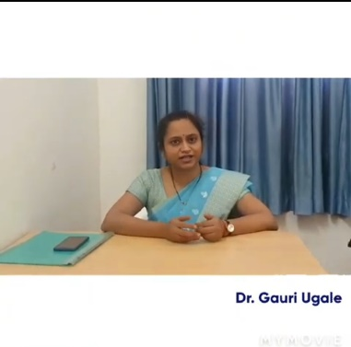 | 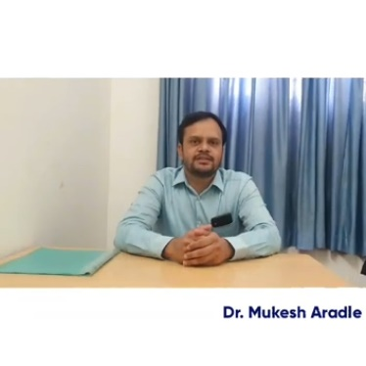

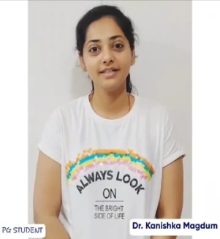 | 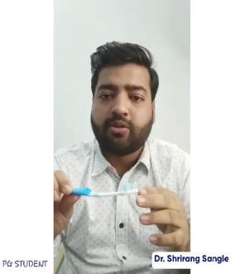 | 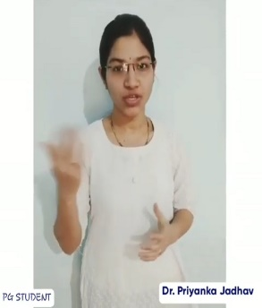 | 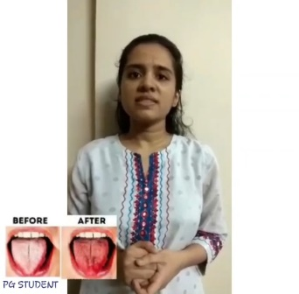

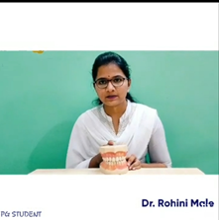 | 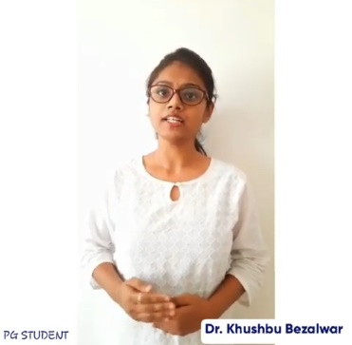 | 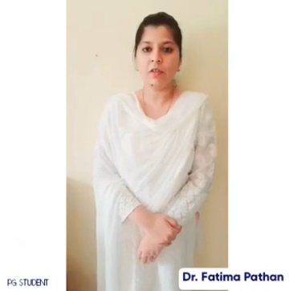 | 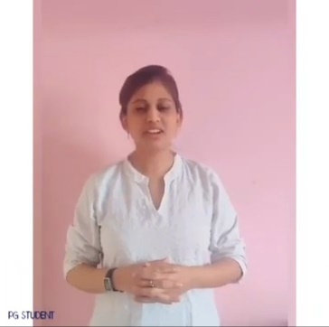

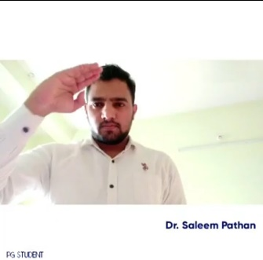 | 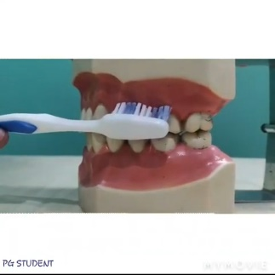 | 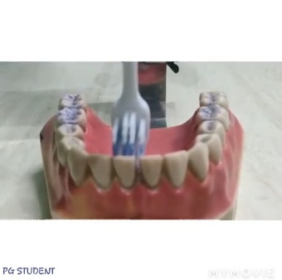 | 