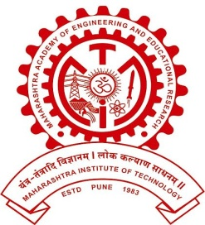
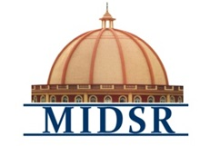
MAEER PUNE’S
MAHARASHTRA INSTITUTE OF DENTAL SCIENCES AND RESEARCH, LATUR
(DENTAL COLLEGE & HOSPITAL)

DEPARTMENT OF PROSTHODONTICS

REPORT

PROSTHODONTIST DAY CELEBRATION 22/01/2021

Department Of Prosthodontics, Crown & Bridge & Implantology held a programme on the occasion of prosthodontic day 22/01/2017 in the premises of MIDSR Dental College, Latur. The programme began with lighting of the lamp at 9.30 am by the esteemed chief guests & the Dean of MIDSR Dental College, Latur,
The event was highlighted by plantation of trees. Poster presentation and rangoli competitions , facepainting , Slogan Competition, Best Smile Competition, Soap Carving Competition,
Poster And Placard Making For Selfie Booth, Teeth Arrangement Competition were held for the undergraduate and post graduate students and prizes were distributed.
10 Complate denture Delivery was done On the occasion of this day. teaching staff , post graduate student and BDS students participants were present.

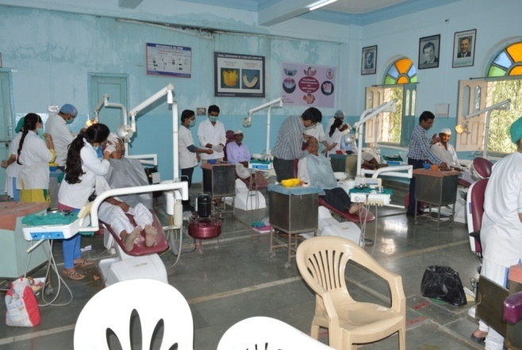
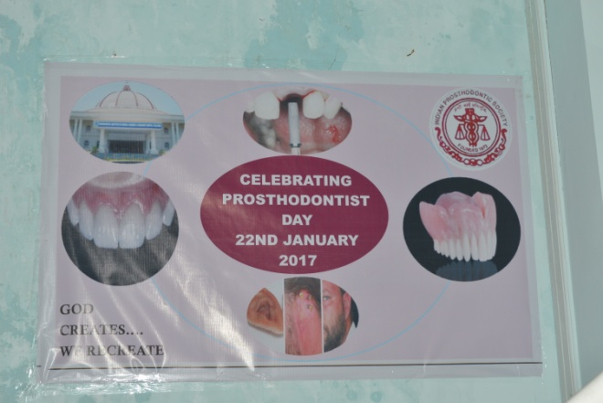
Free dental check up Poster

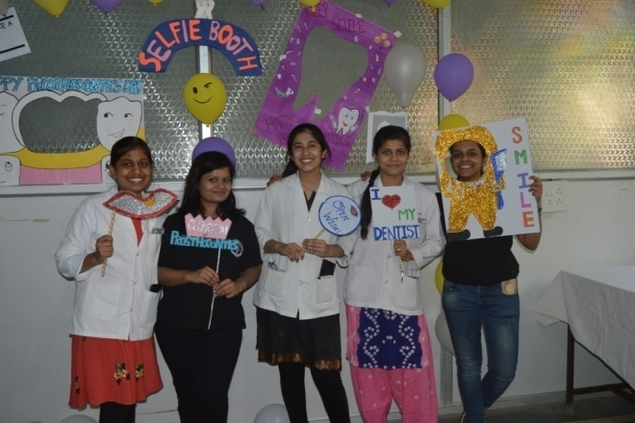
Selfie booth

