
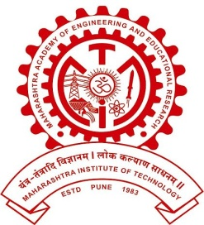
MAEER PUNE’S
MAHARASHTRA INSTITUTE OF DENTAL SCIENCES AND RESEARCH, LATUR
(DENTAL COLLEGE & HOSPITAL)

REPORT

DEPARTMENT OF PROSTHODONTICS

PROSTHODONTIST DAY CELEBRATION REPORT 2022

Prosthodontist is a specialist who replaces missing teeth and associated structures. Main aim of prothodontist day celebration is to create awareness about prosthodontics specialty treatment among patients especially geriatric patients to seek a prosthodontist for their problem associated with edentulousness.

Prosthodontist day was celebrated on 22nd January 2022 by the department of prosthodontics, MIDSR Dental College under the guidance of Dr Suresh Kamble. The event was highlighted by tree plantation. Photography competition, reel and rangoli competitions were conducted were held for the undergraduate and post graduate students and prizes were distributed. On this occasion, free denture treatment was done for around 12 patients. Denture maintenance boxes were also given to all patients. A small speech regarding post insertion instructions, oral hygiene maintenance and importance of preserving natural teeth was given by Dr Ajit Jankar, HOD &Professor, and Department of Prosthodontics.

A special quiz competition programme was conducted by the staffs for post graduates & interns on this occasion at the end of the programme.

PROSTHODONTIST DAY CELEBRATION

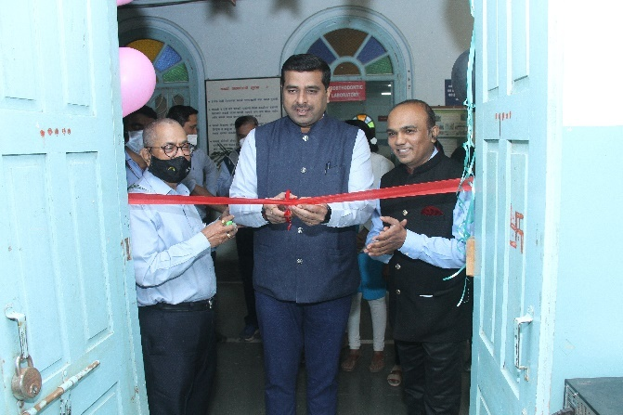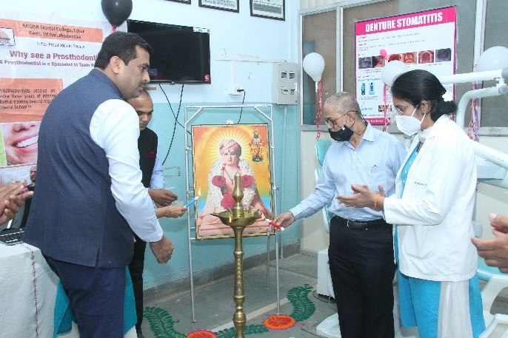
INAUGURATION BY CHIEF GUEST MR SACHIN MUNDE CHIEF ADMINSTRATIVE OFFICER MIMSR MEDICAL COLLEGE, LATUR

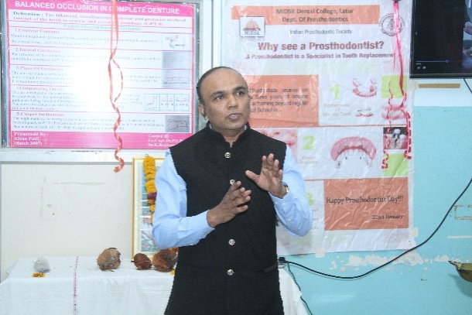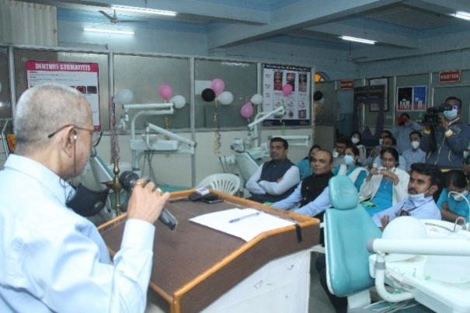
SPEECH BY DR AJIT JANKAR (HOD) GUIDANCE BY DEAN, DR.SURESH KAMBLE

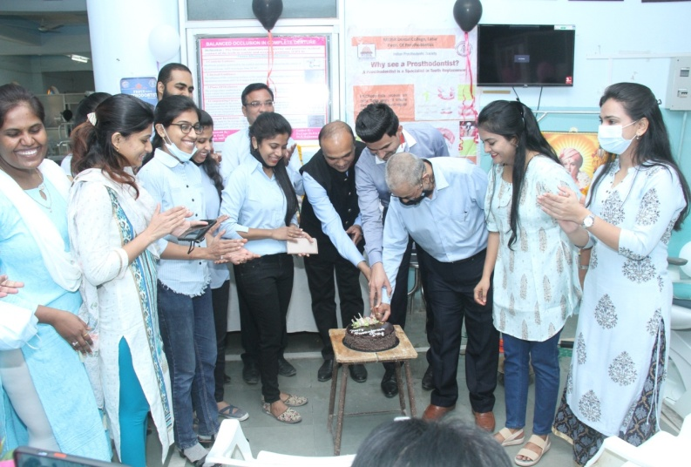
CAKE CUTTING CEREMONY ON THE OCCASION OF PROSTHODONTIC DAY

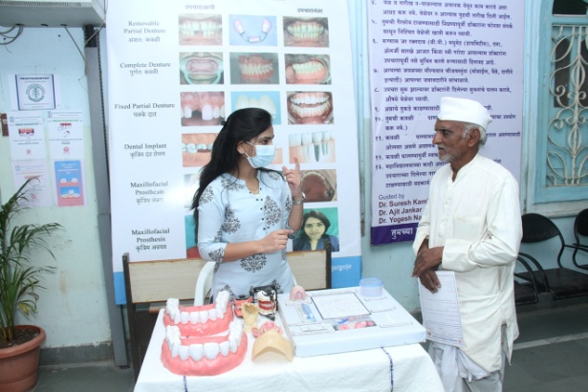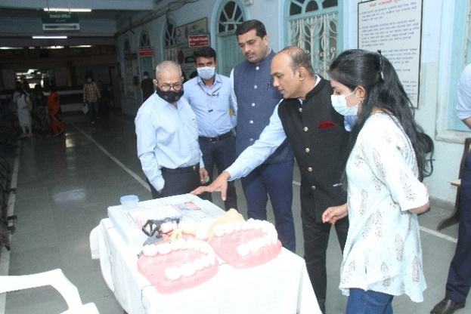
EDUCATING PATIENTS ABOUT THE VARIOUS TREATENT MODALITIES AT PATIENT EDUCATION BOOTH
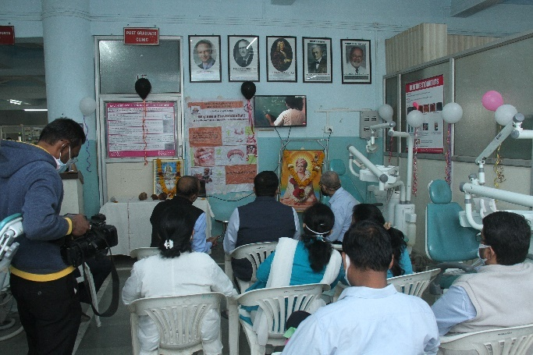
PATIENT EDUCATION VIDEO

TREE PLANTATION PROGRAMME

ON THE OCCASION OF PROSTHODONTIC DAY TREE PLANTATION WAS DONE.

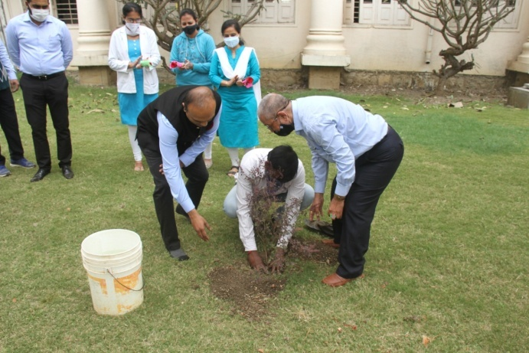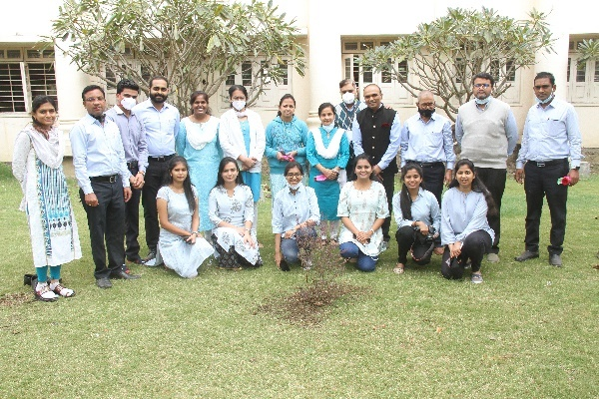

RANGOLI

RANGOLI COMPETITION WAS ORGANISED BY OF DEPARTMENT OF PROSTHODONTICS, THE EVENT WAS JUDGED BY THE DEAN OF MIDSR DENTAL COLLEGE, LATUR,

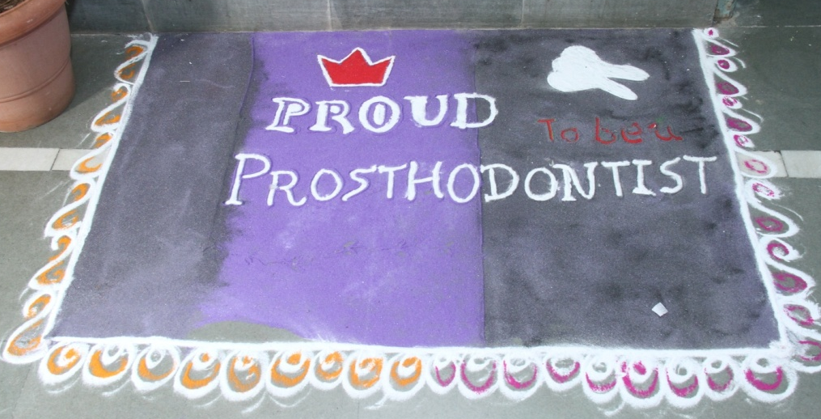

PHOTOGRAPGY COMPETITION

THE COMPETITION WAS ORGANISED BY OF DEPARTMENT OF PROSTHODONTICS, THE EVENT WAS JUDGED BY THE DR AJIT JANKAR SIR OF MIDSR DENTAL COLLEGE, LATUR,

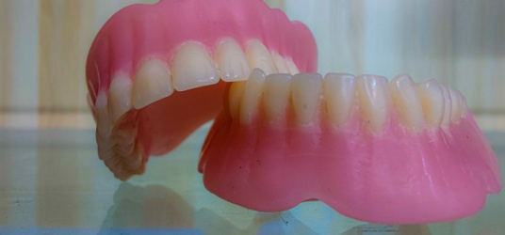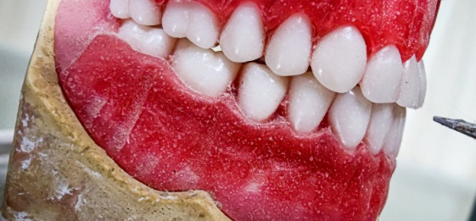

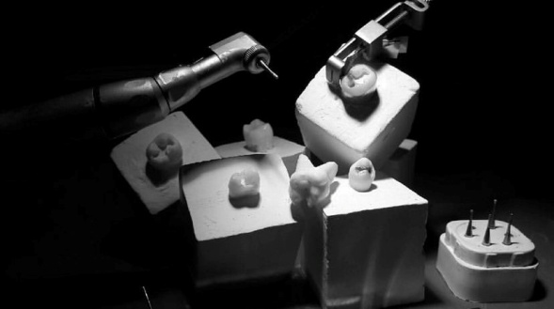

REEL COMPETITITION

THE COMPETITION WAS ORGANISED BY OF DEPARTMENT OF PROSTHODONTICS.
THE EVENT WAS JUDGED BY THE DR SUSHEEN GAJARE SIR OF MIDSR DENTAL COLLEGE, LATUR,

