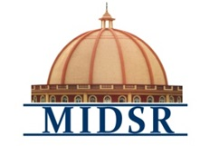
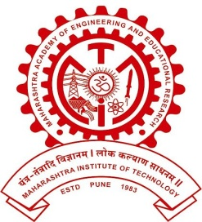
MAEER PUNE’S
MAHARASHTRA INSTITUTE OF DENTAL SCIENCES AND RESEARCH, LATUR
(DENTAL COLLEGE & HOSPITAL)

DEPARTMENT OF PROSTHODONTICS

PROSTHODONTIST DAY CELEBRATION REPORT 2023

Prosthodontics Day was celebrated on 24th January 2023 in the department of Prosthodontics, MIDSR Dental College, latur. The Programme was inaugurated by chief guest Professor Randeet Dangad, Dr. Yatish Joshi (Vice principal of MIDSR Dental College), Dr. Ajit Jankar (HOD department of Prosthodontics).
After the inauguration the tree plantation programme was held in the campus. Various competition like rangoli competition, Soap carving, Tatto, mask decoration, Poster & Meme making competition were organized specially for UG & PG students. The Programme was concluded by the Prize distribution ceremony.

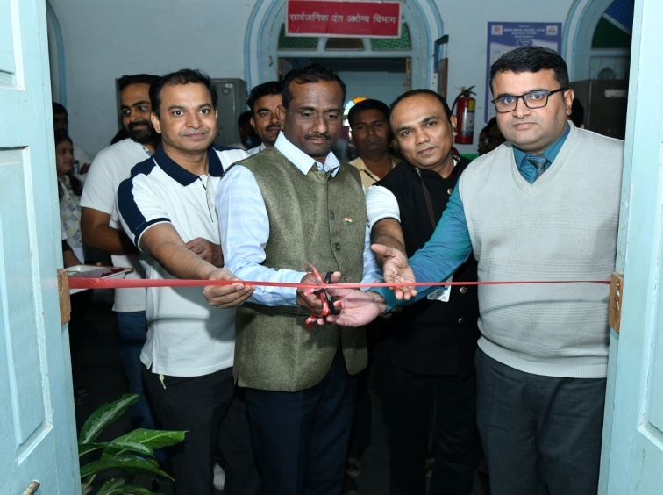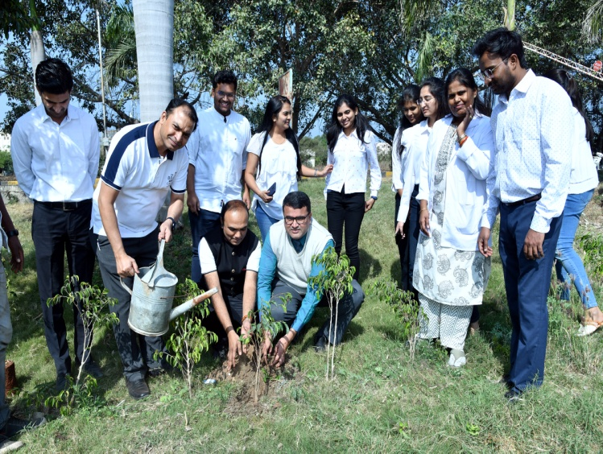
INAUGURATION TREE PLANTATION

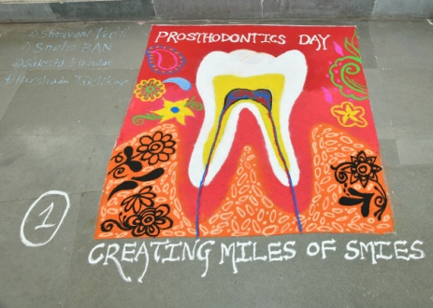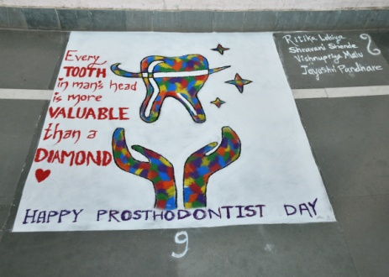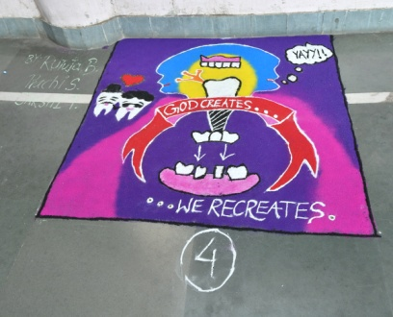

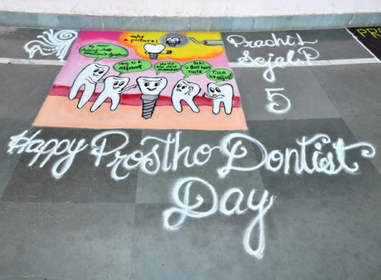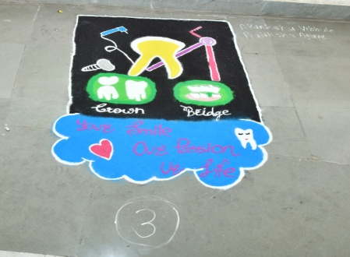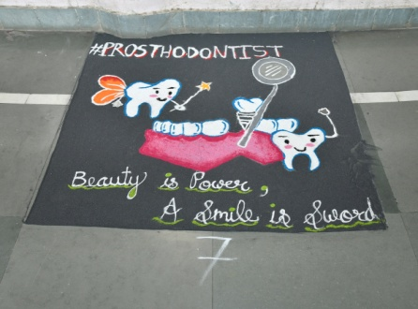

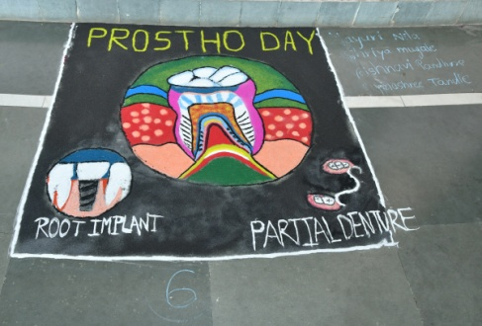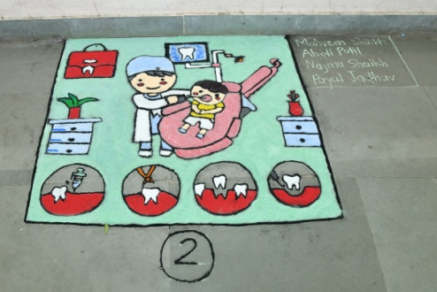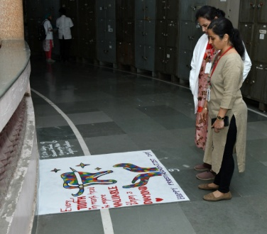
RANGOLI COMPETITION

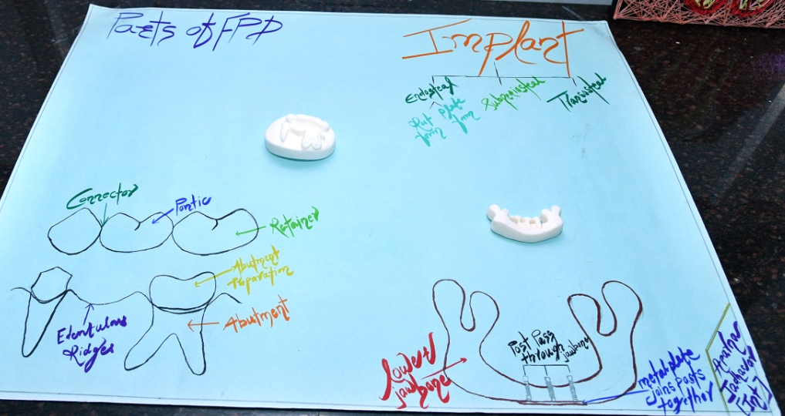
SOAP CARVING

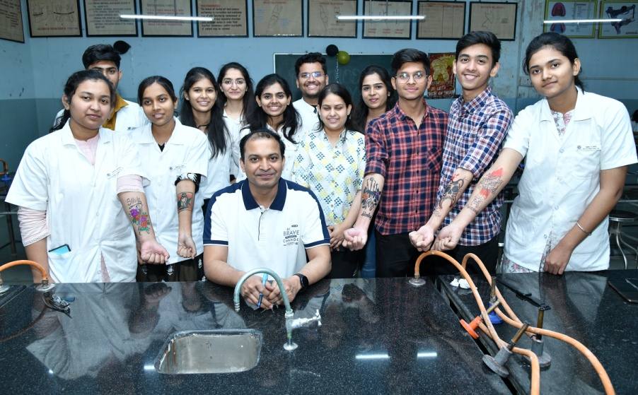
TATTO MASK DECORATION

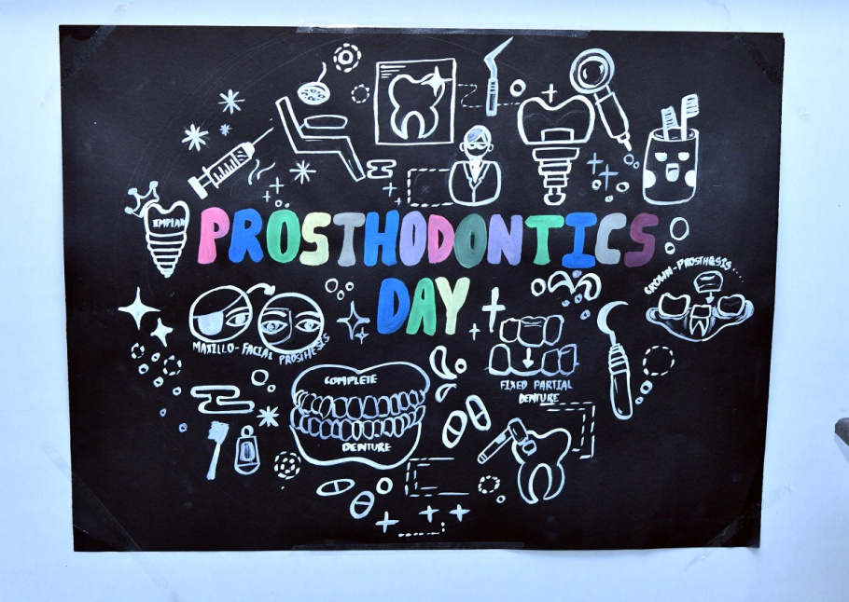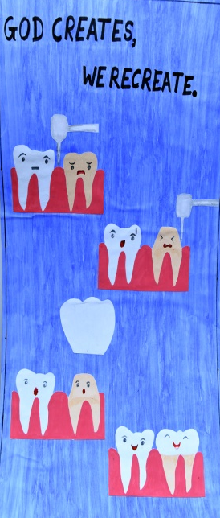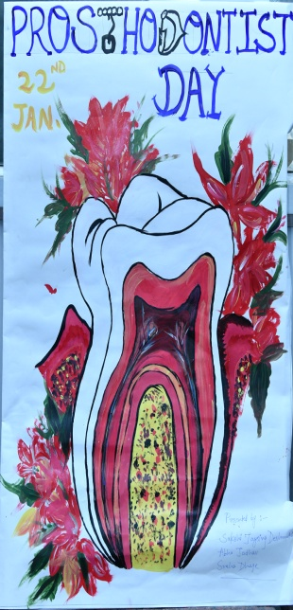

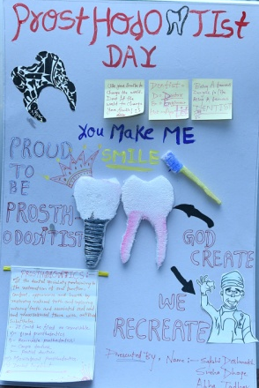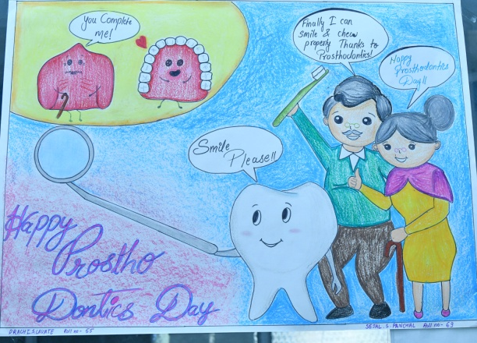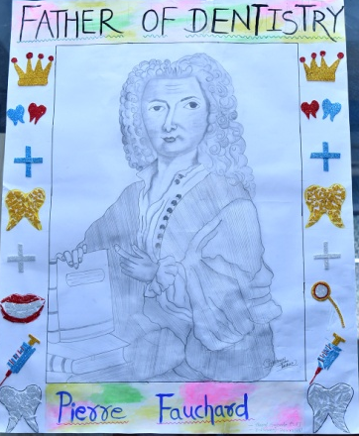

POSTER COMPETITION

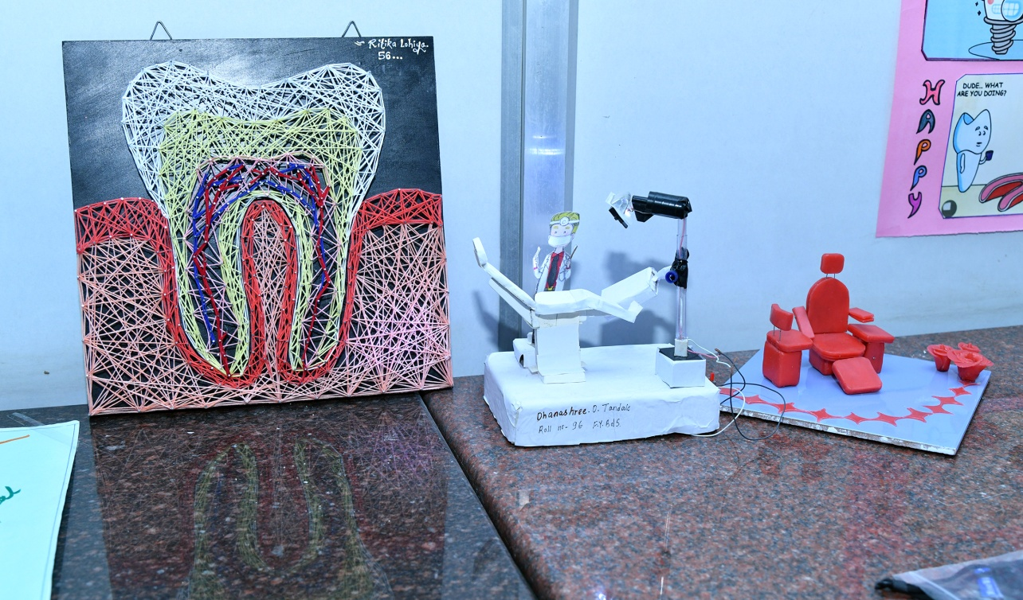
DENTAL ART COMPETITION

