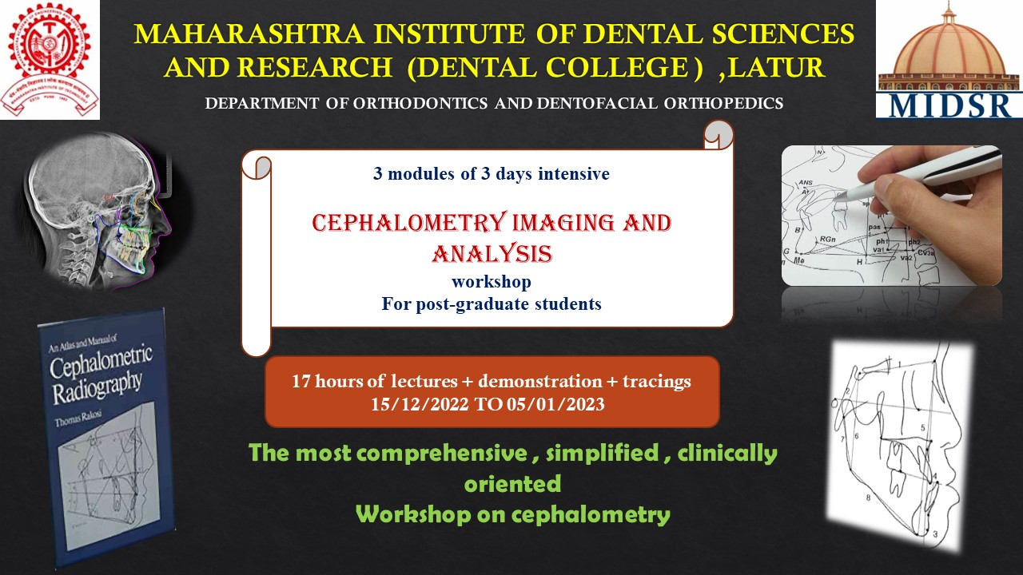

- CONTENT:
The study of the following:
- A brief history and overview of cephalometry.
- Identification of landmarks, planes & their significance.
- Different cephalometric tracing techniques- Manual / Software generated.
- Learning different hard tissue analysis and their clinical implications.
- Study & Application of various soft tissue analysis.
- Usefulness of cephalometry in diagnosis & Treatment planning.
- Numerous Superimposition techniques.

- LEARNING OBJECTIVES:

- Know the history of cephalometric.
- Produce an accurate and diagnostic cephalometric image.
- Recognize, identify, and label important cephalometric landmarks on the skull.
- Hand-trace a cephalometric radiographic image.
- Identify, construct, measure, interpret the measure, and state the limitations of 40 common cephalometric measures.
- Produce a cephalometric superimposition by hand and analyze the changes that have occurred during the treatment time period.
- Digitize and analyze a cephalometric image with accurate results that match the same image that has been traced by hand.
- Understand and correctly interpret the meaning of selected cephalometric measures for predictive diagnosis and interpretation of the changes that have occurred during a time period from a cephalometric superimposition.

- THE PROGRAM CURRICULUM AND SCHEDULE INCLUDES:

1. Theoretical lectures
2. Demonstration of manual and digital method
3. Hands on manual and digital method

IV. WORKSHOP DESCRIPTION
CEPHALOMETRIC IMAGING AND ANALYSIS WORKSHOP is a planned, well organized departmental event that provides a basic information of diagnosis and treatment planning before starting orthodontic treatment to post graduates.
From this knowledge-based workshop, post graduates will learn to understand cephalometric and explains why the methods that are taught are the best that are known at this time and its clinical application, this course will be able to produce a cephalometric image, analyse it, and understand the significance of changes in cephalometric relationships over time.

- TOPICS INCLUDE:
Module I:
- BURSTONE & LEGAN’S ANALYSIS
- RAKOSI’S ANALYSIS
- Mc NAMARA ANALYSIS
- BJORK ANALYSIS
- COBEN’S ANALYSIS
Module II:
- TWEED’S ANALYSIS & WIT’S APPRAISAL
- SASSOUNI’S ANALYSIS
- HARVOLD’S ANALYSIS
- GRUMMON’S ANALYSIS
- DELAIRE’S ANALYSIS
Module III:
- SCHWARZ ANALYSIS
- HOLDAWAWAY ANALYSIS
- TEMPLATE ANALYSIS
- PROPORTIONATE TEMPLATE ANALYSIS

- WORKSHOP OUTCOME
After completion of cephalometric analysis Workshop, post graduate students will be equipped with basic understanding of the following:
- Provide post graduates with the principles of diagnosis & orthodontic treatment plan in daily clinical practice, so they can understand the rationale for clinical use.
- Identify characteristics and phases of treatment to endure efficient treatment outcome.
- To have more focus on fundamental diagnostic skill

- WORKSHOP SUMMARY

MODULES | III MODULES / 3 DAYS
Duration : | 17 HOURS COURSE
Start Date : | 15/ 12 / 2022
End Date : | 05 / 01 / 2023
Category : | Post graduate Student Education
WORKSHOP  Level : | Continuing Education
CEPHALOMETRIC IMAGING AND ANALYSIS WORKSHOP
Module  I | - A brief history and overview of cephalometry  - Identification of landmarks, planes & their significance  - Seminars on  - BURSTONE & LEGAN’S ANALYSIS  - RAKOSI’S ANALYSIS  - McNamara ANALYSIS  - BJORK ANALYSIS  - COBEN’S ANALYSIS
Module  II | - Focus on different cephalometric tracing techniques- Manual / Software generated  - Seminars on  - TWEED’S ANALYSIS & WIT’S APPRAISAL  - SASSOUNI’S ANALYSIS  - HARVOLD’S ANALYSIS  - GRUMMON’S ANALYSIS  - DELAIRE’S ANALYSIS
Module  III | - Focus on numerous Superimposition techniques  - Seminars on  - SCHWARZ ANALYSIS  - HOLDAWAY ANALYSIS  - TEMPLATE ANALYSIS  - PROPORTIONATE TEMPLATE ANALYSIS

- ELIGIBILITY OF CANDIDATES: Orthodontic Post-graduate student

IX. EXPECTED COURSE OUTCOME
To Provide post graduates with the principles of diagnosis & orthodontic treatment plan in daily clinical practice, so they can understand the rationale for clinical use.Identify characteristics and phases of treatment to endure efficient treatment outcome.To have more focus on fundamental diagnostic skills.

X. ASSESSMENT METHODOLOGY
All orthodontic post graduate will be informed through circular regarding curriculum and schedule of the course. All the participants are suppose to gather in the lecture hall 10 minutes prior to start of the workshop and this workshop is compulsory for all the orthodontic post graduates and attendance is compulsory for all 3 modules
XI. REGISTRATION FEES: Free for all students
XII. FACILITIES:
Participation and lecture presentation certificate will be given after completion of workshop.

WORKSHOP “CEPHALOMETRY IMAGING AND ANALYSIS “
ORAGANIZED BY: Department of Orthodontics and Dentofacial Orthopedics
Maharashtra Institute of Dental Sciences and Research, Latur

Sr. No. | Date | Timing & duration |  |  |  | Topic name |  |  |  | Speaker | Signature
1. | Day 1  (15/12/2022) |  | 9 am -10 |  |  | A brief history and overview of cephalometry -lecture  Seminar on burnstone and legan’s analysis |  |  |  | Dr. Suresh Kangane  Dr.Manjusha Patil
1. | Day 1  (15/12/2022) |  | am  (1 hour)
2. |  |  | 10am - |  |  |  |  |  |  | Dr. Anand Ambekar  Dr.Nikhil Mukhedkar
2. |  |  | 11am (1 hour) |  |  |  | rakosi’s analysis
3. |  |  | 11 am - |  |  |  |  |  |  | Dr. Anand Ambekar  Dr.Siddhant Jadhav
3. |  |  | 12pm (1 hour) |  |  |  | Mcnamara’s anlysis
4. |  | 12 Pm -1 pm (1 hour) |  |  |  | Bjork’s analysis  - LECTURE |  |  |  | Dr. Pravin Marure  Dr.Arsalan Shaikh
5. |  |  | 2 pm -3 pm |  |  |  | coben’s anlysis |  |  | Dr. Pravin Marure  Dr.Aavesh Bhoir
5. |  |  | (1 hour) |  |  |  |  |  |  | Dr. Pravin Marure  Dr.Aavesh Bhoir
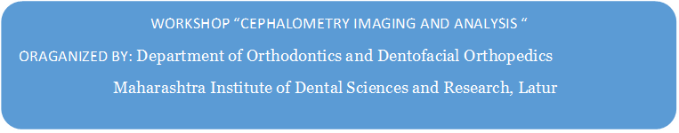
Sr. No. | Date | Timing & duration |  |  |  | Topic name |  |  |  | Speaker | Signature
1. | Day 2  (22/12/2022) |  | 9 am -10 am |  |  | Tweed analysis and wits appraisal |  |  |  | Dr. Yatish Joshi Dr.Manjusha Patil
1. | Day 2  (22/12/2022) |  | (1 hour)
2. |  |  | 10am - |  |  |  |  |  |  | Dr. Anand Ambekar  Dr.Nikhil Mukhedkar
2. |  |  | 11am (1 hour) |  |  |  | sassouni’s analysis
3. |  |  | 11 am - |  |  |  |  |  |  | Dr. Chaitanya  Khanapure Dr.Siddhant Jadhav
3. |  |  | 12pm (1 hour) |  |  |  | harvlod’s analysis
4. |  | 12 Pm -1 pm (1 hour) |  |  |  | Grummon’s analysis |  |  |  | Dr. Shilpa Kendre Dr.Arsalan Shaikh
5. |  |  | 2 pm -3 pm |  |  |  | delaire’s analysis |  |  | Dr. Pravin Marure  Dr.Aavesh Bhoir
5. |  |  | (1 hour) |  |  |  |  |  |  | Dr. Pravin Marure  Dr.Aavesh Bhoir

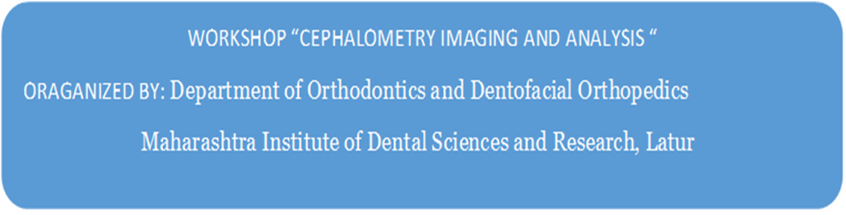

Sr. No. | Date | Timing & duration |  |  |  | Topic name |  |  |  | Speaker | Signature
1. | Day 3  (05/01/2023) |  | 9 am -10am |  |  | Schwarz’s analysais |  |  |  | Dr. Anand Ambekar Dr.Manjusha Patil
1. | Day 3  (05/01/2023) |  | (1 hour)
2. |  |  | 10am - |  |  |  |  |  |  | Dr. Pravin Marure Dr.Nikhil Mukhedkar
2. |  |  | 11am (1 hour) |  |  |  | holdaway analysis
3. |  |  | 11 am - |  |  |  |  |  |  | Dr. Yatish Joshi Dr.Siddhant Jadhav
3. |  |  | 12pm (1 hour) |  |  |  | template analysis
4. |  | 12 Pm -1 pm (1 hour) |  |  |  | Superimposition technique |  |  |  | Dr. Pravin Marure  Dr.Arsalan Shaikh
5. |  |  | 2 pm -3 pm |  |  |  | Proportionate template analysis |  |  | Dr. Chaitanya  Khanapure  Dr. Aavesh Bhoir
5. |  |  | (1 hour) |  |  |  | - |  |  | Dr. Chaitanya  Khanapure  Dr. Aavesh Bhoir

