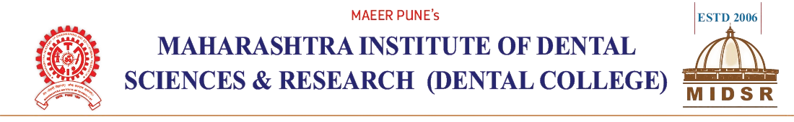

DEPARTMENT OF ORAL PATHOLOGY

REPORT

Department of Oral Pathology, MIDSR Dental College Latur, celebrated “World No Tobacco Day”, 31st May 2023.

A. Introduction:

Department of Oral pathology organized a programme on occasion of “World No Tobacco Day”, 31st May 2023.Programme consist of E-poster competition, for 3rd BDS students Along with Pledge taking.

B. Communication Letters of the programme:- (ANNEXURE I)
C. Report:
An E-poster competition on occasion of “World No Tobacco Day”, 31st May 2023, for 3rd BDS students was conducted in Department of Oral Pathology, MIDSR Dental College Latur.
Dr. Anuja Maniyar (HOD &Prof), Dr. Varsha Sangle (Reader), Tejaswini (Technician) had conducted the program. On occasion of the “World No Tobacco Day”, speech on Hazards of Tobacco Habits deliverd by Dr. Anuja Maniyar also she took a Pledge to create awareness and encourage students along with their family and friends to Quit tobacco habits. Judges for the E-poster competition was Dr. Anita Kale and Dr. Punam Nagargoje. Dr. Varsha Sangle has given vote of thanks.

Communication Letters (ANNEXURE I)

I

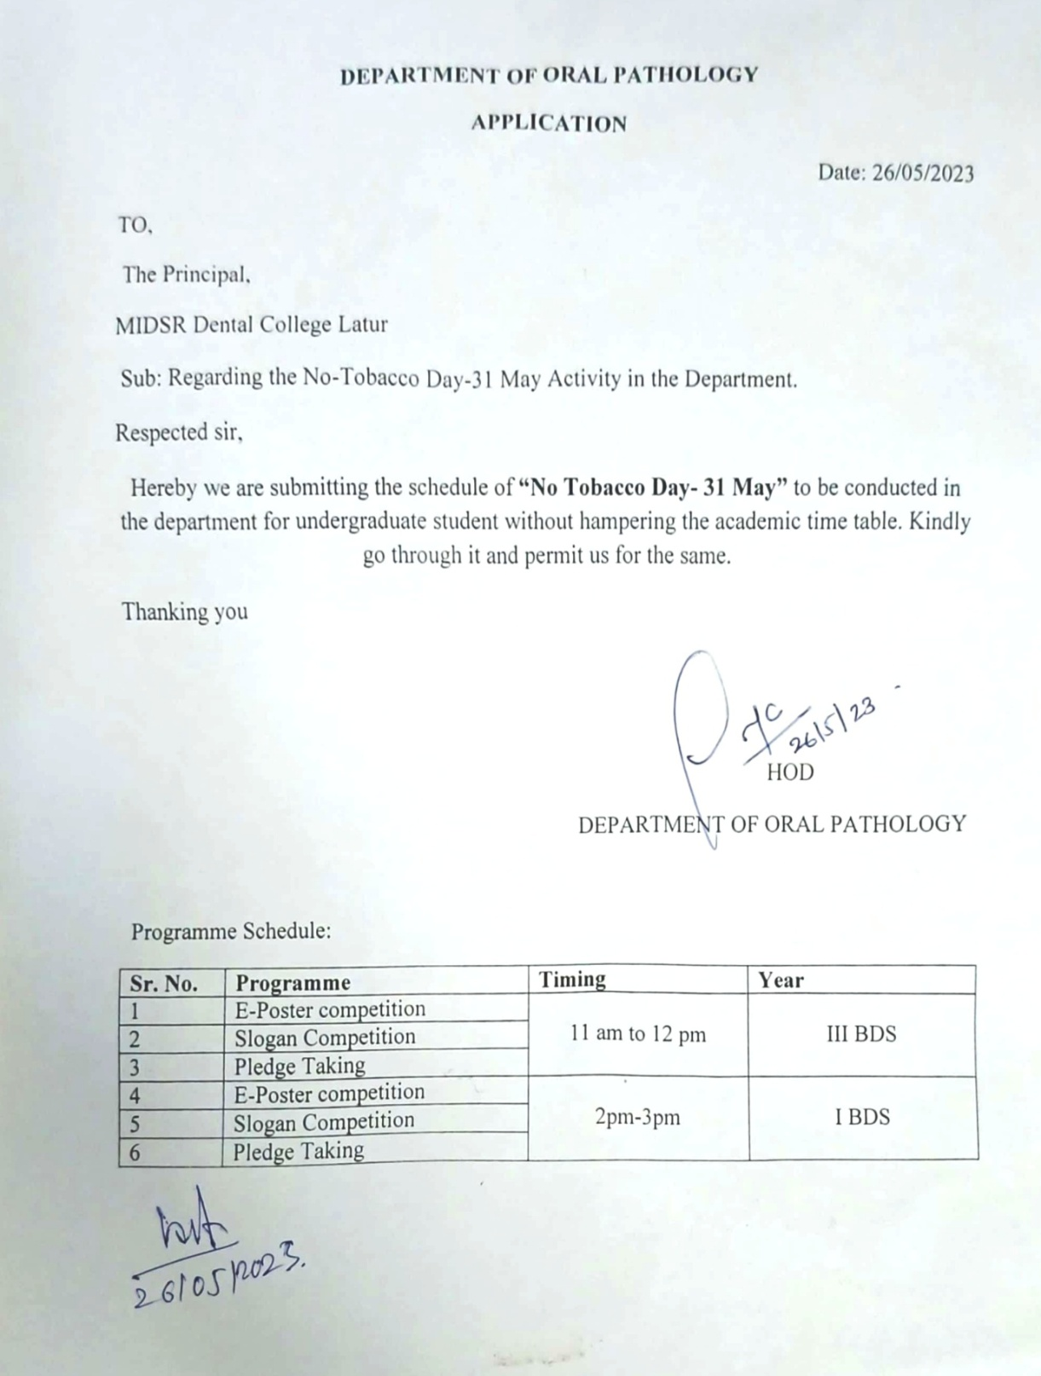

D: Pledge:
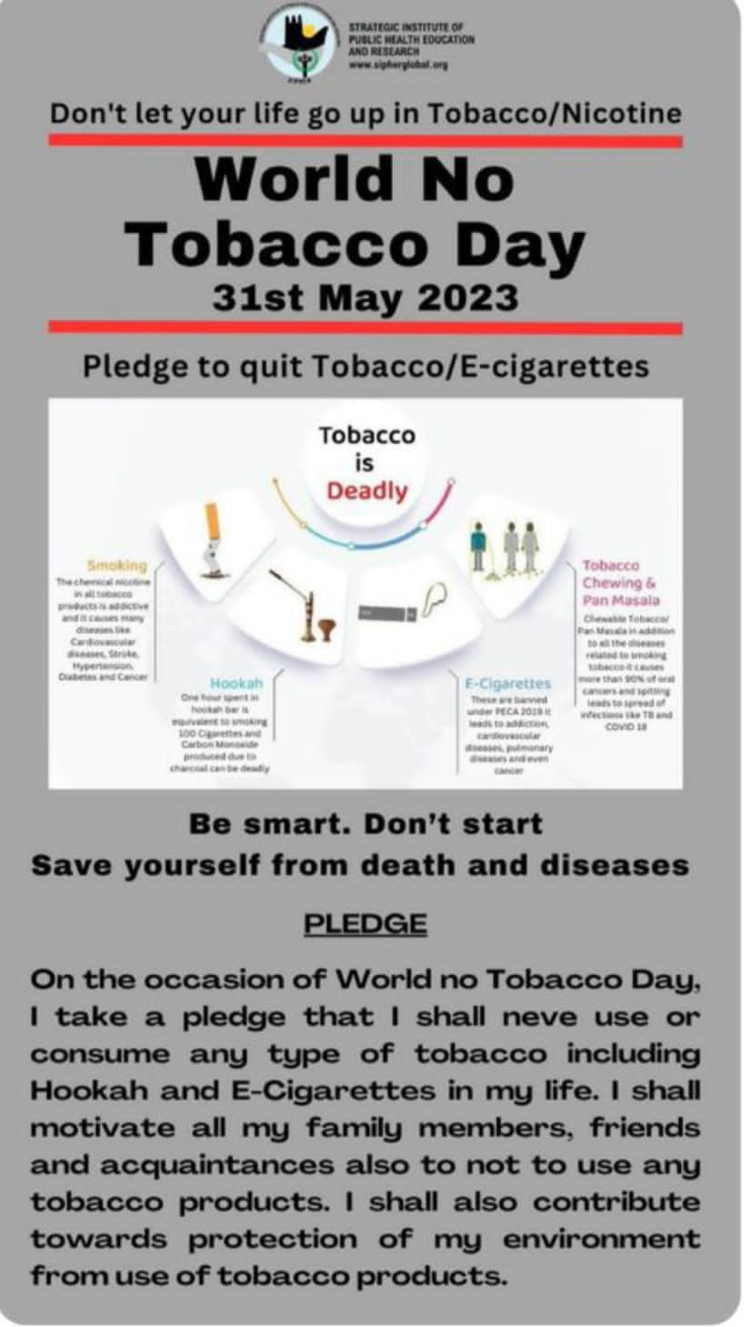

E: Programme Photos:-

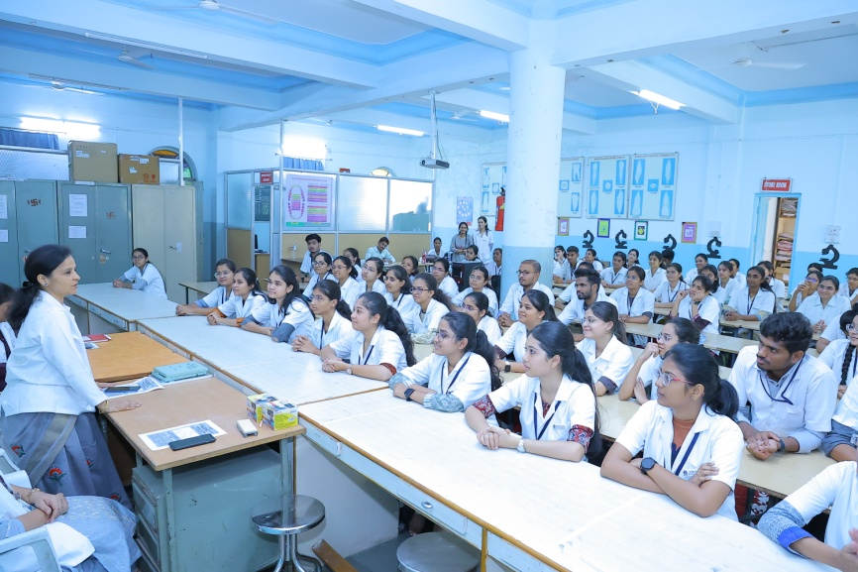
Dr. Anuja Maniyar taking a lecture

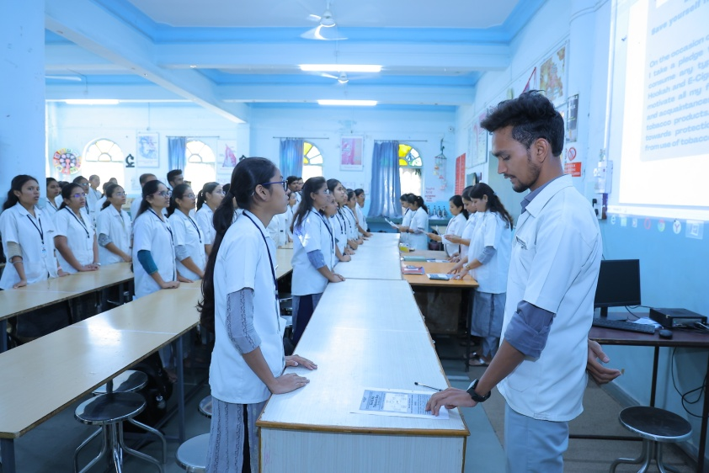
Students taking a pledge
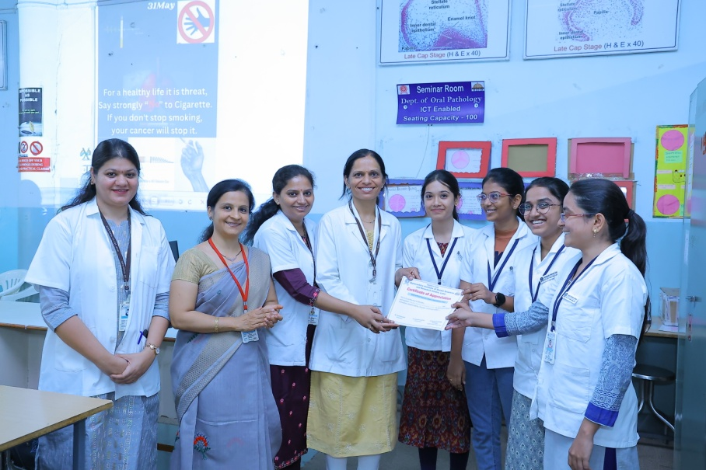
Judges giving a certificate to winners
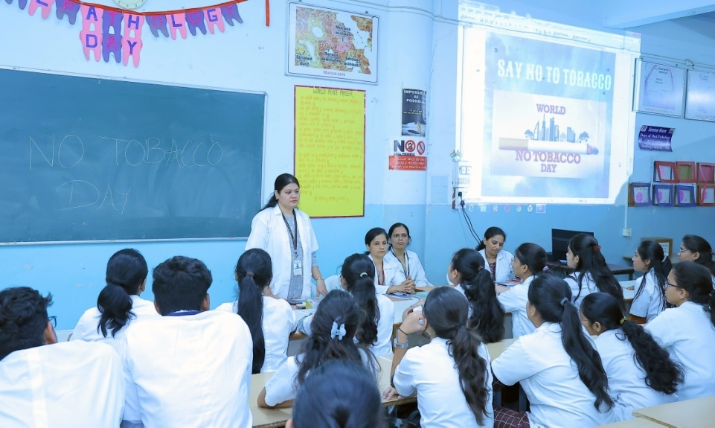
Dr. Varsha Sangle presenting a vote of thanks.

F. LIST OF PARTICIPANTS (ANNEXURE II)

G. Certificate:
H. Overview of the Programme:
The programme was successful. Students get knowledge and cleared their queries regarding Tobacco and their product hazards. Activity improves interactions and sharing of valuable knowledge.

