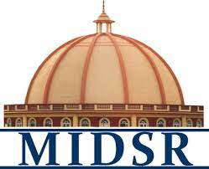
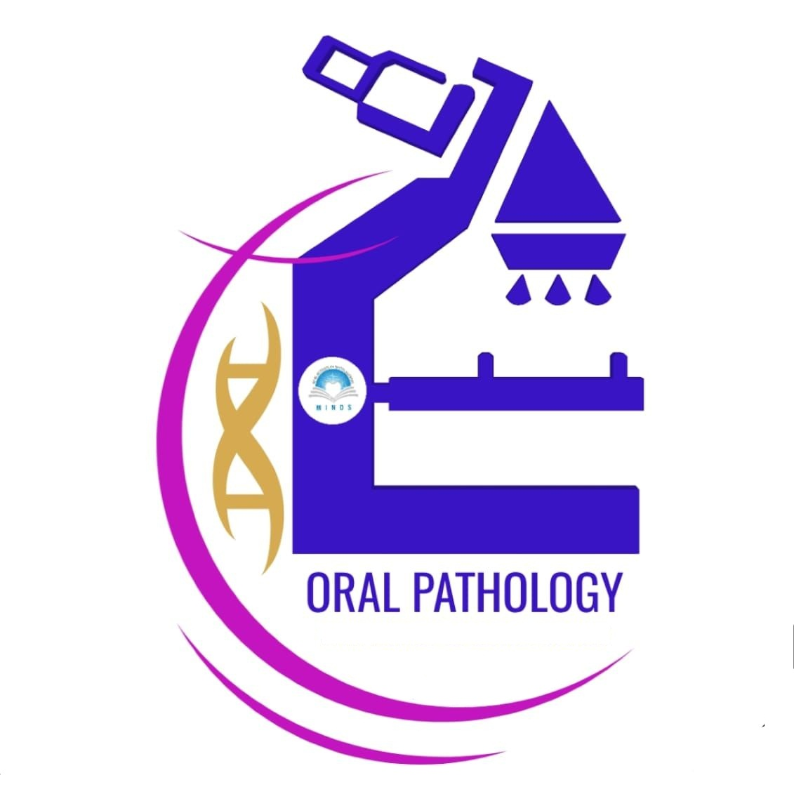
REPORT
Department of oral Pathology and Microbiology day celebration -2024

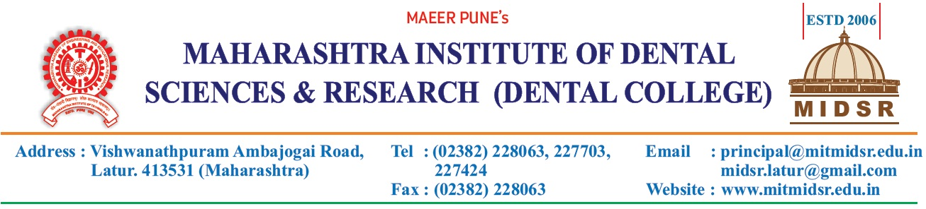
On occasion of birth anniversary of Dr. H. M. Dholkia, National Oral Pathologist Day was celebrated on 24th Feb., 2024 (Saturday).
Program was conducted by Dr. Anuja Maniyar, Dr. Varsha Sangle ,Dr. Dipali Gundre And Dr. Pragya Bhatnagar.

The department has set the theme of Black colour and was beautifully decorated with the theme coloured balloons and decorative items and posters showing the artistic and creative side of our students and staff. The welcome rangoli in H&E colours at the department gate was beautiful, in which art work of students showing “NAAC A accredited” was like a Diamond in the Crown.

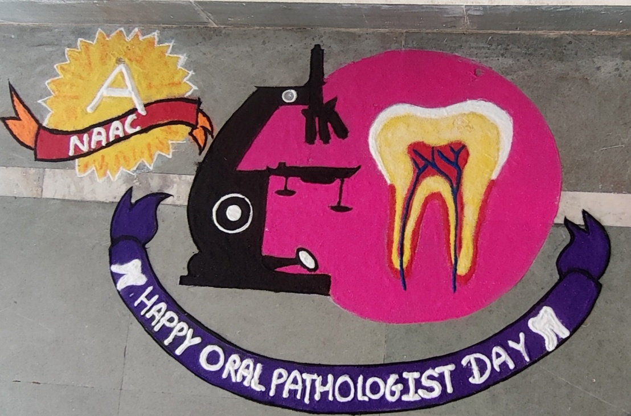
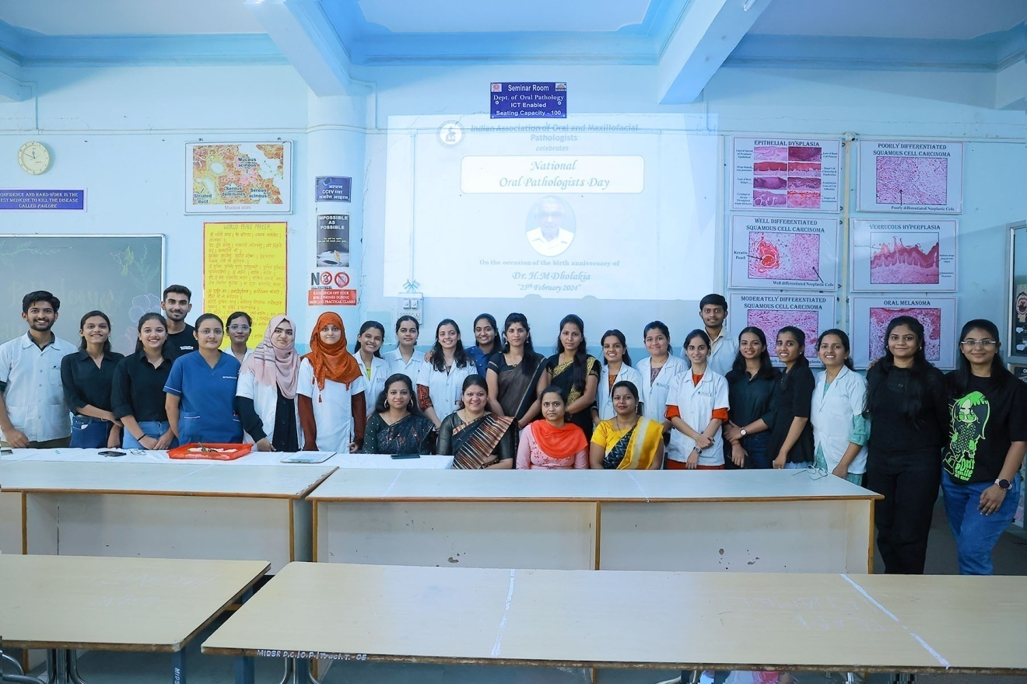

Day celebration was started with the introduction of Dr. H.M. Dholkia sir, by our beloved Professor & Head of the Department , Dr. Anuja Maniyar madam.

The anchoring was done wonderfully by Mirup Shah our intern student.

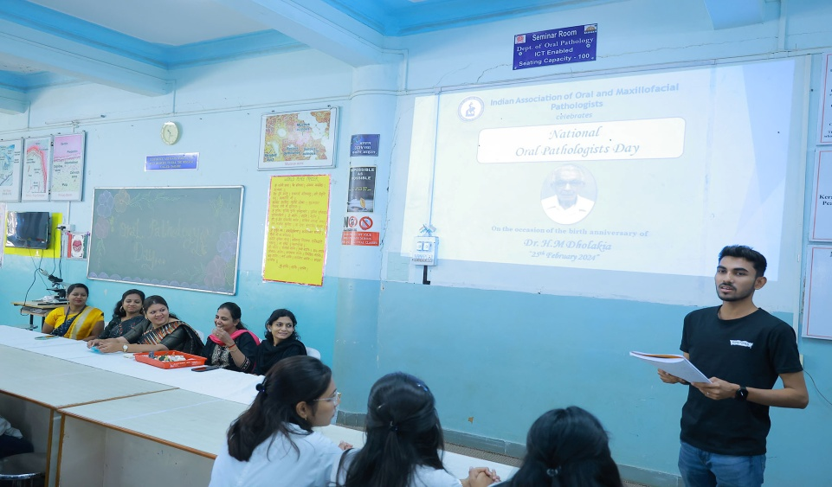

A fabulous speech was given by Dr. Varsha Sangle, which was very educational and motivational for the under graduate students, Enlightning them about the Importance of oral pathology for accurate diagnosis & treatment planning of a disease in dentistry.

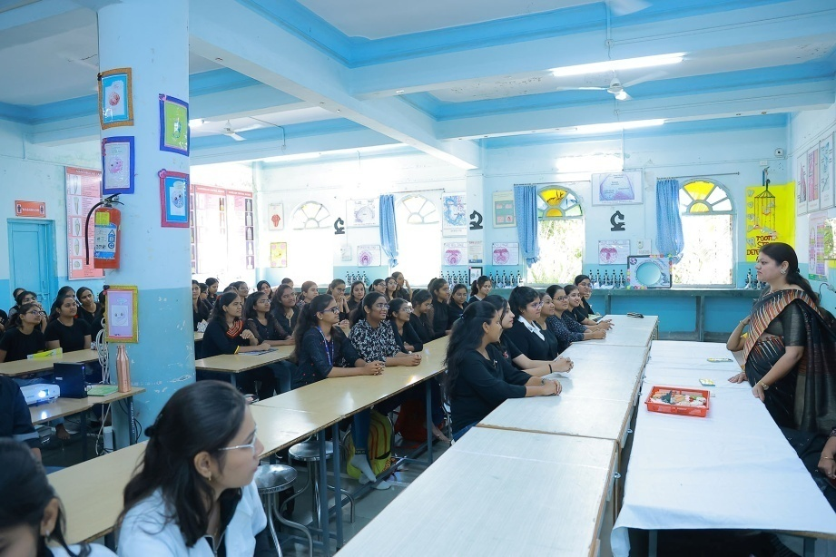

This was followed by knowledgable words of Dr. Ashwini Biradar who is our respected co-judge for Slogan and E-poster competitions, with Dr Shital Wagh.

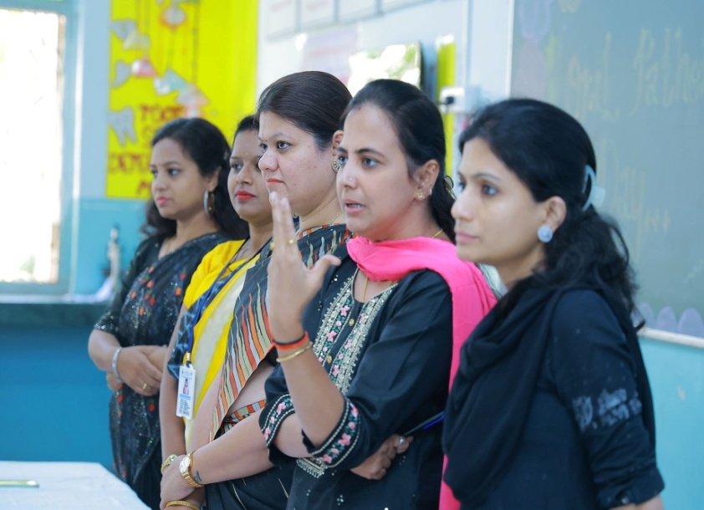

Adding to this joyfully environment our department have arranged various entertaining & educational competitions for the students. We have best from waste (carving waste wax/ soap) carving competition in which Uttkarsha Wani.1st year student secured 1st position by carving Microscope on soap. 2nd position was secured by our 1st year student Misra Sheikhwho carved a beautiful Microscope.

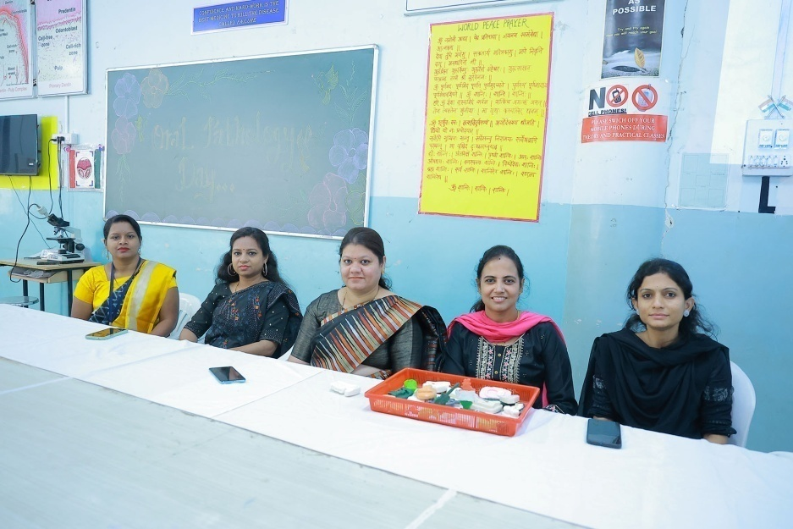

Various carvings of best out of waste competition

Next we had a Slogan competition in which 1st prize winner was 3rd year student Pratiksha Nagargoje,who made a very intresting slogan which shows her keen intrest in the subject
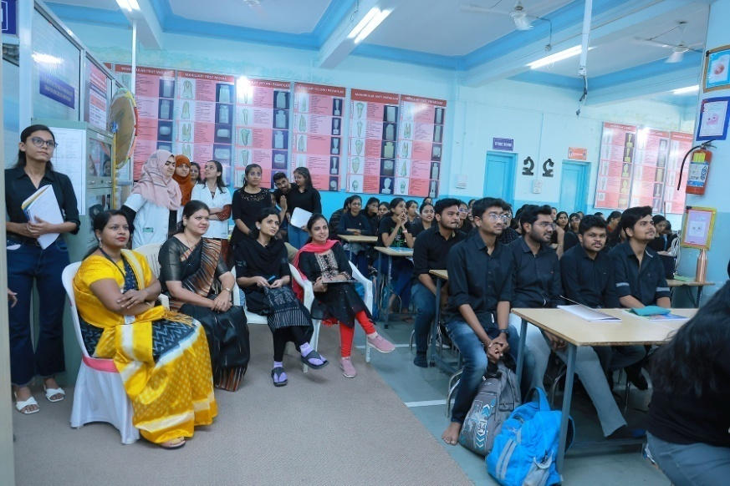
Then there was e-poster competition where Vedant Gadam 3rd BDS student secured 1st position by presenting poster on oral cancer.
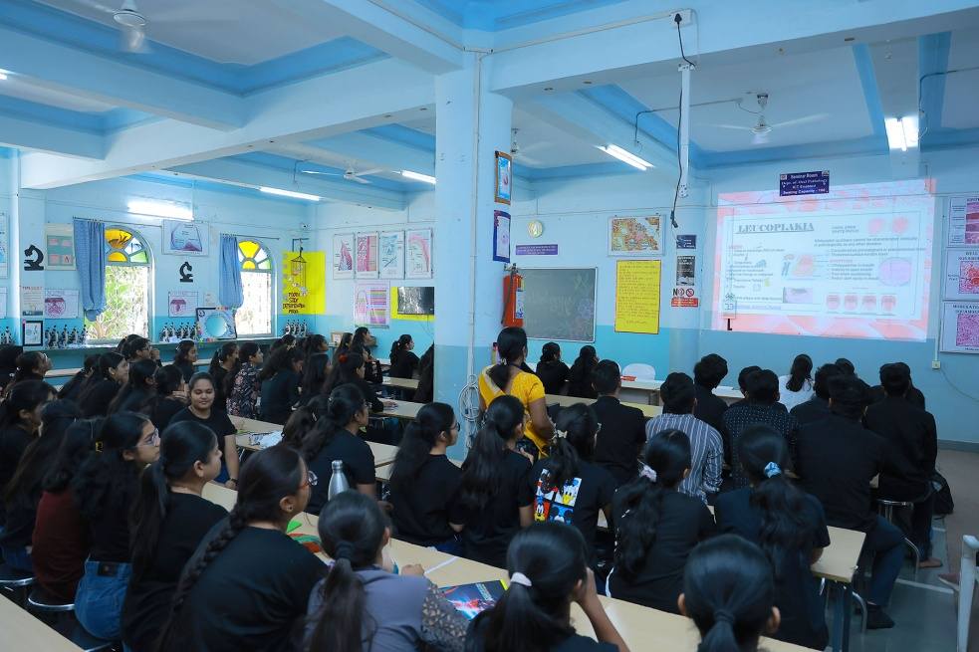

Adding to this lively environment there was a very well arranged QUIZ Competition for Our Interns, in which 4 groups of interns participated very enthusiastically. Dr Gauri Ugle was the Judge of the event.
The winners were team PULP
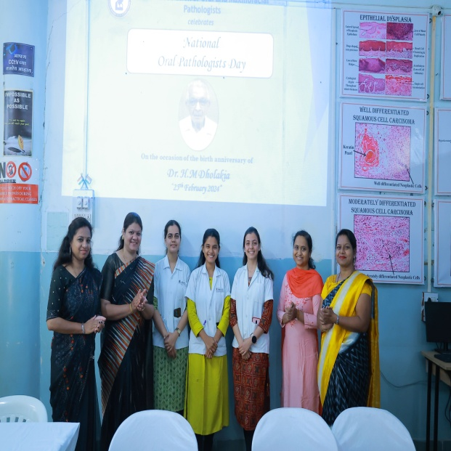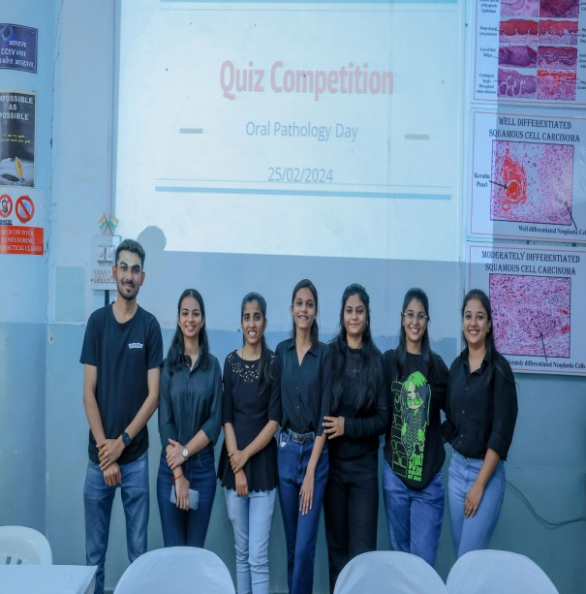

It was our immence pleasure to hear some words of wisdom from our respected executive director , Dr H.T. Karad sir.

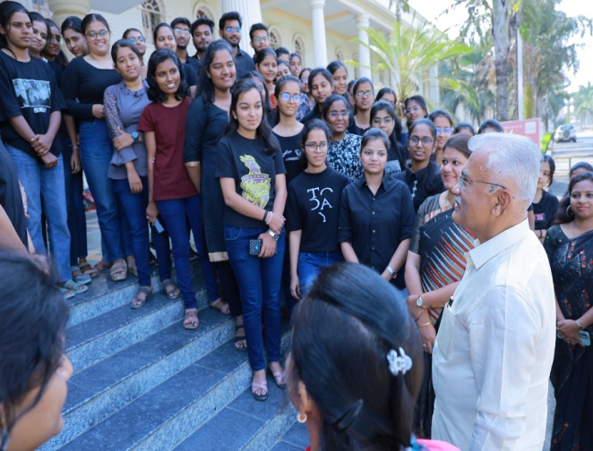
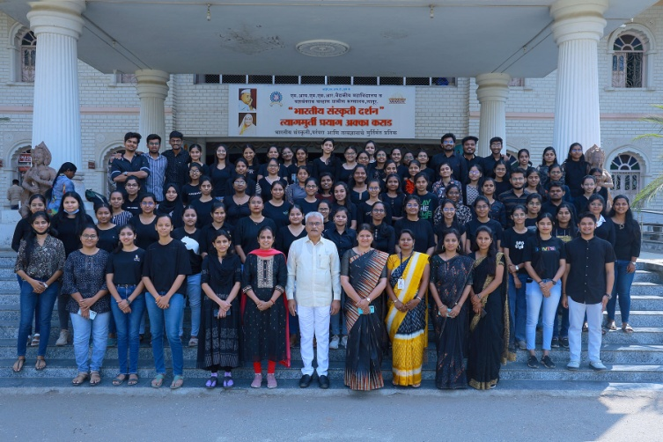
Later the winners were declared and prize distribution was done.
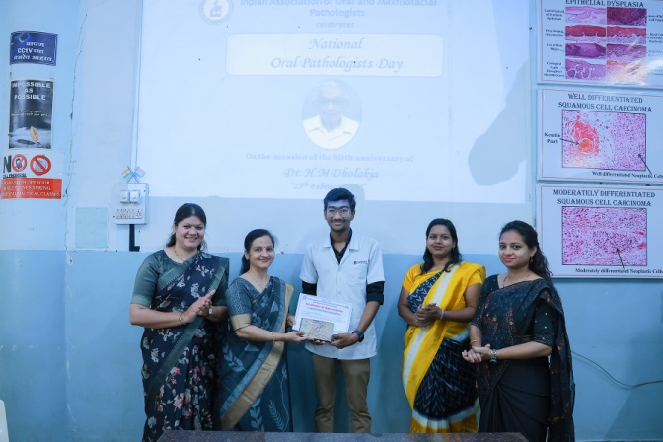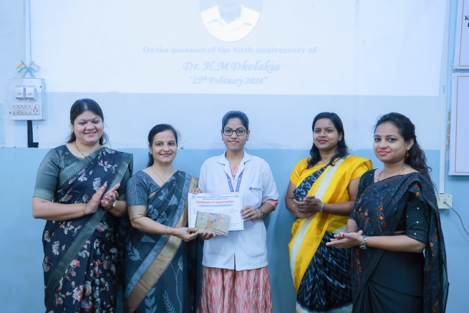
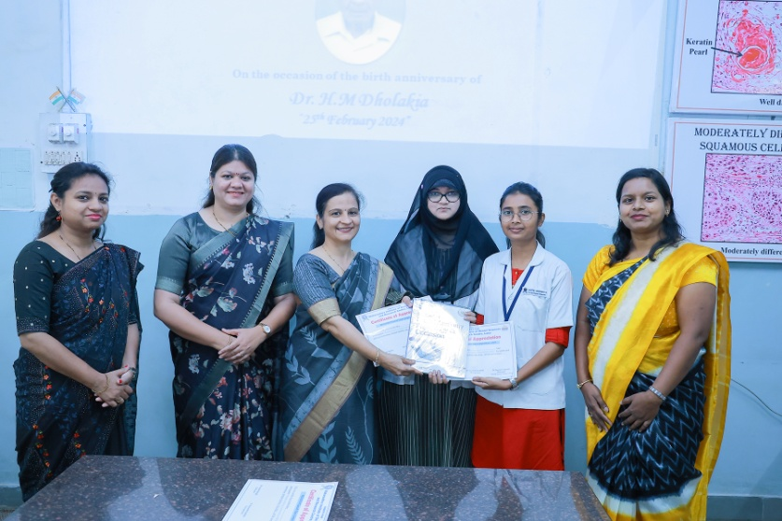

Certificates and prizes distribution was done by Dr Anuja Maniyar to the winners
Dr Dipali Gundre gave vote of thanks.

